Editorial Supplement
LINKS TO DATA AND GRAPHS REFERRED TO IN RELEASE:
Climate Change Summit No Shows Leave Obama and Clinton out on a Limb on Global Warming Rhetoric say Friends of Science
HadCrut Data Link
http://www.metoffice.gov.uk/hadobs/hadcrut4/data/current/time_series/HadCRUT.4.2.0.0.annual_ns_avg.txt
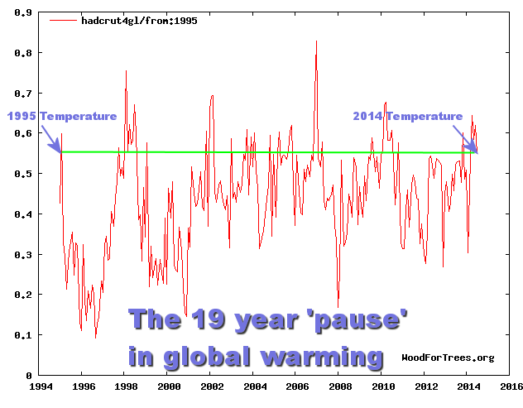
http://wattsupwiththat.files.wordpress.com/2014/09/19_years_pause.png?w=720

NASA Satellite temperature data of the lower atmosphere indicates no global warming for over 17 years – Data link:
http://data.remss.com/msu/monthly_time_series/RSS_Monthly_MSU_AMSU_Channel_TLT_Anomalies_Land_and_Ocean_v03_3.txt
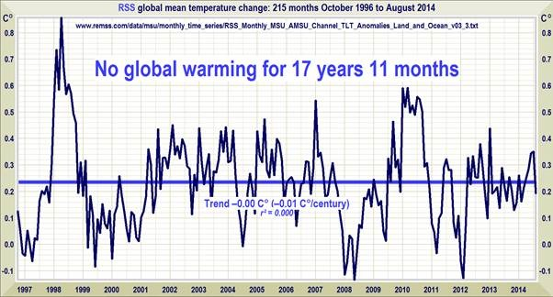
http://www.friendsofscience.org/assets/documents/FOS%20Essay/Christy34CMIP5.jpg
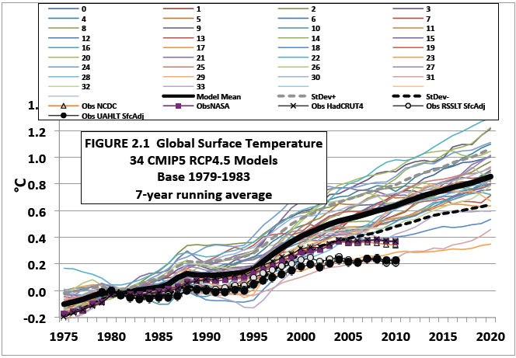
The 2013 annual average sea ice area is the largest of the century.
http://arctic.atmos.uiuc.edu/cryosphere/timeseries.global.anom.1979-2008
