

Clint Haynes, CMFC®
Founder, Financial Planner

Registered Investment Advisor

Lee’s Summit, MO 64081

Clint.Haynes@NextGen-Wealth.com

(816) 206-8195
NextGen-Wealth.com

A Little Bit About NextGen Wealth…

After being in the industry a few years, it became quite apparent to me that if you weren’t getting ready to retire and/or had at least $1,000,000 in investable assets, you weren’t going to get much help from the majority of financial planning firms out there – and if you did, most likely it was going to be the same generic advice they give to anyone no matter their situation.

With that being the case, I wanted to create a practice that was centered on working with individuals who didn’t exactly fit that mold, but were certainly on their way – the truly overlooked and underappreciated. So that’s exactly what I did in creating NextGen Wealth, where we cater to successful Generation X/Y professionals, entrepreneurs and business owners.

It’s been an exciting calling as I’ve been able to build a great financial planning practice working with individuals and families who are all going through similar situations and share many of the same needs, wants and goals. Plus, we’re one of the select few firms in the United States that specifically caters to this awesome group of individuals.

I truly believe that no other advisor is going to be more deeply committed to your success than I am.

What We Believe In

For me, I am truly a financial planner first and a portfolio manager only in the sense that investments will provide the funding for the overall financial plan. Investments, no matter the type (stocks, bonds, mutual funds, exchange traded funds, alternatives, etc.) or where they're held (IRA, 401k, trust, joint, 529, etc.) are merely one slice of the overall financial planning pie.

The first step in our process is determining what you're wanting to accomplish, how much time you’ve got to accomplish it, and what you already have in place to achieve these goals. Once we've completed this, we will then develop an investment strategy to help us to reach your goals. Then, and only then, I will work with my Investment Management Partner, Loring Ward, to design a portfolio (or portfolio's) that will accomplish the goals we've set forth - based on historical rates of return, of course.

That's the easy part though. Once this is complete, I become what I call your behavioral financial planner – helping you to continue to make good decisions, about what to do – and what not to do – regarding your investments and personal finances.

I will never EVER say that the investments I recommend will “outperform” anyone else’s. It is certainly a possibility, but I will never promise it nor can any other financial planner – and to be completely transparent, investment performance doesn't have much of a connection with everything else that I will be doing for you.

My approach is goal-focused and planning-driven, rather than being based on some attempt to outguess the economy or the markets (which I’ll never do or make any attempt to do). I believe successful investing involves constantly acting towards the realization of goals, and all unsuccessful investing is based on reacting to whatever the markets happen to be doing at the moment (easier said than done for many individuals).

Once we are completely on the same page, our next step is to determine your most important financial goals. Then we will look at your financial condition and consider the time we have for each goal: when do you want to retire, how to pay off debt, automating your finances, and so forth.

Finally, we will figure out if there is any additional money you can add to your investments before you need to start drawing on them, and of course what other resources you can rely on. Once we have established all of this, we will then know exactly the appropriate portfolio - allocation - for each goal.

In my opinion (and it’s well documented), by far the most important factor determining the long-term investment returns people get in real life is their own behavior. So the issue for me isn’t predicting when markets will peak or bottom out – which no one can consistently do – but managing the way you respond to those periods of enthusiasm near market tops, and to the fear and hopelessness, which are very human reactions, around market bottoms.

The Cycle of Market Emotions

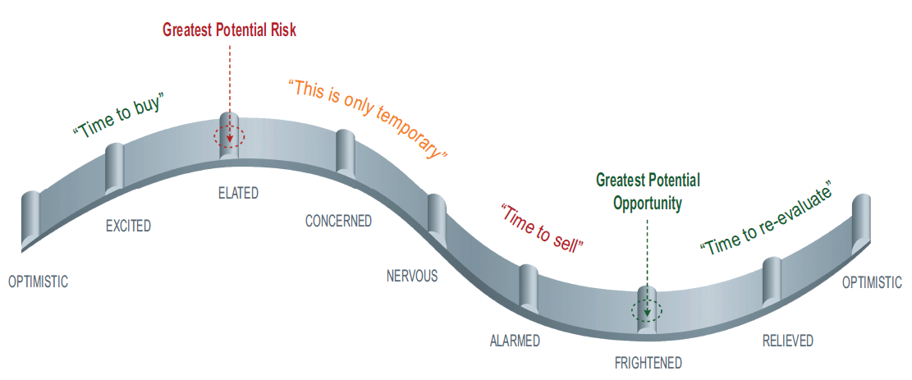

I can promise that I will never try to predict when the next bubble will form (although I can say on average to expect one about every 5-10 years). However, I will make sure you never get overly exposed in the first place. I’ll also never try to pick a point at which the market might bottom.
However, I will be working as hard as humanly possible to make sure you don’t panic out of a bear market when clearly the right thing to do is stick to your financial plan (and possibly investing more cash at rock bottom prices). This is the true definition and tremendous value of behavioral financial planning.

And because this is so important, let me reiterate: I cannot and will never guarantee your investments will be “outperforming” at any given moment (whatever yours or the media’s definition of outperforming is). But I can feel reasonably be sure that you will be achieving better long-term results than most of your peers simply because I helped you avoid some of the very common human mistakes that most people make.

Your plan will always dictate your investments.
Our Philosophy

- Faith in the future – Based on the history of the markets, optimism is the only realism.

- Patience – “The stock market is a highly efficient mechanism for the transfer of wealth from the impatient to the patient.” – Warren Buffett

- Discipline – Keep doing the right things and history will take care of itself.

- Asset Allocation – The proper mix of stocks and bonds is by far the dominate element of a portfolio’s return.

- Diversification – “Never own enough of any one thing to make a killing in it and never own enough of one thing to be able to get killed by it.” – Nick Murray

- Rebalancing – This will virtually ensure we’re always buying low and selling high.

Getting on a plan is the easy part, but staying on plan with the emotions of the market is the hard part. We’re here to help.
How Do We Get Paid

The way we charge for our advice is twofold. There is a fixed cost for the full financial plan which becomes the foundation for the creation and management of your investments. The other cost to you is a small percentage fee of the investments we manage.

Think of this fee somewhat like an insurance premium. Just like you pay a small fraction of the value to protect your home, I charge a small fee to try to keep you from making bad decisions which would ultimately cost the portfolio multiples of that fee per year. This is where my value far exceeds the cost.

The Cost of Emotions

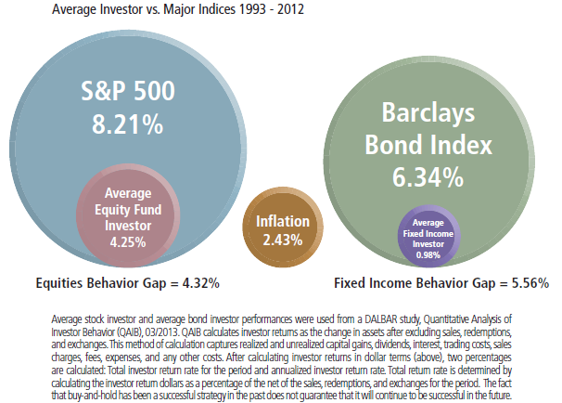

NextGen Wealth, LLC is a registered Investment Advisor. Information presented is for educational purposes only and does not intend to make an offer or solicitation for the sale or purchase of any specific securities product, service, or investment strategy. Investments involve risk and unless otherwise stated, are not guaranteed. Be sure to first consult with a qualified financial advisor, tax professional, or attorney before implementing any strategy or recommendation discussed herein.

