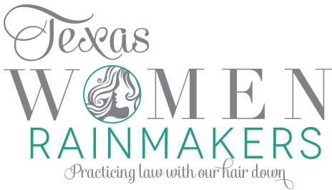
Annual CLE – September 19, 2014
St. Regis Hotel, Houston, Texas

Litigation Best Practices for Female Trial Lawyers

8:00 AM Event Registration, Sponsor Showcase & Breakfast
- Sponsored by Continental Trust Services

9:00 AM Seminar Introduction
- Co-Chairs
- Sofia Bruera, Partner, Piere Chapman Skrabanek Bruera LLP
- Stacey Burke, Owner, Stacey E. Burke, P.C.

Announcement from Robin Young & Company

9:15 AM Unconscious Gender Bias in the Legal Profession 1.0 CLE hours
Collyn Peddie, The Law Offices of Collyn Peddie

While gender “fairness” is a noble and important goal, it is a fundamentally limited one that does not and cannot address the two most critical problems identified as preventing women’s further progress: unconscious bias and the fact that real money and power have never historically been shared because it is “fair” to do so.

Announcement from LitCap

10:15 AM Recent Cases and Ethical Rules – Social Media in Litigation and Practice 0.75 CLE hours
- Digital Marketing Panel Moderator Caryn Papantonakis, Johnson Law Group
Stacey Burke, Owner, Stacey E. Burke, P.C.
- Meagan Hassan, Partner, Demond & Hassan, PLLC
- Jenny Selber, Integrate Agency

This panel will discuss the rules when utilizing social media in litigation and in your practice. Social media is the newest, and in some cases most affordable, trend in law firm digital marketing. Relevant considerations can include setting up the channels properly, branding yourself consistently, developing an appropriate strategy, setting internal protocol for how to handle social communications, and of course adhering to ethical guidelines.

The panel will also address online defamation. Panelist Meagan Hassan has the largest reported verdict in the arena of online defamation and she will impart the knowledge and trial techniques that she used to succeed in this case.

- Announcement from Memorial MRI & Diagnostic

11:00 AM Mid-Morning Break
- Sponsored by Verve Media

11:15 AM A Re-Definition of “Leadership” 1.0 CLE hours
- Karen Walrond, Lawyer and Leadership Advisor
Karen will help enhance legal skills and techniques that female lawyers utilize every day in their practice and profession to help them succeed as leaders within their firm and more importantly to succeed for their clients. Through anecdotal evidence, Karen will propose a redefinition of "leadership," which includes the possession of a certain healthy sense of entitlement: being confident enough in ourselves to know we have every right to an invitation to sit at the leadership table and counsel table.

12:15 Lunch
- Sponsored By Garretson Resolution Group

1:30 PM Becoming the Best Advocate for your Client and Yourself 0.75 CLE hours
- Leadership Panel Moderator: Chelsie Garza, Abraham, Watkins, Nichols, Sorrels, Agosto & Friend.
- Erin Copeland, Partner, Fibich, Leebron, Copeland, Briggs, & Josephson, LLP
- Ellen A. Presby, The Nemeroff Law Firm
- Kathy Snapka, Snapka Law Firm

Whether you are making a name for yourself on the steering committee of a mass tort docket, or taking the seat at the head of the table of a complex litigation matter, our panel will provide tips on how to move up the ranks within the legal profession. The panelists will share lessons learned both inside and outside of the courtroom to help you advance your career and practice. Most importantly, these panelists will discuss how to ethically promote yourself for the benefit of both you and your clients.

- Announcement from The Settlement Alliance

2:30 PM Afternoon Break
- Sponsored By Needles

2:45 PM Negotiating Strategies for Yourself and Your Client 0.75 CLE hours
- Negotiation Panel Moderator: Shalimar Wallis, Partner, Watts Guerra LLP
- Laura G. Tamez, The Herrera Law Firm
- Martha Newman, Top Lawyer Coach
- Alice Oliver-Parrott, Former Chief Justice of the First Court of Appeals, Mediator and Arbitrator

This panel is designed to help you enhance your negotiating skills in mediation and alternative dispute resolution (ADR) in order to effectively represent your clients. The panelists will discuss ethical considerations arising when in presenting the “Day in the Life” of your client. This panel not only addresses negotiations within a case, it will also address how you will have to negotiation within your career to succeed. Whether you are negotiating your first salary or renegotiating your bonus structure, this panel will help coach to become your own best advocate. They will provide tips as to how to ethically, firmly, yet politely ask for and get what you want.

Announcement from Stratos Legal

3:45 PM The Connected and Committed Woman Lawyer 1.0 CLE hours
- Laura Lopez

In this content-rich, and interactive session, Laura will draw from her leadership experiences, both good and bad, and utilize information taken from her book, “The Connected and Committed Leader”, which outlines leadership insights that are based on a new, feminine approach to leadership that is highly relevant for today’s legal climate. She will provide tips on how to enhance legal skills and techniques to better serve clients and to use in law practice management.

Announcement from Shapiro Settlement Solutions

5:00 PM Happy Hour
- Sponsored By Wise Law Group, a Thomson Reuters Business

Thank you to all of our Sponsors!

Gold Sponsor Silver Sponsor
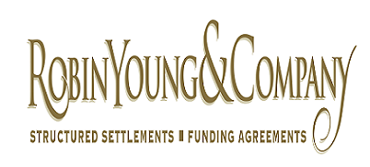

Bronze Sponsors
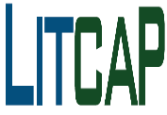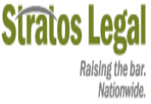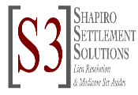

Breakfast Sponsor Luncheon Sponsor Happy Hour Sponsor
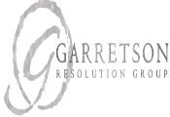

Lanyard Sponsorship Morning Break Sponsor Afternoon Break Sponsor

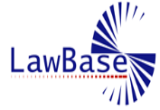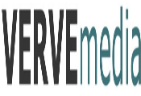

Website Sponsor Invitation and Program Sponsor
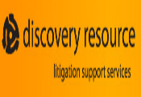

Supporting Sponsors
