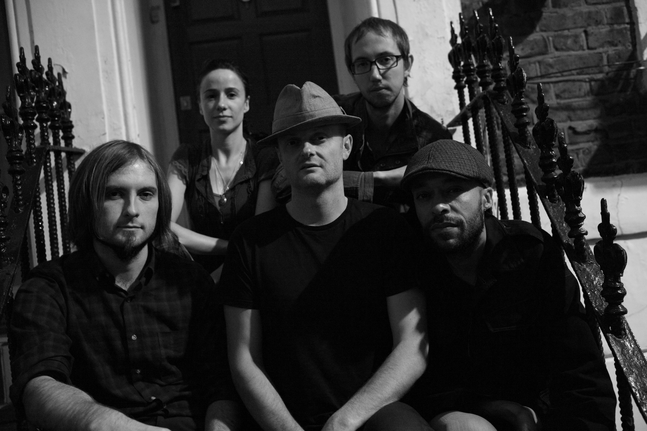
Hornman live line-up from left to right: Simon Whitton, Aoife Hegarty, Carl Davies, Laurence Hill and Wayne Maslin.

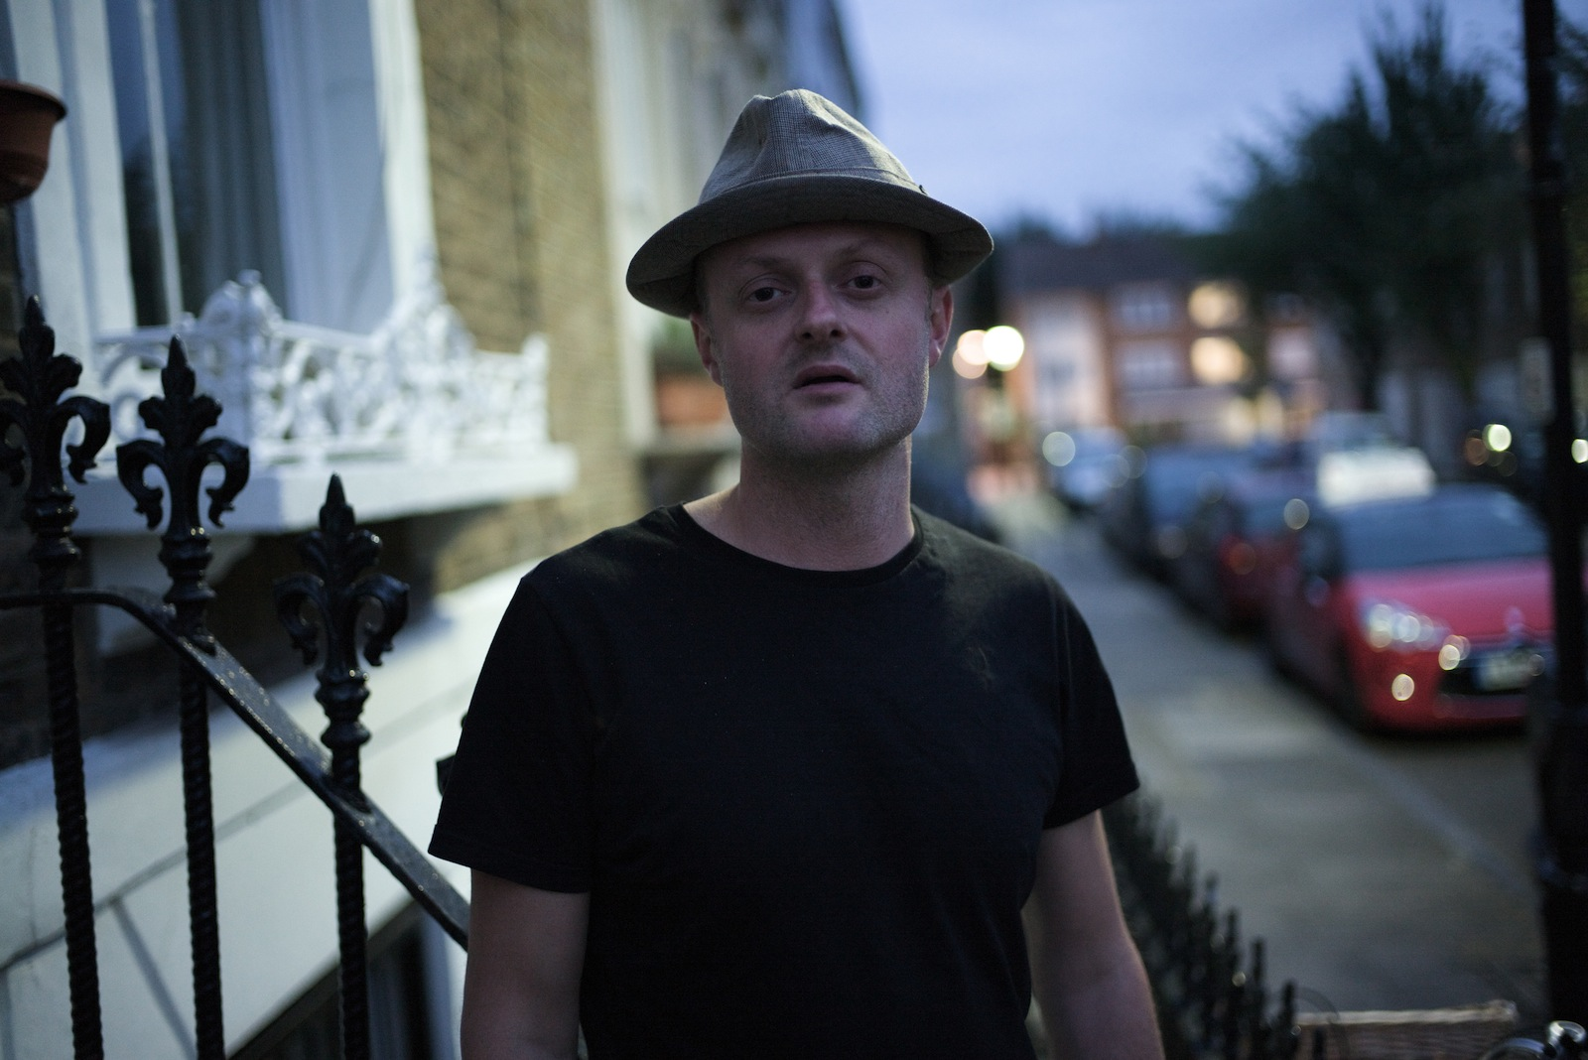
Hornman frontman Carl Davies on vocals and sax.

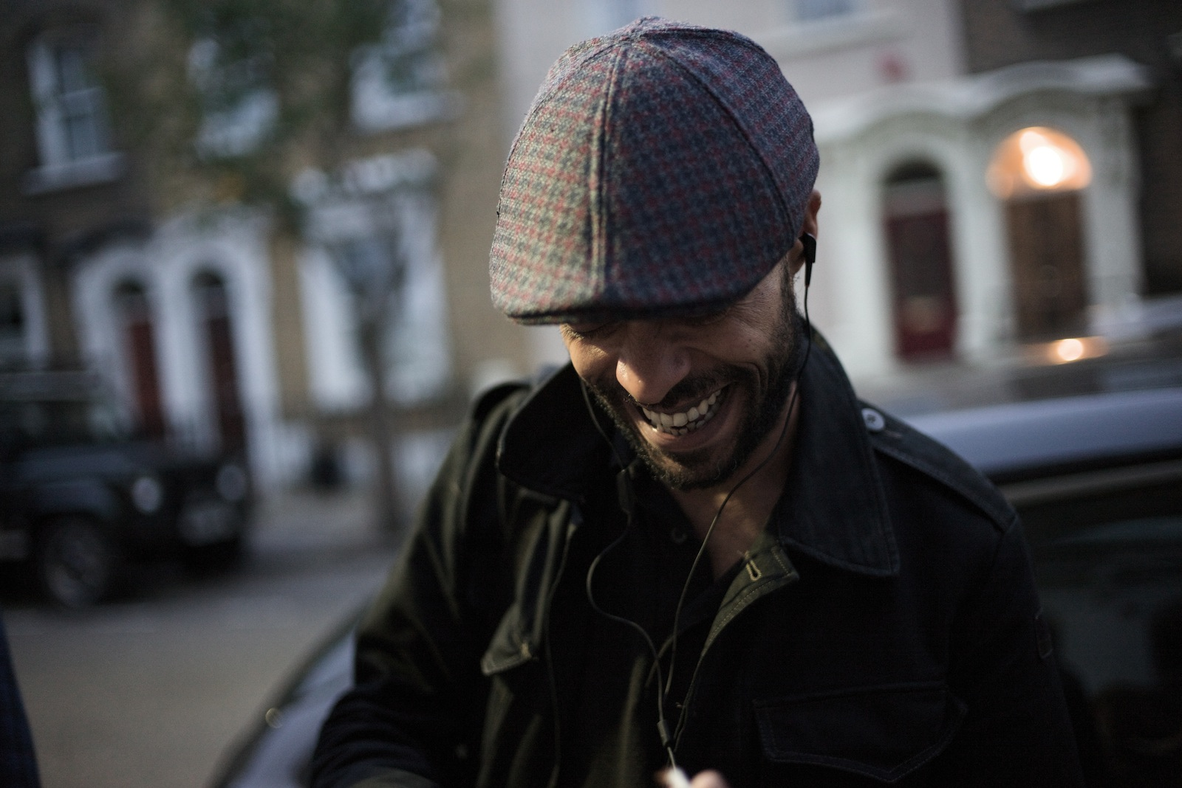
Wayne Maslin is a strong presence on trombone and vocals.

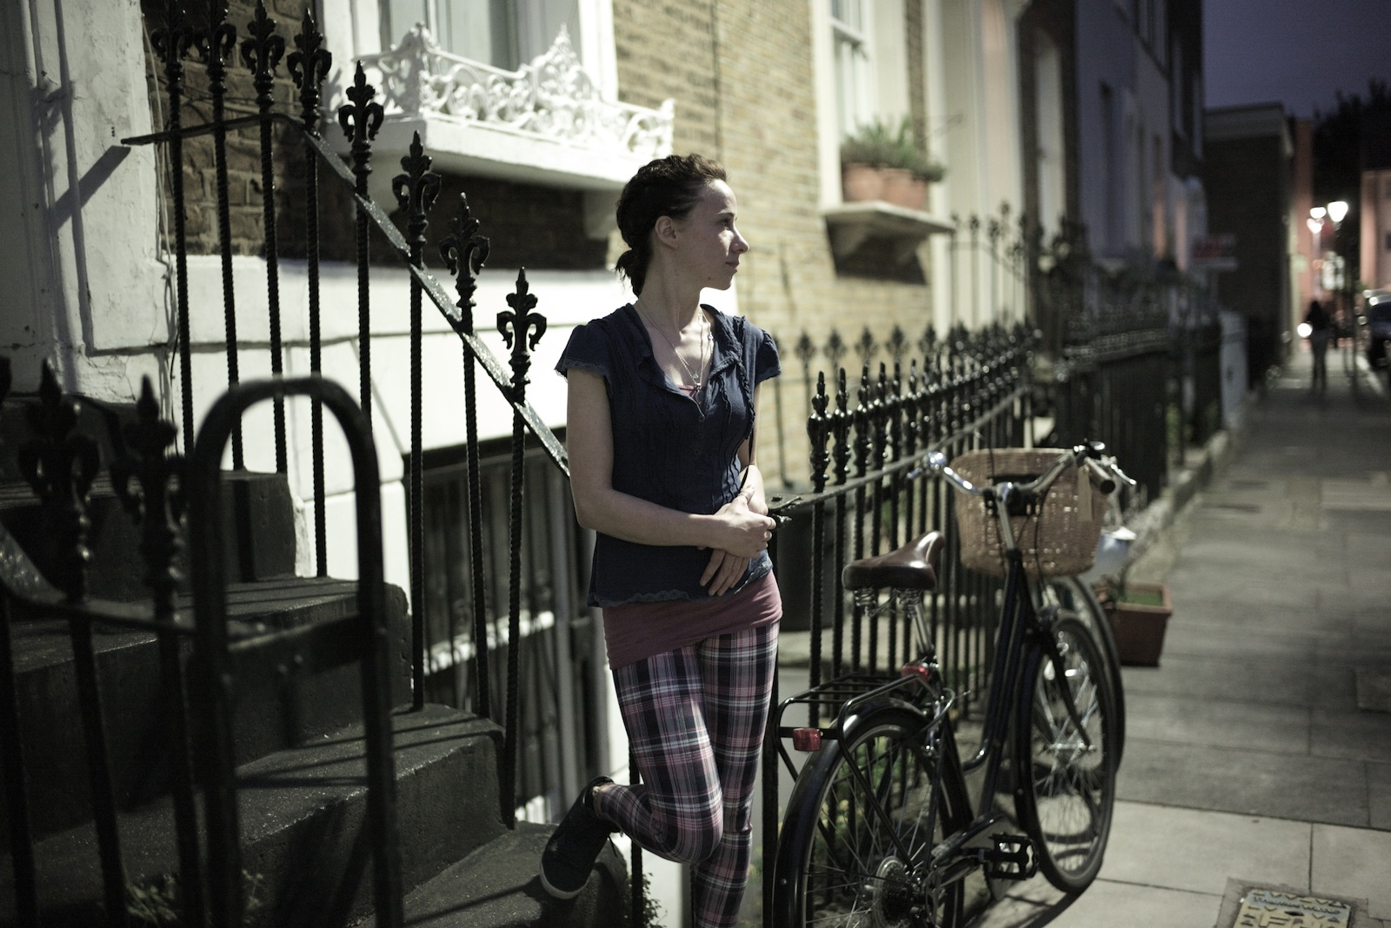Aoife Hegarty brings a feminine touch to the hornman vocal harmonies.
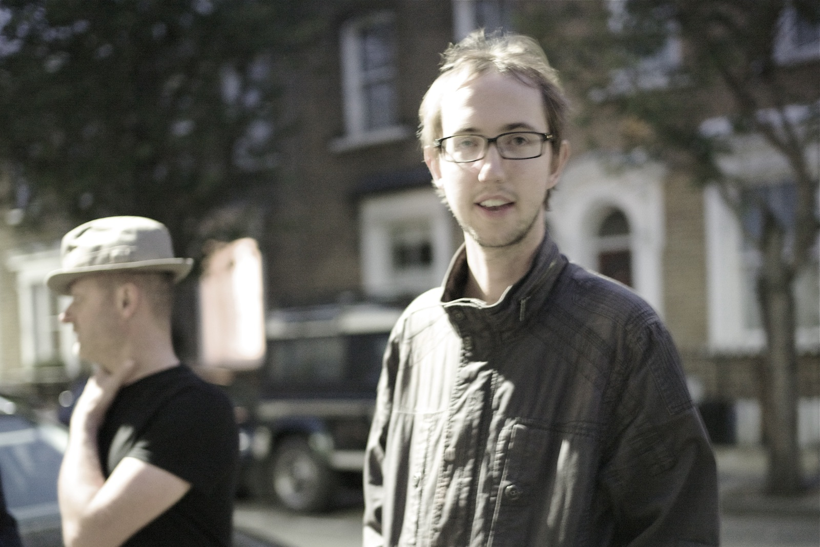Hornman drummer Laurence Hill blends various beats into the hornman mix.

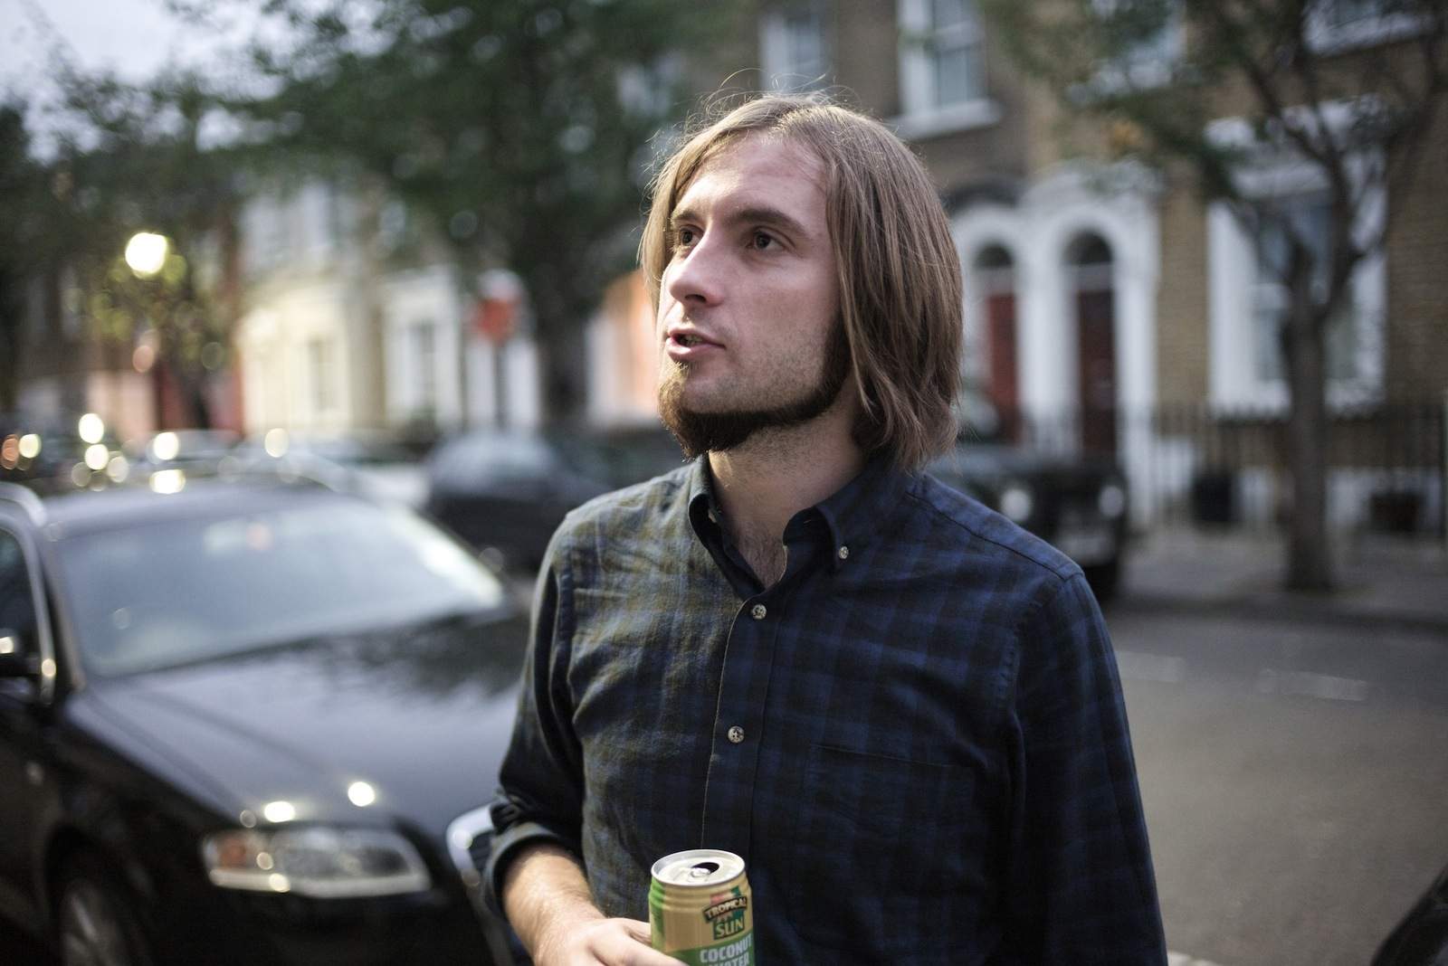Hornman guitarist Simon Whitton who’s main influence is the band “Tool”.

