Media Contact:
Lydia Baehr 713-208-3421 Lydia@LTBaehr.com

Public Contact:
Fiona Cunningham 281-687-7955 fcunningham@arthritis.org

Arthritis Foundation: http://www.arthritis.org/texas/

For Immediate Release: Sept. 29, 2014

Arthritis Impacts Texas Economy
By 2030, an estimated 67 million Americans will have arthritis

Link to stat images: Arthritis statistical information
Photo credit: Arthritis Foundation

HOUSTON – Arthritis has a significant economic impact on our economy, costing $128 billion annually in medical care and indirect expenses, including lost wages and productivity. And osteoarthritis arthritis is the second most expensive condition treated in U.S. hospitals.

Arthritis takes a toll on individuals and families, as well as businesses. By 2030, an estimated 67 million Americans will have arthritis. The Texas offices of the Arthritis Foundation work to improve the lives of 3.9 million adults and 25,000 children across the state who struggle every day with this serious health epidemic.

“The impact on resources in the state of Texas is astronomical,” stated Susan Carter, CEO of the South Central Region of the Arthritis Foundation. “According to the Centers for Disease Control and Prevention, in 2003, costs due to arthritis represented between 0.3 to 2.6 percent of each state’s gross domestic product( GDP). That equates to $8.7 billion for the third largest state in the U.S., representing more than 1% of our GDP.”
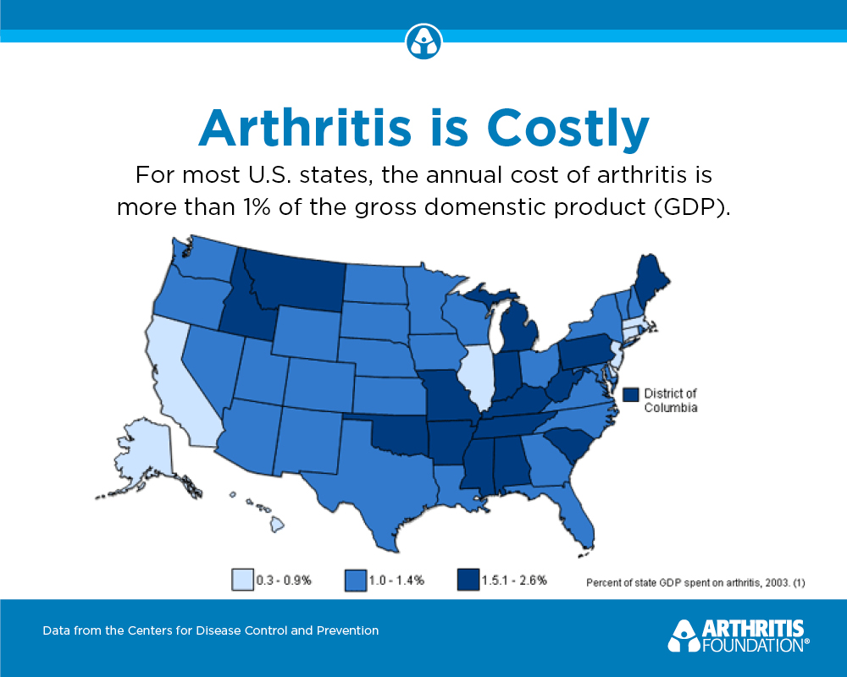
The National Center for Biotechnology Information accounts for the top five conditions treated in U.S. hospitals as – septicemia [SEP-tuh-SEE-mee-uh]; osteoarthritis; complication of device, implant or graft; liveborn (newborn) infants; and acute myocardial [my-a-CARD-ial] infarction – accounted for nearly one-fifth of the total aggregate cost for hospitalizations in 2011. That is over $70 million for the top five conditions alone.

Arthritis accounts for the second and third most expensive conditions billed to private insurance. Osteoarthritis is the second most expensive condition billed to private insurance and Spondylosis [SPON-dy-LO-sis], which includes Ankylosing Spondylitis [ANK-ee-low-sing SPON-dy-LI-tis], is number three. Osteoarthritis is also the second most expensive condition for Medicare.

"We stand with our members in sickness and in health, and we're committed to providing them access to the care they need to manage their arthritis," said Preston Johnson, Houston and Southeast Region President of Blue Cross and Blue Shield of Texas. "We applaud the work the Arthritis Foundation has undertaken to help educate the Greater Houston community and to bring funding partners and researchers together to combat this painful and debilitating disease. We're proud to be their partner in this effort."

“Partnering with Blue Cross and Blue Shield of Texas will catapult our efforts to provide people with the care that they need,” added Carter. “Their support and shared commitment to improve the health and wellbeing of those living with over 100 different forms of arthritis will make a significant impact in the lives of Texans. We are grateful for their dedicated partnership.
-more-

Arthritis Impacts Texas Economy/2

Individuals not only pay dearly for having arthritis, but so does our health care system and businesses. Fighting arthritis and finding a cure would literally grow the bottom line of the nation’s businesses – small, medium or large – as well as the overall economy. It is in everyone’s best interest – individuals, small businesses and corporations – to join in the fight against arthritis.

About the Arthritis Foundation
Striking one in every five adults and 300,000 children, arthritis is the nation’s leading cause of disability. The Arthritis Foundation (www.arthritis.org) is committed to raising awareness and reducing the impact of this serious, painful and unacceptable disease, which can severely damage joints and rob people of living life to its fullest. The Foundation funds life-changing research that has restored mobility in patients for more than six decades; fights for health care policies that improve the lives of the millions who live with arthritis; and partners with families to provide empowering programs and information.

###

