RESEARCH CONDUCTED BY WOODHOUSE REVEALS THAT THE FIRST THING WOMEN NOTICE ABOUT MEN ARE THEIR CLOTHES

Research conducted by one of the UK’s leading premium menswear retailers, Woodhouse Clothing reveals that the first thing women notice about men is clothing and style.
Woodhouse asked over 100 women what they notice first about the opposite sex. The results revealed that:
- A resounding 45% of the women who took part selected clothing and overall style as the most noticeable thing about men.
- The second is his hair 22%
- The third is his shoes 5%
- The fourth is his facial hair 2%
- The fifth is his scent 1%
Other responses (25%) took in height, body shape, teeth and smile.
Menswear buyer for Woodhouse Clothing, Gavin Crossland said, “We know that looking good in the eyes of the opposite sex is important to our customers so we were keen to understand what women notice about men when they first meet. The fact that 45% of the women who took part in the survey said that a man’s clothes were the first thing they noticed reinforces how important personal style is”
Gavin’s tips for this season are;
- Invest in a versatile piece of outerwear, a jacket that can take you from work, to the pub and even out on a date
- Knitwear is also key, warm autumnal colours and soft fabrics that can be worm smart or casual
- Never cut corners on footwear, invest in a smart pair of boots
- You can never fail with a bright white shirt to lift a whole outfit
- Accessories are key but don’t overdo it! A bag or simple hat sets any winter outfit off perfectly.

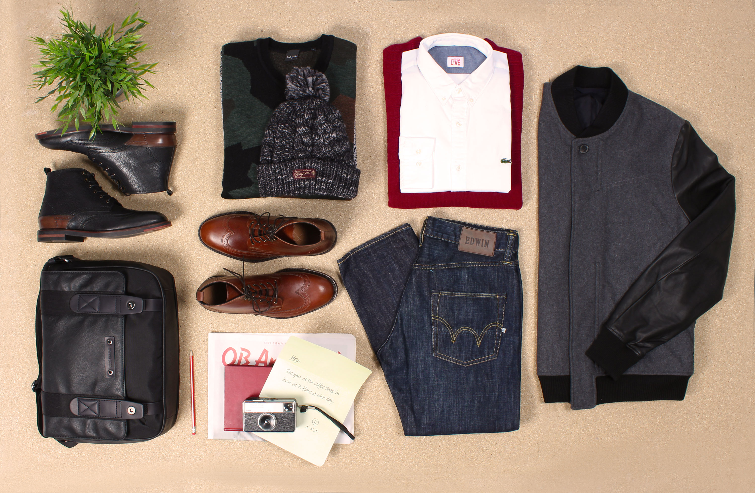

Image credit, from top left to right; Hudson Harland Black Brogue Boots, Paul Smith Khaki Green 'Camo Jacquard' Merino Wool Sweater, Scotch & Soda Grey Melange Chunky Knit Bobble Hat, Lyle & Scott Bright Claret Garter Stitch Crew Neck Sweater, Lacoste L!ve White & Chambray Shirt, Paul Smith Jeans Grey & Black Wool/Lambskin Bomber Jacket, BOSS Orange Naphtha Black Fabric & Leather Messenger Bag; Hudson Harland Tan Leather Wing-Tip Brogue Boot, Edwin ED-55 Blue Burner Wash Denim Relaxed Tapered Fit Jeans.
All available at www.woodhouseclothing.com
Joe Cotton of Woodhouse’s in-house barbers, Carter & Bond added, “the beard is now waning and the hairstyle is reclaiming its rightful number one spot. Our resident barber Ryan strives to combine what works best for a client’s hairline and the shape of his face, with a measure of what’s on trend – that measure is down to how adventurous the client feels.”
For styling and grooming tips and to get your hands on some dapper menswear, visit the Woodhouse Clothing website – www.woodhouseclothing.com

-END-

*Research took in the views of 100 women living in the UK, aged between 20-60 years old. Research conducted in September 2014 on behalf of Woodhouse Clothing.
For more information please contact:
Lizzie Morris, GUNG HO +44 121 604 6366 | lizzie@gunghoco.com
Fay Silverthorne, GUNG HO +44 121 604 6366 | fay@gunghoco.com
About Woodhouse:
Established since 1975, Woodhouse is one of the UKs leading premium menswear retailers.
The flagship Woodhouse Clothing store is located in Notting Hill, housing limited edition collections and rare labels, as well as an in-house gents grooming service, courtesy of in-house barbers Carter and Bond.
Woodhouse also has a global website – www.woodhouseclothing.com offering the online customer choice of over 90 desirable premium menswear brands such as; Stone Island, Armani, Boss, Barbour, CP Company, Fred Perry, Lacoste, Baracuta, New Balance, Swims, G-Star Raw, True Religion and Paul Smith.

