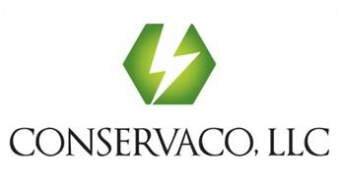
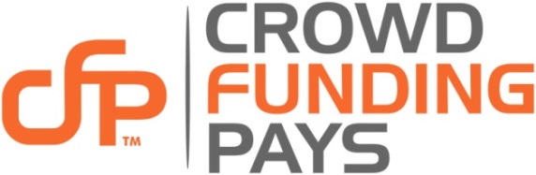

Crowd Funding Pays.com Launches New Global Crowdfunding Platform

“Innovative resources significantly improve funding goal achievement!”

First with an integrated crowdfunding Marketing and PR firm

October 2, 2014 | Source: Crowd Funding Pays (CFP)
Irvine, California, –Crowd Funding Pays (CFP), (www.crowdfundingpays.com) a division of Conservaco, LLC, launched a new crowdfunding platform today with integrated campaign development resources to significantly improve the prospects of campaigners reaching their funding goals.
Free to launch a campaign, CrowdFundingPays.com is the newest generation of global crowdfunding platforms, created with powerful market differentiators. Get started with Fixed or Flexible rewards based funding paths at competitive platform fees. Do-it-Yourself with affordable curriculum offered through LearnCFP.com, or choose IgniteCFP.com to build part or all of your campaign. IgniteCFP.com will design, develop, load, launch and manage your campaign from start to finish.
Placing the highest priority on campaign funding goal achievement, we plan to become the Gold Standard amongst crowdfunding platforms. With our information, education and integrated crowdfunding focused marketing and PR agency, we give campaigners all the tools they need to create the very best campaigns and reach their funding goals, stated Mark Thimmig. “For us, it’s about funding hopes and dreams!"
Crowdfunding is a way for businesses and non-profits to raise money, typically from about $1,000 to $1 million+. The crowdfunding economy has more than tripled in the last three years, raising $1.5 B in 2011, $2.7B in 2012, and $5.1B in 2013, with 2014 expected to see similar gains. Our audience realizes that crowdfunding is not so much generational as it is cultural; it’s much more about contributing to people and ideas that will shape the future.
"Crowdfunding is the new paradigm of small business and social funding” said Mark Thimmig, Founder, Chairman, CEO. “People around the world need startup funding for small business and social good. They quite often do not qualify for Angel, VC, or traditional bank financing. Our platform gives everyone a place to be heard and a simple process to receive funding. Bringing family, friends and followers heightens the prospects of success. It’s also a great place to get validation from independent, objective consumers.”
About Crowd Funding Pays:
Crowd Funding Pays, (CFP) a division of Conservaco, LLC, was formed to meet the rapidly growing demand for rewards-based crowdfunding. CFP offers a simple platform to present your vision, make your story come alive, and persuade others to pitch in. We are a place where you will find everything you can imagine: music, films, theater, comics, games, art, design, technology, nonprofits, small businesses and so much more. Our LearnCFP.com portal offers crowding funding courses to assist the do-it-yourselfer, or get all the help you need through IgniteCFP.com, a fully integrated Marketing and PR firm for those who want start-to-finish guidance and support.

There is no fee to create and launch a campaign on CrowdFundPays.com. Regardless of the process you choose, our resources are designed to help you reach your funding goal.

For more information, please visit: www.crowdfundingpays.com.
Media Contact: Mark F. Thimmig, mthimmig@crowdfundingpays.com

