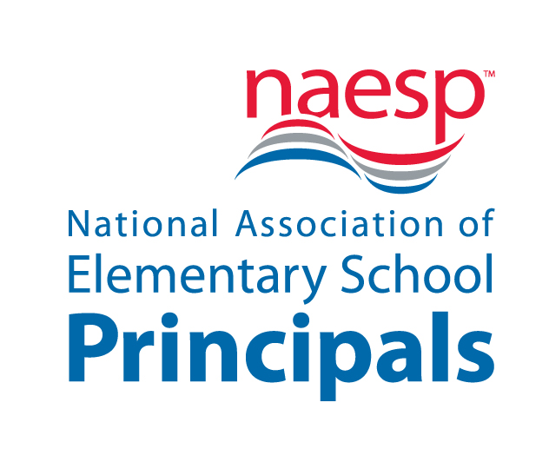

For Immediate Release
Contact: Kaylen Tucker, NAESP
703-518-6257
ktucker@naesp.org

NAESP Honors Nation’s Top K-8 Principals in Washington, D.C.

U.S. Secretary of Education Arne Duncan will provide congratulatory remarks to K-8 principal honorees.

ALEXANDRIA, VA–October 7, 2014–Outstanding elementary and middle school principals from across the nation and abroad have been named 2014 National Distinguished Principals (NDPs) by the National Association of Elementary School Principals (NAESP). The K-8 principals will be honored October 17 at an awards banquet in Washington, D.C., where U.S. Secretary of Education Arne Duncan will deliver opening remarks. This year marks the 25th year that the program has been generously funded by VALIC.

Established in 1984, the two-day NDP celebration program, which will be held at the Capital Hilton Hotel, recognizes public and private school principals who make superior contributions to their schools and communities. The principals will also have the opportunity to share best practices. The 61 principal honorees are selected by NAESP state affiliates and by committees representing private and overseas schools.

NAESP Executive Director Gail Connelly congratulated the class of outstanding principals, noting their significant role in successfully leading students, schools, and communities through seismic shifts in education. “These principals lead their school communities with courage and compassion,” she said. “They represent the best and brightest of the more than 65,000 elementary and middle-level principals who are educating our nation’s children to their fullest potential.”

“VALIC is very proud of our 25 year partnership with the National Distinguished Principals Award Program,” said Jana Greer, President and CEO of VALIC. “We recognize the critical role education plays in the lives of our nation’s children, and principals are the key to ensuring the highest quality education. On behalf of VALIC, I warmly congratulate all 61 of this year’s National Distinguished Principals and extend my deepest thanks for all that they do.”

It is particularly fitting to acknowledge the work of principals in October because it is National Principals Month, which was established to recognize and honor the contributions of school principals and assistant principals toward the success of the nation’s students, and encourage awareness of their significance.

NOTE: A list of the 2014 NDPs and their biographical information can be accessed at www.naesp.org/ndp. To request an interview with the honored principals or to attend and cover the October 17 banquet and address by Secretary Duncan, contact Kaylen Tucker at ktucker@naesp.org or 703-518-6257.

###

Established in 1921, the National Association of Elementary School Principals (NAESP) leads in the advocacy and support for elementary and middle school principals in the United States and internationally. NAESP supports principals as the primary catalysts for creating lasting foundations for learning through policy and professional development, advocacy, programs, and resources for effective instructional leadership. NAESP advances the profession on behalf of all principals, providing specialized support and mentoring for early career principals. Key focus areas including pre-K-3 education, school safety, technology and digital learning, and capacity-building educator evaluation. For more information about NAESP, please visit www.naesp.org.

For more than half a century, VALIC has served as a leading retirement plan provider for K-12 schools and school districts, healthcare, higher education, government and other not-for-profit institutions. As of June 30, 2014, VALIC has more than $88 billion in total customer assets under management and manages plans for nearly 24,000 groups serving more than 2 million plan participants. VALIC represents The Variable Annuity Life Insurance Company and its subsidiaries, VALIC Financial Advisors, Inc. and VALIC Retirement Services Company.

