 **DATE** 7 October 2014 **RELEASE NUMBER** 93/14

**Outrigger Unveils the Stunning Similan Ballroom in Phuket**

*Outrigger Laguna Phuket Beach Resort announces the opening of its magnificent Similan Ballroom featuring natural light, three breakout rooms, and innovative team building options that connect with local culture to create memorable meetings*

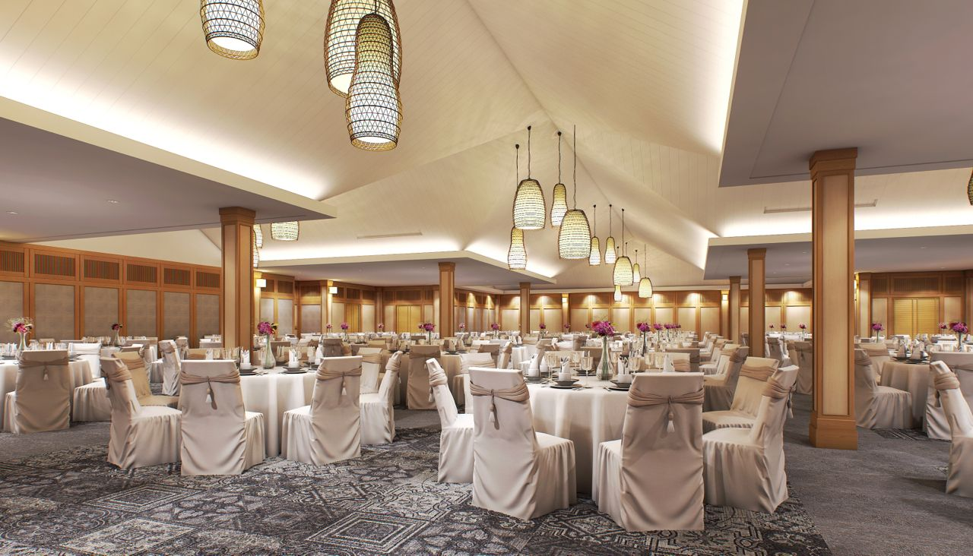

*The Similan Ballroom: 716 sqm, natural light, Wi-Fi and audio-visual excellence; the full technical spec of the Similan Ballroom and the three breakout rooms can be found* [*here*](http://www.outriggerthailand.com/laguna-phuket-beach-resort/meetings-and-events.php?CID=OHR_PR_Press%20Release_OHR__#93/14_41919)*.*

**PHUKET, THAILAND** – The Outrigger Laguna Phuket Beach Resort has unveiled its brand new meeting space, designed to host world-class business events from November 2014 onwards.

Named after the beautiful Similan Islands in the Andaman Sea near Phuket, the Similan Ballroom and three meeting rooms called Tongfah (Sky), Tawan (Sun) and Talay (Sea), will position Outrigger Laguna Phuket Beach Resort as one of the best medium-sized meeting facilities, not just in Phuket and Thailand, but in Southeast Asia.

The Similan Ballroom measures 716sqm; the Tongfah 158sqm; the Tawan and Talay breakout rooms are 77sqm each. The new facilities further boost Phuket’s considerable business events reputation and credentials.

“With the unveiling of this fantastic addition to the property, Outrigger Laguna Phuket Beach Resort is now committed to MICE excellence,” says Darren Edmonstone, Outrigger

- more -

*Outrigger Unveils the Stunning Similan Ballroom in Phuket*

*Page 2*

managing director, Asia Pacific. “The new Similan meeting space allows Outrigger to extend its unique passion for meetings excellence and team building to event organizers around the world.”

Tony Pedroni, the Outrigger Laguna Phuket Beach Resort general manager, says the new facility will offer team-building programs with a “uniquely Thai twist” that will connect customers with local culture.

“Our commitment to the MICE sector will be underpinned by the support of a dedicated Events team for each client meeting,” says Pedroni. “Outrigger hosts will work with clients to deliver inspirational service quality that will match the superlative setting of our beachside location.”

Outrigger management says conference guest meetings will benefit from a range of high-end in-house AV equipment and technical support that will ensure high quality productions.

The four meeting spaces feature free Wi-Fi everywhere, all the time, natural daylight in all meeting rooms including the Similan Ballroom, dedicated technical support, an event and catering team and state-of-the-art audio visual and conference amenities.

**Flexible Space, Natural Light**

The Similan Ballroom can comfortably host executive conferences of up to 350 delegates in theatre-style and 290 guests banquet-style.

A few steps away, the setting is perfect for a variety of events outdoors. Extensive gardens and a peaceful beachfront create inspirational settings for team building activities and outdoor banquets.

Rory Campbell, director of Sales & Marketing at the property said that meetings guests can expect “excellent morning and afternoon refreshment breaks, culinary lunches and unforgettable dinners – either special banquets, or at any of our three in-house restaurants”.

Outsourced team building activities can be arranged by specialist teams within 30 minutes of Outrigger. The resort’s own Savitar Tennis Centre with an in-house professional and instructors is also ideal as a team building resource.

In addition, the greater resort community of Laguna Phuket offers the 18-hole Laguna Golf Club, award-winning spas, land excursions and sea tours to the Andaman Sea as well as over 30 restaurants and bars. The Outrigger property is a 20-minute road transfer from Phuket International Airport.

Appreciating the often challenging task of room assignment, an inventory of 164 Deluxe Rooms and 91 Club Rooms ensures a consistency of room allocation for attendees – with Club Suites and Villas for VIPs.

Since opening in April 2013, the award winning Outrigger Laguna Phuket Beach Resort has become one of the most praised and sought-after resorts in Asia.

- more -

*Outrigger Unveils the Stunning Similan Ballroom in Phuket*

*Page 3*

The full technical spec of the Similan Ballroom and the three breakout rooms can be found [here](http://www.outriggerthailand.com/laguna-phuket-beach-resort/meetings-and-events.php?CID=OHR_PR_Press%20Release_OHR__#93/13_41919). For meeting queries, please contact the Outrigger Laguna Phuket Beach Resort MICE team at +66 (0)76 360 600 or email [reservation.phuketbeach@outrigger.co.th](mailto:reservation.phuketbeach@outrigger.co.th).

-30-

**About Outrigger Enterprises Group**

[Outrigger Enterprises Group](http://www.outrigger.com/?CID=OHR_PR_Press%20Release_OHR__#93/13_41919) is one of the largest and fastest growing privately held leisure lodging, retail and hospitality companies operating in the Asia Pacific, Oceania and Indian Ocean regions. As part of its unique hospitality offering, the values-based company extends exceptional hospitality and authentic cultural experiences, incorporating local traditions and customs into the guest experience at each of its properties worldwide. Guided by more than 67 years of family leadership, Outrigger runs a highly-successful, multibranded portfolio of hotels, condominiums and vacation resort properties, including Outrigger® Resorts, OHANA® Hotels and Resorts, Embassy Suites®, Holiday Inn®, Best Western®, Wyndham Vacation Ownership® and Hilton Grand VacationsTM. Currently, Outrigger operates and/or has under development 45 properties with approximately 11,000 rooms located in Hawaii; Australia; Guam; Fiji; Thailand; Mauritius; Maldives; Vietnam; and Hainan Island, China. For online information, log on at [www.outriggerenterprisesgroup.com](http://www.outrigger.com/about-us/outrigger-enterprises-group/overview?CID=OHR_PR_Press%20Release_OHR__#93/13_41919) and [www.outrigger.com](http://www.outrigger.com/?CID=OHR_PR_Press%20Release_OHR__#93/13_41919).

###

**MEDIA CONTACTS**:

**Asia: North America:**

Ken Scott, Managing Director Nancy Daniels, APR, Director of PR

ScottAsia Communications Outrigger Enterprises Group

Mobile: (+44) 7572 027264 Ph: 808-921-6839

Email: [kens@scottasia.net](mailto:kens@scottasia.net) Email: [nancy.daniels@outrigger.com](mailto:nancy.daniels@outrigger.com)