FOR IMMEDIATE RELEASE

Wastequip Introduces Roll-Off Container Covers
Lightweight, Durable, Affordable Covers Meet EPA Regulations for Storm Water Exposure

CHARLOTTE, N.C. [Oct. 9, 2014] — Wastequip®, the leading North American manufacturer of waste and recycling equipment, today announces the launch of lockable roll-off container covers.

Designed to meet EPA regulations for storm water exposure, Wastequip’s new heavy-duty covers for
roll-off containers are an ideal solution for combating harsh weather like rain, sleet, or snow. Built with
UV-protected, impact-resistant high-density polyethylene (HDPE), they’re lockable to protect container contents from theft, as well as prevent the aggravating – and costly – issue of unauthorized dumping.

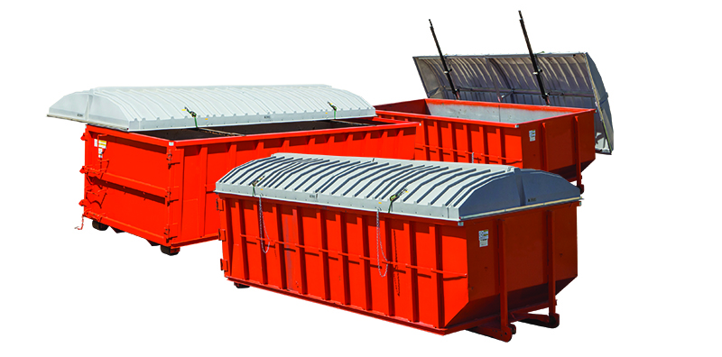

Wastequip’s roll-off container covers open to 90 degrees, providing full access to container contents. Opening and closing the cover takes no more than a few seconds, and requires no tools or machines. User simply pulls the lid back, then pushes it toward the ground as lid tilts open. It’s equally simple to close the cover. Covers are permanently mounted to the container, so they stay on at all times, including during transportation to the landfill or scrap yard.

Click here to view a video of the product in action.

Wastequip’s new roll-off container covers are available in multiple sizes and configurations. Standard covers are available to fit the most common containers, and custom models can be built to fit unique container shapes or sizes. They can ship pre-installed on new Wastequip roll-off containers, or sold separately for simple retrofitting on existing containers. They can be shipped fully-assembled, or as unassembled “kits” that are ready for assembly right on the jobsite.

“Oftentimes roll-offs sit on a construction site where they’re subject to rain, sleet, snow, wind and other forces of nature for a long period of time. No one wants the added weight of precipitation at the landfill or scrap yard,” said Amanda Maeyaert, product manager for Wastequip containers. “Our new covers for roll-off containers meet EPA regulations for storm water exposure, and prevent rain or snow from getting inside the container. They are lightweight, durable, and affordable, and they lock, preventing theft and unauthorized dumping.”

###

ABOUT WASTEQUIP
Wastequip is the leading North American manufacturer of waste and recycling equipment, with an international network of manufacturing facilities and the most extensive dealer network in North America. Wastequip’s broad range of waste and recycling equipment and systems is used to collect, process and transport recyclables, solid waste, liquid waste and organics. The company’s brands include Wastequip, Toter, Galbreath, Pioneer, Accurate, Cusco, Mountain Tarp and Go To Parts. For more information, visit www.wastequip.com.

Media Contact:
Kelly Rouse
Marketing Manager
Wastequip
704-501-8207
krouse@wastequip.com

