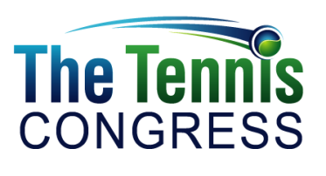



P.J. Simmons, Founder, is a self-professed Tennisaholic who didn’t start playing until relatively late in life—despite being infatuated with the sport since his youth. His passion lies in helping other adult players accelerate their progress towards their personal best while enjoying the journey and enriching their lives in the process. He is also an ISSA-certified personal trainer and an iTPA Certified Tennis Performance Specialist (CTPS). P.J. chronicles his own experiences trying to become a better player on the blog, “The Road to 4.5 Tennis”. He strives to bring the same energy, enthusiasm & impact to the adult recreational tennis community that he has brought to the global sustainability arena for nearly two decades. P.J. is co-founder and Chair of the Corporate Eco Forum —one of the world’s preeminent networks for senior executives from about seventy Fortune 500 companies with combined revenues of over $3 trillion. He has also held senior positions at the Woodrow Wilson International Center for Scholars, the Carnegie Endowment for International Peace, the Rockefeller Brothers Fund, and the Clinton Global Initiative. His publications include the highly acclaimed The Green to Gold Business Playbook.He was one of the youngest individuals in history to be awarded life membership in the Council on Foreign Relations at age 35.

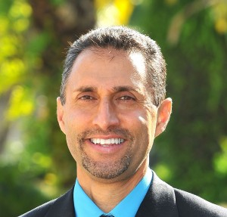

Feisal Hassan, Program Chair, is a PTR 5A Pro and USPTA Master Professional, and is the General Manager and Tennis Director at the Midlothian Tennis Club in Midlothian, Virginia. He is also a member of the Head/Penn Racquet Sports National Advisory Board and National Speaker’s Bureau and holds USPTA specialist degrees in Competitive Player Development, Facility Management and Little Tennis. He is a USTA Recreation Coach National and Quickstart Trainer, a member of the National Cardio Tennis Speakers Team and co-chairs the USPTA National Education Committee and the USPTA College Curriculum Committee. He is also on the USPTA Testing Committee and USTA National Youth Education Committee. He was also the Director of Certification & Testing for the USPTA Middle States division and was co-chair of the USPTA National Diversity Committee.

Feisal was also the Director of Coaches’ Education and Junior Davis Cup Team Coach for Tennis Zimbabwe. He was also voted in Tennis Industry magazine’s prestigious “40 Under 40” list for being one of the top 40 men and women under 40 years old who have had and will continue to have a strong influence in the sport and in the business of tennis– both nationally and internationally.

Hassan writes and conducts seminars, workshops and clinics for international, national and sectional organizations and events. He has also written the book, How to Handle Difficult Players and Conditions, and is currently working on his second book, Doubles: Phases & Situations.

In 2011, he was awarded the USPTA’s most prestigious award, the Alex Gordon National Professional of the Year and the 2011 Racquet Sports Industry Champions of Tennis Award. This is the Racquet Sports Industry’s (RSI) most prestigious award recognizing and honoring the people, businesses and organizations that are making a difference in the tennis industry. He was also a recipient for the USPTA Mid-Atlantic Hall of Fame recipient Inaugural Class of 2012 and the 2012 USPTA George Bacso National Tester of the Year.

Previous accolades include the USPTA Industry Excellence Award in 1999, 5-time Division Tester of the Year, 11-time USPTA Division/State Pro of the Year, and 9-time national Top-10 point holder in the USPTA’s Career Development Program.



Dr. Mark Kovacs, Director of Performance & Fitness Education, is a renowned performance physiologist, researcher, university professor, author, speaker and coach with an extensive background training and researching athletes at all levels. He serves as both the Executive Director of the International Tennis Performance Association (iTPA) and Director of the Gatorade Sports Science Institute. Dr. Kovacs’ work has helped improve the way the physical aspects of tennis are trained throughout the world, and he has personally tested and trained hundreds of world class athletes in numerous sports. He formerly directed the Sport Science, Strength & Conditioning and Coaching Education departments for the United States Tennis Association (USTA).

Dr. Kovacs is a Fellow of the American College of Sports Medicine, has published over 50 peer-reviewed scientific articles and abstracts in top journals and was the Associate Editor-in-Chief of the Strength & Conditioning Journal. He is on the editorial board for multiple journals including the Journal of the International Society of Sports Nutrition and has presented workshops, keynote addresses and well over 100 presentations on four continents.

Along with his academic and scientific background, Dr. Kovacs is also a coach and former professional athlete. While originally from Melbourne, Australia, he was an All-American and NCAA doubles champion in tennis at Auburn University. After playing professionally, he completed his graduate work at Auburn University and earned his Ph.D. in Exercise Physiology from The University of Alabama. Dr. Kovacs is a Certified Strength and Conditioning Specialist through the National Strength and Conditioning Association, a Certified Tennis Performance Specialist (CTPS) through the ITPA, a certified Health/Fitness Specialist through the American College of Sports Medicine, a United States Track and Field Level II Sprints Coach and Certified Tennis Coach.

He has published five books on topics ranging from dynamic stretching to recovery. Mark has organized a number of medical and sport science conferences aimed at improving the education of medical professionals, coaches, athletes, parents and sport administrators. In 2010 he was awarded the prestigious Plagenhoef Award for sport science achievement (youngest ever recipient); in 2012 he was the youngest ever International Tennis Hall of Fame Educational Merit Award winner.

