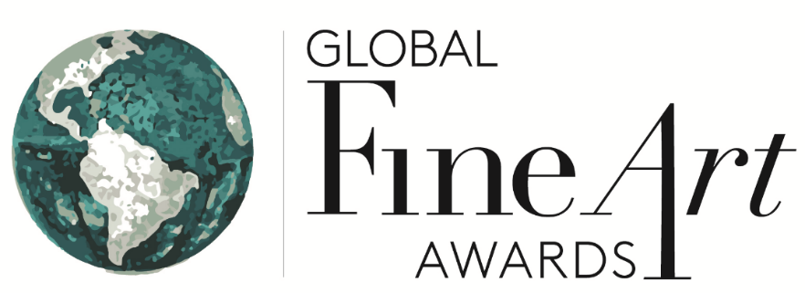

Some highlights of the reactions and support from nominees and finalists including: The Solomon R. Guggenheim Museum and The Metropolitan Museum of Art, New York, LACMA and Getty Museum in LA; Le Petit Palais in Paris and Louvre-Lens; Seattle, Boston and Philadelphia Museums of Art; Palazzo Strozzi in Florence, The National Gallery, London and London's Arts Council, and the Brouq Natural Reserve in Qatar.
“Thank you …and please extend our thanks to the judges for nominating the Guggenheim Museum's 2014 exhibition, Italian Futurism, 1909-1944: Reconstructing the Universe, for this newly founded award.”
Dr. Vivien M. Greene, Senior Curator, 19th- and Early 20th-Century Art, Solomon R. Guggenheim Museum

“We are thrilled to learn that Strange Beauty has been selected as a Finalist for a Global Fine Art Award. This is very exciting news…Thank you again and best wishes for a very successful awards! Yours sincerely, Jane “
Jane Knowles, Head of Exhibitions, The National Gallery, Trafalgar Square, London

The Getty Museum | The Scandalous Art of James Ensor exhibition is a Finalist for a Global Fine Art Award

"This is wonderful news! ..... the Assistant Director over at the J Paul Getty Museum will be able to let others know about this great news over at the museum. - Jack Ludden"

“Thank you Judy.”
John A. Giurini, Assistant Director for Public Affairs, J. Paul Getty Museum

“Thanks for explaining … the Global Fine Arts award. I am honored to be a finalist!”
Sarah Kennel, Associate Curator, Department of Photographs, National Gallery of Art, Washington

”Thank you, we are all very excited about this nomination.”
Lavinia Rinaldi, Fondazione Palazzo Strozzi press officer. Florence, Italy, Aug 28, 2014
“Thanks for the nomination. I´m happy to be in such good company… “Borders” was sponsored by Bloomberg with additional support by Chicago Park District, Grant Park Conservancy and the Icelandic Ministry of Culture.
Best wishes,”
Steinunn Thorarinsdottir, Nominated Artist

“Stephanie Barron forwarded me your email regarding the Global Fine Art Award- we are very honored to have been nominated!... Thank you again for the nomination! Best wishes,”

Lauren Bergman, Assistant Curator, Modern Art, LACMA

“It was very exciting to receive the nomination (for the “Uncommon Ground” Installation organized by the Arts Council Collection Touring Exhibition from the Southbank Centre) and I hope that we might be nominated in our own right in 2015 for our exhibition Unreliable Evidence: The Execution of Maximilian and Other Histories which opens here next week.”

“I wish you every success with these new awards.”

Sarah Shalgosky, Curator, The University of Warwick

“This is a really exciting project, thank you for the nomination of East/West-West/East.”
Federica Zuccarini , Press Officer, Brouq Natural Reserve, Qatar, Sep 11, 2014

“… We are thrilled that we have been nominated for this award… for our Dorothea Tanning exhibition 'Web of Dreams.'
Sophie Clark, Assistant Director, ALISON JACQUES GALLERY, LONDON W1T 3LN

“The Jewish Museum is thrilled to be one of the finalists for a Global Fine Art Award for our exhibition, Other Primary Structures.”
Alex Wittenberg , Communications Coordinator

“We are so pleased to be considered for the Global Fine Art Award for the exhibition Permission To Be Global.”
Isabella Bulkeley, Public Relations Coordinator, Museum of Fine Arts, Boston

#####

Press Contact:
Judy Holm, Founder and Co-Producer, Global Fine Art Awards
judyh@aspirationspr.com 917.589.0247
http://www.globalfineartawards.org/

