1/2

LAUNCH OF HOTEL-IN-MONTREAL.COM, THE WEBSITE SPECIALIZED IN MONTREAL’S HOTELS.

Montreal, October 20th, 2014

In between a blog and a tourist guide, Hotel-in-Montreal.com offers critical reviews of hotels in Montreal. Our goal? To help travellers find the right hotel!

Finding the “right” hotel

Each of us has their own criteria when it comes to finding the perfect hotel room. Whether it’s for a sleep over or a longer stay, for vacations or a business trip, to sleep in the heart of the historical district or in the heart of the action, to feel at home or to enjoy the best breakfast in town… we all have our preferences. The Internet is loaded with all kinds of more or less interesting information, making it difficult to sort the good from the bad. Hotel-in-Montreal.com has synthetized facts about our favorite topic, that being hotels in Montreal.

“Helping travellers find the right hotel in Montreal” is our mission.

High Quality Content

As opposed to the sites that promise to find the best deals or those compiling web surfers’ opinions, Hotel-in-Montreal.com features the comments of an expert on the matter. The expert is a French journalist who also happens to be a seasoned traveller who fell under the charm of his new hometown: the Quebec metropolis.

Each hotel review is formatted as a report. In addition to the critical stance of our journalist, you’ll find a series of useful information: pictures, rates, location, a “on the + side” section, maps, and metro access details…The hotels we reviewed have been visited and tested, thus travellers have all the right information to choose “the right hotel” and avoid being surprised or disappointed.

The founder of the site explains, “Our approach aims to offer quality editorial content on hotels in Montreal. You won’t find all the hotels of the city but only those that charmed us, that intrigued us, and that we carefully selected for you.”

Media Contact: Lucas Rivoire, Founder – lucas@hotel-in-montral.com - 514 815-0035
Photo gallery
All you need to know at a glance
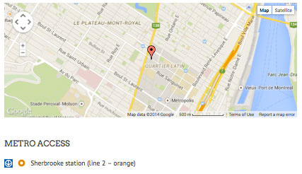
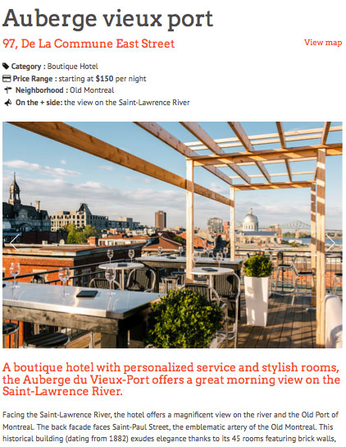
An accurate analysis of the hotel location
2/2

Adapts to the size of your screen on computers, tablets, or smartphones
Metro station nearby
Website: www.hotel-in-montreal.com
Languages : English and French
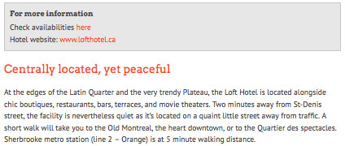
Meaningful titles
Responsive site
To go further
