Press Release Contacts:
For Immediate Release Vinitaly International
International Media Dept.
+39 045 8101447
media@vinitalytour.com
www.vinitalytour.com
Twitter: @VinitalyTour
Join Vinitaly International Network on LinkedIn

Vinitaly International Academy takes on the challenge of overcoming the Aussie love of beer

Vinitaly International is getting ready to travel to Australia to take part in Vinitalia Down Under (26 – 26 October2014) in Melbourne with the intent of paving the way for a decisive leap forward for Italian wines in the Land of the Kangaroo. The decision comes at a time when Australia's love for beer has sunk to the lowest level since the days of the post-war six o'clock swill, overcome by an increasing interest towards more sophisticated alcoholic beverages such as wine.
According to the Australian Bureau of Statistics, if on the one hand Australia is one of the first top five wine producing countries in the world, on the other it is showing an increasing receptiveness towards imported wines, that reached an impressive 8.9 million litres in 2013 (+32,8% in just two years)
There are many reasons behind this positive trend, last but not the least a more sophisticated approach to drinking that has left beer desperately holding on to a 38% market share that will soon have to give way to a continuously expanding average consumption of 30 L of wine per capita. A drop in the prices and an emerging tendency towards food and wine paring are also contributing to the increase in demand for good quality, mid to upper range wines.
Holding third place after New Zealand and France, Italian wine does not, at this stage, represent a primary choice for Aussie consumers, but with its 8.9 million litres sold in 2013 and a constant upwards trend, the future doesn’t seem too bleak: Australian consumers are strongly attracted by “Made in Italy”, they show a healthy interest towards all that is new and like to get to know more about wines, wineries and grape varietals. (Source: Italian Chamber of Commerce in Melbourne, March 2014, http://tinyurl.com/oo9wka3)
All good reasons for Vinitaly International to partner with the Italian Chamber of Commerce and Industry in Melbourne in the organization of the second edition of Vinitalia Down Under, a boutique Italian wine tasting and commercial event with the avowed objective of supporting sales and awareness of certified Italian wines in Australia. The event is also part of the project “Italian Wine Meets Australia” - Extraordinary Campaign for the Promotion of Made in Italy, and has been financed by the Italian Ministry of Economic Development.

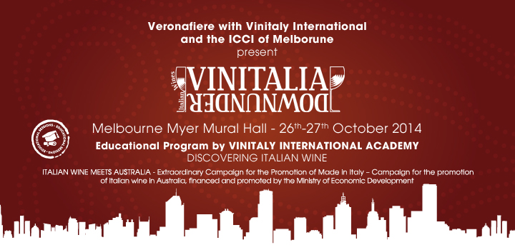

On this occasion, the Ambassador of Italian wine will be leveraging once again its leading edge, the Vinitaly International Academy, and presenting three Executive Wine Seminars to be held by Dr. Ian D’Agata, Scientific Director of VIA and award winning author of “Native Wine Grapes of Italy”. “We want to showcase the huge variety of Italy's many terroirs and grapes.” explains Doctor D’Agata. “With 540 different native grapes, Italy has over 30% of the world's grapes, hence its wines offer a unique plethora of aromas and flavours that no other country in the world is proud of. This means also, however, that our wines are complicated and need to be explained well by people who really have the experience and knowledge base to do so”.
The first seminar, “Italy’s best wines from the country’s best producers”, will be a truly unique tasting featuring some of Italy’s most famous estates such as Marchesi De’ Frescobaldi, Donnafugata and Livio Felluga, as well as up and coming superstars such as Falkenstein and Tiberio.
During “The many different terroirs and wines of Barolo”, Doctor D’Agata will take the audience through the different characteristics and intricacies of Barolos made even in little known communes such as Novello and Verduno. “There is not one Barolo but many” he explains. “The reason for this is that wines made from grapes grown in La Morra are clearly different from those culled in Serralunga. This is because of many factors, such as diverse geology, rootstocks, Nebbiolo biotypes and more”.
Finally, the third and last seminar “Great grape varieties and wines from Friuli Venezia Giulia”, will close the Australian kermesse presenting some remarkable white wines from the region, such as the Pinot Grigio of the Toros Franco winery, Toc Bas produced by Ronco del Gelso and Arbis Blanc of Borgo San Daniele.

About:

Veronafiere is the leading organizer of trade shows in Italy including Vinitaly (www.vinitaly.com), the largest wine event in the world. The 48th edition of Vinitaly counted some 155,000 visitors (+6%) in four days of event, of which 56.000 were international attendees representing 36% of the total. On 100.000 square meters, 4.000 exhibitors welcomed trade professionals, media and producers alike. The next instalment of the fair will take place on 22 – 25 March 2015. The premier event to Vinitaly, OperaWine (www.vinitalyinternational.com) “Finest Italian Wines: 100 Great Producers,” will unite international wine professionals on March 21st 2015 in the heart of Verona, offering them the unique opportunity to discover and taste the 100 best Italian wines, as selected by Wine Spectator. In 1998 Veronafiere also created Vinitaly International to develop a global platform for the promotion of Italian wine producers in foreign markets such as Russia, China, USA and Hong Kong.

# # #

