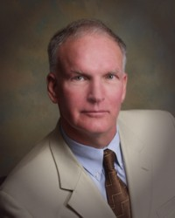
2014 Encore.org Fellow Douglas E. Noll, J.D., M.A. specializes in helping people solve difficult, complex, and intractable problems. As a lawyer turned peacemaker, Doug has been voted as one of the Best Lawyers in America since 2005, by US News & World Report and has been recognized since 2006 as a Northern California Super Lawyer. He is listed in the Who’s Who of International Commercial Mediators. He has been honored as Lawyer of the Year in 2014 by Best Lawyers in America.
Along with his colleague Laurel Kaufer, Doug was named California Attorney of the Year in 2012 for their pro bono Prison of Peace project.
Doug is the author of the book Elusive Peace: How Modern Diplomatic Strategies Could Better Resolve World Conflicts (Prometheus Books, April 2011), winner of the Institute for Conflict Prevention and Resolution (CPR) International Peace and Justice Book Award for 2011.
In addition, Doug is the author of Sex, Politics & Religion at the Office: The New Competitive Advantage (Auberry Press 2006), with John Boogaert, and Peacemaking: Practicing at the Intersection of Law and Human Conflict (Cascadia 2002) and, numerous articles on peacemaking, restorative justice, conflict resolution and mediation, and is a mediator trainer, lecturer, and continuing education panelist.

