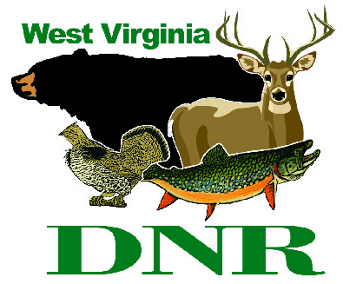 | West Virginia Division of Natural Resources  www.wvdnr.gov  Earl Ray Tomblin, Governor  Frank Jezioro, Director  News Release: Oct. 29, 2014  Facebook: West Virginia State Parks  Twitter: WV State Parks  Hoy Murphy, Public Information Officer 304-957-9365 hoy.r.murphy@wv.gov  Contact: Sissie Summers, West Virginia State Parks dnr.parks@wv.gov 304-558-2764

“First Day” Hikes at West Virginia State Parks in 2015
Resolve to get outdoors

SOUTH CHARLESTON, W.Va. – It’s not too early to think about New Year’s resolutions, and a good one would be to get outdoors more often. At least four areas in the West Virginia state park system will offer First Day Hikes Jan. 1, 2014. It is West Virginia’s invitation to get outdoors as one of the 50 state park systems participating in America’s State Parks First Day Hikes. Participating in the First Day Hikes challenge will be Kanawha State Forest, Blackwater Falls State Park, Cacapon Resort State Park, and Pipestem Resort State Park.
“Hiking or walking at a state park or forest is an activity open to anyone who comes to visit,” said West Virginia State Parks Programming Coordinator Sissie Summers. “Parks and forests operated by the West Virginia state park system do not charge an admission fee, so it’s fun exercise, hiking beautiful trails at no cost.”
“We’re venturing out again the first day of the year in 2015,” said Kevin Dials, assistant superintendent of Kanawha State Forest, which is near the state capitol in Charleston. Dials led a 3-mile First Day Hike January 1, 2012, with more than 120 people participating. In 2013 and 2014, Dials had close to 200 folks hiking and walking. “It’s a great day and we’re looking forward another First Day Hike event at Kanawha State Forest.”
Massachusetts state parks began offering First Day Hikes more than 23 years ago. The National Association of State Park Directors issues a challenge to all park directors nationwide to establish similar First Day hikes.
“Hiking is a year-round activity and the experience is different each time, depending upon the seasons and temperatures,” said Paulita Cousin, naturalist at Blackwater Falls State Park. The Jan. 1 departure times are 10 a.m. at Blackwater Falls, 2 p.m. at Kanawha State Forest, 10 a.m. at Cacapon Resort, and 1 p.m. at Pipestem Resort.
“The First Day Hike is open to anyone and leaders will provide hiking program information to those enjoying the first day of the year outdoors,” Summers said.
Participants will receive a First Day Hike patch and attendance card that records the hiked distance. Miles are tallied and reported to the national organization and West Virginia patches, new for 2015, will be mailed following the event.
The First Day Hike is one of the special hikes on the West Virginia State Park Hiking Program. However, unlike other special hikes, it is not necessary to be enrolled in the Hiking Program to receive the First Day Hike patch. The Hiking Program is a nominal-fee-based, self-directed outdoor pursuit that logs miles hiked and includes a walking stick reward and cane shields for various mileage plateaus. “Special hikes” are also recognized by cane shields.
Individuals planning to participate in a First Day Hike should arrive at least 15 minutes before the starting time. Hikers should bring water and wear layers of clothing and sturdy, warm hiking boots or shoes, as well as hats and gloves. Hikes will depart on time and return to the starting point. Additional information and other areas providing guided First Day Hikes will be posted on www.wvstateparks.com

**DNR**

Photo courtesy of the West Virginia Department of Commerce
Kanawha State Forest and at least three other West Virginia State Parks areas will participate in First Day Hikes Jan. 1, 2015.

