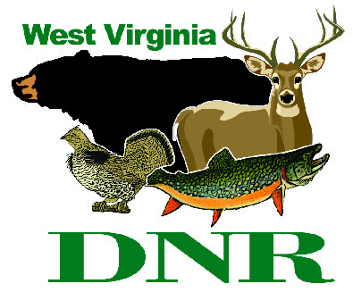 | West Virginia Division of Natural Resources  www.wvdnr.gov  Earl Ray Tomblin, Governor  Frank Jezioro, Director  News Release: Oct. 29, 2014  Facebook: West Virginia State Parks  Twitter: WV State Parks  Hoy Murphy, Public Information Officer 304-957-9365 hoy.r.murphy@wv.gov  Contact: Sissie Summers, Parks and Recreaton Section 204-558-2764 Sissie.A.Summers@wv.gov

West Virginia State Parks are Something Special

Gift Card Program include “Something Extra” when visiting in 2015

SOUTH CHARLESTON, W.Va. – It’s the time of year for holiday and Christmas gift ideas and West Virginia’s state parks “Something Extra” program returns. Gift card purchases made online or by telephone order between Nov. 1 and Dec. 15, 2014, receive additional promotional discounts for the card recipient, or for the person who purchases the card.
For every $100 card purchased, the “Something Extra” cards are mailed with the West Virginia State Park gift card. Together, the plastic gift card with the purchased monetary value added and the paper “Something Extra” cards have a value totaling approximately $125, depending on use dates and if redeemed. Unlike the gift card itself, which can be used any time for all purchases and services at all state parks, “Something Extra” cards have expiration dates.
The “Something Extra” promotion is only offered on gift card purchases made online from Nov. 1 through Dec. 15, 2014, or by telephone order to 304-558-2764, (ask for Carol). There is no shipping or handling fee. Cards are mailed via standard US Postal Service.
The extras have become a requested add-on to our holiday program says Sissie Summers of West Virginia State Park. “Each season we look as some new opportunities and also retaining popular extras, such as a round of golf at Pipestem or Twin Falls. This year includes sternwheeler ride to Blennerhassett Island and a substantial room rate savings at Hawks Nest, Chief Logan and Cacapon Resort state parks.“ Gift cards convey to the recipient that a person knows you or your family interests and encourages seeing West Virginia via state parks.”
West Virginia State Park gift cards can be used on lodging, dining, gift shops or other activities that charge a fee. In addition, each gift card purchase of $100 made online or by telephone order before Dec. 15 will receive up to eight “extras” such as “two for one” offers and other discounts at West Virginia State Parks and Forests. To place an order, visit www.wvstateparks.com and click “Gift Card Purchase” or call 304-558-2764, ext. 51828 (Carol).

About the eight “Something Extras!”
This list of the eight “extras” is a general description. The cards, when received, provide full details with disclaimers.
- Free issue of West Virginia Magazine

- $25 off room rates at Chief Logan, Hawks Nest and Cacapon Resort Lodges
Stay two or more nights and get $25 off standard rate with “extra” card.
- A.M. or P.M. Sled Run Pass at Blackwater Falls
Enjoy the Blackwater Falls State Park “magic carpet” at the Sled Run when using the “extra.”

- 18-hole Golf Play at One of Three Courses: Cacapon, Twin Falls, Canaan Valley or Pipestem
Rent a motorized cart and play 18-holes of golf for free in exchange for the “extra” card.

- Go! Camp – One night free at Little Beaver or Twin Falls Resort state parks.
Redeem the “extra” card for second night free on first-come, first-served site rentals. Dates include most dates from opening day through the end of the traditional camping season in 2015.

- Paddle Boat at Watoga State Park
Two individuals enjoy one-half hour paddle boat ride, Tuesday-Thursday in 2015, as available.

- Double Wheeeee! Aerial Tram Ride at Pipestem Resort.
With the “extra” card, two can ride the tram at Pipestem Resort State Park or play a round of disc golf.

- Blennerhassett Island – Island Belle Sternwheeler
Purchase a sternwheeler ticket for a ride to Blennerhassett Island and your friend rides free.

**DNR**

Graphic courtesy of the West Virginia Department of Commerce
West Virginia State Parks gift card purchase of $100 or more made online or by telephone before Dec. 15 will receive “Something Extra” promotions worth up to an additional $120 when redeemed.

**DNR**

