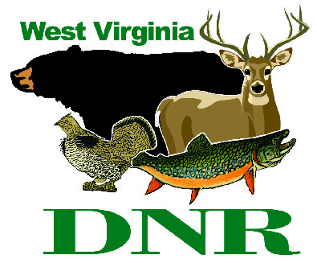 | West Virginia Division of Natural Resources  www.wvdnr.gov  Earl Ray Tomblin, Governor  Frank Jezioro, Director  News Release: Oct. 29, 2014  Facebook: West Virginia State Parks  Twitter: WV State Parks  Hoy Murphy, Public Information Officer 304-957-9365 hoy.r.murphy@wv.gov  Contact: Paul Redford, Parks and Recreation Section  304-558-2764 Paul.A.Redford@wv.gov

Special lodging rates at West Virginia State Parks

recognize veterans Nov. 1-16, 2014

Special golf play discount at Pipestem and Twin Falls state parks Nov. 11

SOUTH CHARLESTON, W.Va. – Veterans staying at West Virginia state parks the first two weeks of November are eligible for special overnight rates.
“The Veterans Day appreciation program has been offered for many years,” said Paul Redford, district administrator for West Virginia State Parks. “It is quite popular and appropriate as many West Virginians have served in the military. We offer this rate to thank them for their service.”
Room and cabin rates are reduced Nov. 1-16, 2014. The rate special is available to all military personnel who have served or who currently serve in the reserves or are on active duty. Presentation of military or veteran status is requested.
The program is available any rental night with the exception of two-night rentals on weekends for cabins or cottages, and is based on availability. Reservations are requested. When calling for reservations, ask for the Veterans Appreciation rate.
Participating areas are: Beech Fork, Blackwater Falls, Bluestone, Cacapon Resort,, Canaan Valley Resort, Cass Scenic Railroad, Chief Logan Lodge, Hawks Nest State Park, Holly River, Lost River, North Bend, Pipestem Resort, Stonewall Resort, Twin Falls Resort, Tygart Lake and Watoga state parks, and Kumbrabow and Seneca state forests.
Information about Veterans Appreciation and other overnight packages is posted on the state parks website www.wvstateparks.com.
***
Veterans Day golf discount at West Virginia’s state parks Nov. 11
If weather conditions are right on Veteran’s Day, Monday, Nov.11, 2014, West Virginia state parks golf professionals encourage golfers to hit the fairways.
“November days can be autumn-like. The Veterans Day rate offer encourages late season golf play,” said Paul Redford, district administrator for West Virginia State Parks.
Golf play Nov. 11 is $11 per person for 18-hole play at Twin Falls or Pipestem resort state parks. The fee is offered to any golfer and tee time. The fee does not include state sales tax or cart rental costs.
For golf information, call Twin Falls, 304-294-4000 or Pipestem, 304-466-1800. To learn more about West Virginia’s state parks, visit www.wvstateparks.com.

**DNR**

Photo courtesy of the West Virginia Department of Commerce
Blackwater Falls is one of many West Virginia state parks offering a Veterans Appreciation lodging discount Nov. 1-16, 2014.

