2014 GEORGIA O’KEEFFE MUSEUM GIFT GUIDE
The Tea Story
On a shelf in the pantry of Georgia O’Keeffe’s home in Abiquiu, New Mexico, we found a glass jar of loose tea, hand labeled in her writing, on a scrap of brown paper, “good tea”. From that humble cupboard item and O’Keeffe’s lifelong love of tea came the inspiration for a line of exceptional teas. Choose from Cup of Serenity (herbal blend), Abiquiu Morning (black tea), and Japanese Green Tea with Mint. $10.00 each, $8.50 Member price.

The Book of Tea, a classic book on the Japanese art of tea and one of Georgia O’Keeffe’s favorite books, expanded and edited by Bruce Richardson. $19.95, $16.96 Member price.
Cast iron teapot with persimmon patina, $110.00, $93.50 Member price.

Georgia O’Keeffe Rocks
Rock paperweight engraved with O’Keeffe’s quote, “Take time to look…”, $15.00 (approximately 4” wide, size varies), $12.75 Member price.
Garden rock engraved with O’Keeffe’s quote, “Take time to look…”, $60.00 (approximately 12” wide, size varies), $51.00 Member price.

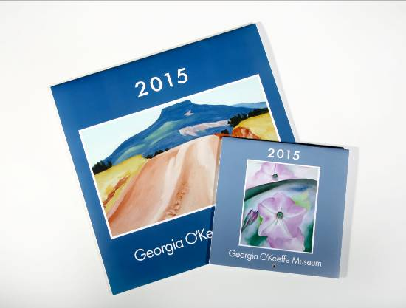Calendars
Wall calendars, $14.00, $11.90 Member price. Mini calendar, $8.00, $6.80 Member price.

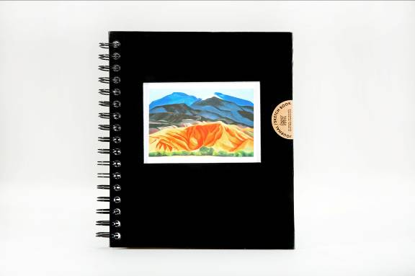Blank Book
Spiral-bound blank sketchbook/journal, $22.00, $18.70 Member price.

Jewelry

Bracelet
Pewter cuff bracelet engraved with O’Keeffe’s quote, “Take time to look…”, $22.00, $18.70 Member price.


Earrings
Inspired by Georgia O’Keeffe’s paintings, these earrings reflect the dominant hues of each image. Enameled silvertone earrings, $30.00 per pair, $25.50 Member price.

Contact:
Alexandra Pratt
JLH Media
505 310 2489
alexandra@jlhmedia.com

