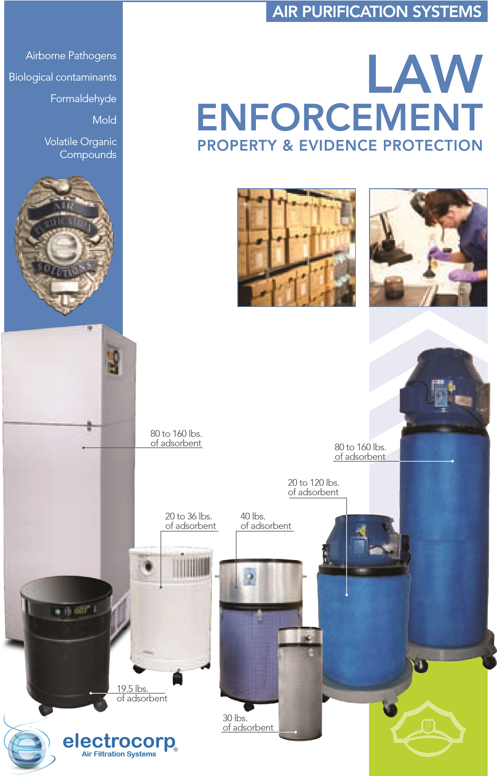
AIR PURIFICATION SYSTEMS

Pathogen and Biohazard Protection
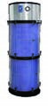
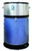
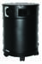
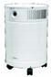
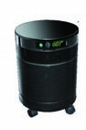
Electrocorp's air filtration systems for evidence rooms and property rooms are designed to protect personnel from a broad spectrum of dangerous airborne contaminants including narcotics fumes, aspergillus mold spores, microorganisms, biohazards, chemicals, gases, odors, and particles.
Series
6000
RAP Series
AirFactor 007
· 18 lbs. of carbon
· Micro-HEPA Wrap 99% efficient to 0.1 microns
· Carbonized 10 micron pre-filter
· 50 to 160 CFM delivered
· Dimensions: 23.5” x 15”
Options:
· 30, 60, 120 or 240 lbs. of carbon for heavy chemical control
· Medical-grade HEPA filter 99.97% efficient to 0.3 microns (on H or
CCH units only)
· 50 - 1650 CFM delivered
· UV Capsule
· Caddy wheels
· 19.5 lb. Activated Carbon Filter,
· Medical-Grade HEPA Filter
· Pre-Filter
· Carbon Canister Wraps
· Sure Seal Gaskets
· On/Off Indicator Light
· Remote Control
Options:
· UV technology
· Exclusive carbon blends to target specific airborne pollutants
· 360 - 560 CFM rated, variable speed
· Available in Gloss Black and Sandstone
· 24 lb. activated carbon filter, 2 ½” deep physical bed wall carbon
· Medical-grade HEPA filter 99.97% efficient to 0.3 microns
· Prodense pre-filter
· Sure Seal gaskets
· 400 CFM turbo rated motor
· Dimensions: 23.5” x 15”
Options:
· Deeper 3” or 3
½
” carbon bed for heavy chemical control
· Exclusive carbon blends to target specific airborne pollutants
· UV technology
· Available in Black, White or Sandstone
These tough industrial units are designed for 24/7 continuous use and feature activated carbon and HEPA technology originally developed by the military for hazardous airborne toxins. Currently used by law enforcement agencies across America, these air filtration units can also be custom-built to address specific air quality concerns in various storage areas and departments.
www.electrocorp.net 1.866.667.0297
We protect law enforcement agencies across America

Alameda County Coroner's Office
Alburquerque Public Schools Police Dept. Arizona DPS Crime Lab Ashland Police Dept.
Aztec Police Dept.
Bainbridge Island Police Dept. Barbados Forensic Sciences Centre Bibb County Sheriff's Dept. Brookline Police Dept.
California Highway Patrol
Cassia County Police Dept.
City of East Pointe Police Dept. City of Houston Police Dept.
City of Morristown Police Dept.
City of Napa Police Dept.
City of Odessa Police Dept.
City of Portage Police Dept. City of Temple Police Dept.
Clark County Sheriff's Office
Columbus State Comm. College
Contra Costa County Coroner's Office Davie County Sheriff's Office Downey Police Dept.
EastPointe Police Dept.
Fort Wayne Police
Fort Wayne Police Dept.
Franklin Township Grass Valley Police Department Greenville Sheriff's Dept.
Henderson Police Dept.
Honolulu Police Dept.
Huntington Park Police Dept.
Jackson County Sheriff's Dept. Kansas Bureau of Investigation
Knoxville FBI Lynn Police Headquarters Milpitas Police Dept.
Napa County Sheriff's Dept.
New Mexico State Police
New York City Chief Medical Examiner Orville Police Dept.
Paradise Police Dept.
Park Ridge Police Dept.
Pima County Sheriff's Dept. Placer County Sheriff-Coroner Office Plano Police Dept.
U.S. Border Patrol
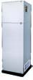
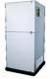
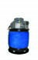
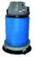
Portland FBI
I-6500 Series
RSU Series
· 23 lbs. of activated carbon
· Electrostatic particle filter, material rated at 99% efficient at 0.1 microns
· Industrial-grade
· 10 micron adhesive capturing pre-filter
· 350 CFM delivered
Options:
· 60 or 120 lb. activated carbon filters for heavy chemical and odor control
· Medical-Grade HEPA (on CCH only)
· Up to 1800 CFM delivered
· Custom carbon blends for specific chemicals and odors
· 80 lb. refillable activated carbon filter
· 12” deep medical-grade HEPA filter 99.97% efficient to 0.3 microns
· Particle and dust pre-filter
· 750 to 1000 CFM delivered
· Dimensions: 70” x 24.5” x 21”
Options:
· 160 lb. activated carbon filter with a particle and dust filters
· 12” gel sealed medical-grade HEPA
· 2 Medical-grade HEPA filters (12”X12”)
· 1500 CFM / 1 speed 230 w 60 Hz
Raleigh Police Dept. Riverside County Coroner's Office Riverside County Sheriff's Dept.
Rockwall Police Dept.
Sacremento County Sheriff's Dept.
San Bernardino County Coroner's Office San Joaquin County Sheriff's Office Santa Clara Police Dept. Santa Rosa Police Dept.
Sarasota County Sheriff's Office Sherwood Arkansas Police Dept.
Solano County Coroner's Office
Solano County Sheriff's Office Sonoma County Sheriff's Office
Texas A&M University Police Dept. Texas Dept of Public Security Crime Lab Millbrae Police Dept.
Town of Garner Polic Dept.
Town of Vail Police Dept.
Tyler Police Dept.
U.S. Park Police in Presidio
Washington State Patrol Waxahachie Police Dept.
Winston-Salem Police Dept.

ACTIVATED
CARBON

+ HEPA

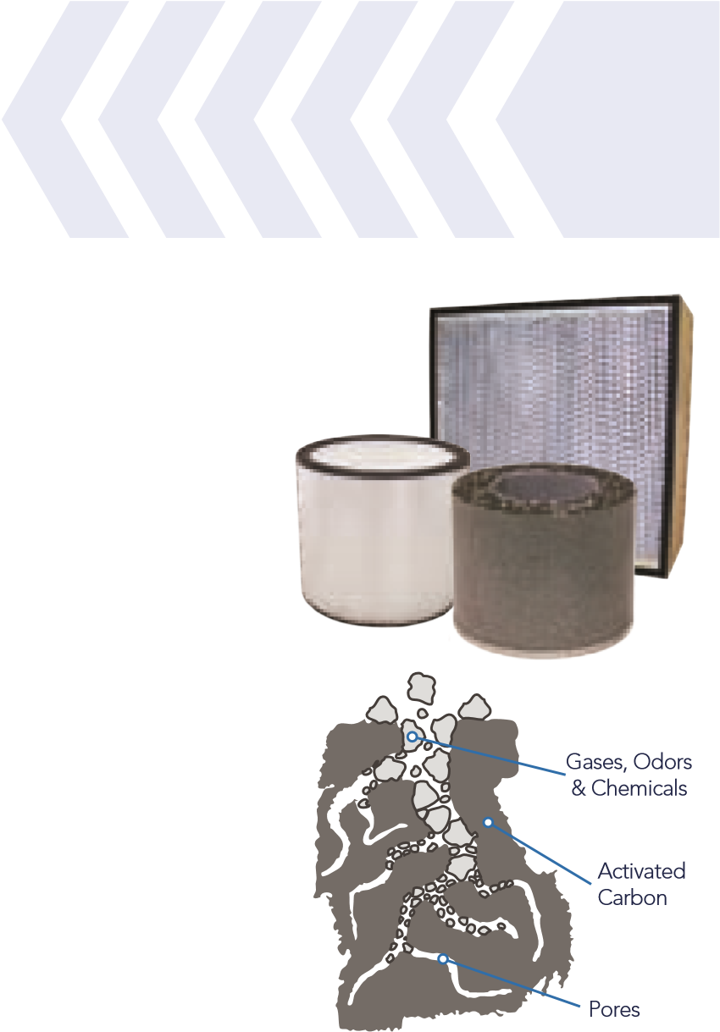
Our Hybrid Filtration Technology
Electrocorp air cleaners combine the most efficient filtration methods for removing both chemicals and particles proving the most complete and versatile air cleaning system available.

About Activated Carbon Filtration
Carbon that is 'activated' undergoes a process that opens up millions of tiny pores and fissures to enhance the material's adsorbent properties. The process creates a very large internal surface area, which is key to the power of activated carbon - the more surface area - the more the carbon can adsorb. Only one pound of activated carbon typically has a surface area of 125 acres. Activated carbon is so effective that it's used in military gas masks.
1.866.667.0297 www.electrocorp.net

About HEPA Filtration
HEPA stands for high efficiency particulate air filter and describes a filter that can remove at least 99.97% of airborne particles 0.3 microns in diameter. Particles of this size are used to evaluate the performance of a HEPA filter because they are among the most difficult to remove. HEPA filters are considered the safest and most efficient method to treat airborne particles.
What is MRAF?
MRAF or Maximum Radial Air Filtration describes the superior filtration system incorporated into our RAP and RSU industrial units. This cylindrical “Super Wall” of carbon provides the largest adsorbent surface area in the industry providing maximum efficiency.
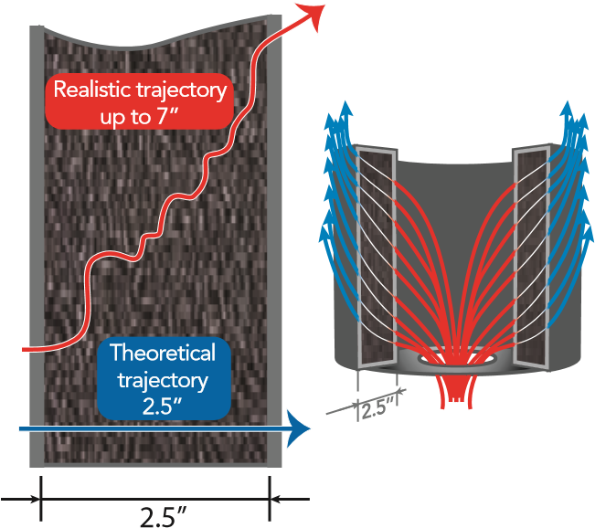
What is PDF?
PDF or Progressive Diagonal Filtration describes the path of pollutants in our bottom intake air cleaners. This exclusive air intake configuration allows for extended dwell time which maximizes the adsorption of chemicals, gases and odors.
electrocorp
Air Filtration Systems
E-0009

