Press Release Contacts:
For Immediate Release Vinitaly International
International Media Dept.
+39 045 8101447
media@vinitalytour.com
www.vinitalytour.com
Twitter: @VinitalyTour
Join Vinitaly International Network on LinkedIn

Vinitaly leads Italian Pavilion for Shanghai Wine & Dine Festival 2015

Just a few days after Vinitaly Hong Kong, with 120 Italian wineries and an unprecedented series of educational ses- sions on Italian wine counting a total of 15 Masterclasses in three days (including the four Executive Wine Seminars of the Vinitaly International Academy), Vinitaly has now returned to Shanghai (where it opened an office one year ago) with a press conference reviewing the activities from 2014 to date as well as future plans for the upcoming 2015. This is a year that will see Vinitaly ‘s unconventional return to Shanghai in two specific moments: in January, for the sixth stop of the Expo Road Show (14 – 18 January 2015) and in the Fall, for the very first edition of the Shanghai Wine & Dine Festival where Vinitaly will be the sole organizer of the Italian Pavilion. Next year’s event in Chengdu at the Off-Site Showcase at Kempinski Hotel, will be exclusively b2b. The dates have already been set: from the 23rd to the 25th of March 2015, the same days of the yearly appointment with Vinitaly in Verona.
EDUCATIONAL, B2C AND B2B – Wanting to create a sense of continuity all year round, Vinitaly will concentrate on two main moments: educational and b2c in Shanghai and b2b in Chengdu. As to the former, given the great success of the Educational Sessions during all events organized in China, Vinitaly will continue in the same direction by recru- iting new “Ambassadors of Italian Wine”.
Among the first ten candidates (out of a total of 50 from all around the world), eight are from Greater China. After the intensive certification course to be held in Verona and Barolo from the 16th to the 20th of March 2015, these same eight candidates will become the new official ambassadors and help increase the knowledge of Italian wine and its consumption.
“They will become the key advocates for the success of Italian wine in such a vast country” says Stevie Kim, Mana- ging Director of Vinitaly International. “China has been described as the Eldorado for far too long now, but the real numbers are still far away when compared to other countries where our wine has become the true protagonist of the local wine market”.
WINE2WINE & EXPO – Vinitaly is still continuing in its mission to bridge the gap between Italy and China: after Hong Kong, top Chinese sommelier Yang Lu, Sunny Zhang of Pinor, Yanni Wu, wine marketing expert in China and Chinese producer Judy Chan will be present on the 3rd and 4th of December at wine2wine in Verona. They will talk about new trends and the key players in the Chinese wine market. Richard Wei, Secretarial Manager of the Post - Expo Shanghai Research Centre and key player in the China Corporate United Pavilion Project in Milan, will then talk about Expo offering the point of view of the city that was the last to hold an Expo and explaining possible future synergies between China and Italy.
The Expo in Milan will also offer Vinitaly the opportunity to return to Shanghai in January for the sixth stop of the Expo Road Show. As in Beijing and Changsha, it will present its Vinitaly Wine List in collaboration with importers, producers and brand ambassadors.

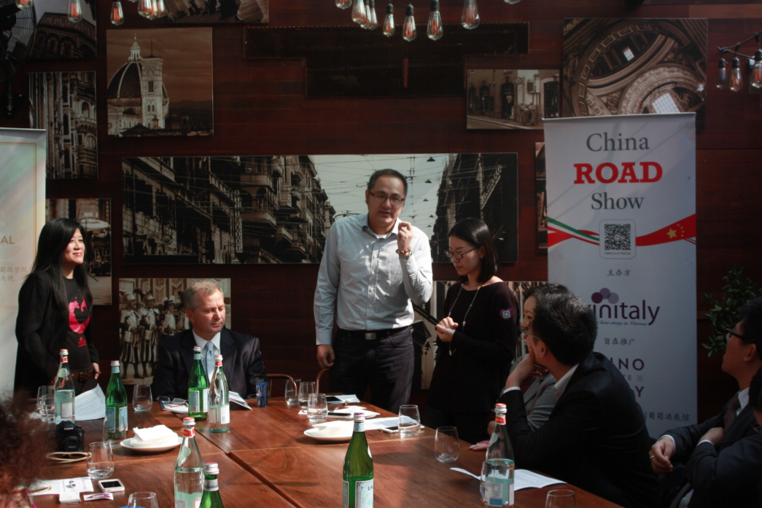

THE SHANGHAI WINE & DINE FESTIVAL – 2015 in the Fall will also be the first edition of the Wine & Dine Festival in Shanghai. Vinitaly will be the sole organizer of the Italian Pavilion, returning to China with an entirely b2c event, thanks to the collaboration with Shanghai Morning Post. Shanghai remains, therefore, Vinitaly’s major focus not only as a traditional fair but with an eye to new consumer trends that in Shanghai seem to be very different from those of other second and third-tier cities. The b2b focus will remain at the centre of Chinese distribution, in Sichuan, precisely in Chengdu, while in Shanghai, Vinitaly will look to an entirely new means of promoting Italian wine in China.

About:

Veronafiere is the leading organizer of trade shows in Italy including Vinitaly (www.vinitaly.com), the largest wine event in the world. The 48th edition of Vinitaly counted some 155,000 visitors (+6%) in four days of event, of which 56.000 were international attendees representing 36% of the total. On 100.000 square meters, 4.000 exhibitors welcomed trade professionals, media and producers alike. The next instalment of the fair will take place on 22 – 25 March 2015. The premier event to Vinitaly, OperaWine (www.vinitalyinternational.com) “Finest Italian Wines: 100 Great Producers,” will unite international wine professionals on March 21st 2015 in the heart of Verona, offering them the unique opportunity to discover and taste the 100 best Italian wines, as selected by Wine Spectator. In 1998 Veronafiere also created Vinitaly International to develop a global platform for the promotion of Italian wine producers in foreign markets such as Russia, China, USA and Hong Kong.

# # #

