ExecNet Properties is Now Blvd Suites Corporate Housing
In September, we announced that Denver-based ExecNet Properties will be rebranding itself as Blvd Suites Corporate Housing. As of tomorrow, November 18, that rebrand is complete. It is the culmination of years spent by Blvd Suites and ExectNet benchmarking against one another, sharing experiences and molding one another into worldclass service providers.
We are excited to finally join the talents, ambitions and passions of our people into one incredible team that is wholly focused on finding solutions and crafting a personalized guest experience.
Blvd Suites is now positioned to service every major market in the United States, and we can do so with best in class quality and outstanding service provided by local representation.
Zac Cihak, the owner of ExecNet Properties, has now joined the ownership group of Blvd Suites where he will have an equal ownership position and input in directing growth, strategy and the development of our team members. In addition to this, one hundred percent of the ExecNet team will remain in place and become Blvd Suites team members.
The new Blvd Suites Corporate Housing is the single source you can trust for all your temporary furnished housing needs. We are the market experts in locations across the United States and parts of Canada. Just make one call. Our passionate team members are driven to exceed your expectations.
A few housekeeping issues we hope will assist you with this transition:
- The existing phone numbers you used for ExecNet team members remain the same.
- Email addresses for ExecNet team members will now be the person’s first initial and last name @ blvdsuites.com (i.e. jdoe@blvdsuites.com), however the ExecNet email addresses will automatically forward to their new, respective Blvd Suites accounts.
- Please remit payments and invoices to the same address you presently do.
This is a momentous occasion for Blvd Suites and our incredible team who have been unbelievably patient, supportive and collaborative through this transition. We want to publicly thank them for being so amazing. As a unified team, we are more motivated than ever to bring an unparalleled experience to our clients and guests, and we strive to cause you minimal inconvenience as you transition with us.
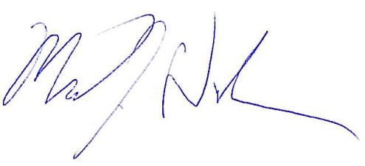
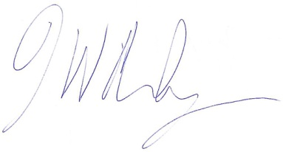
Thank you for your partnership and support thus far, and we are tremendously enthused to continue our relationship with you.
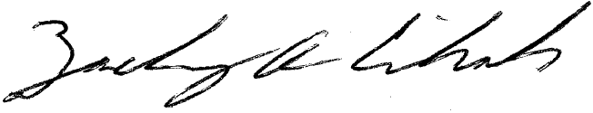

Jeff Hurley Mike Dunklee Zac Cihak
Founding Partner Founding Partner Founding Partner

