Press Release Contacts:
For Immediate Release Vinitaly International
International Media Dept.
+39 045 8101447
media@vinitalytour.com
www.vinitalytour.com
Twitter: @VinitalyTour
Join Vinitaly International Network on LinkedIn

Vinitaly Russia, adapts new tools for new challenges: digital technology, education and market debates

This year’s edition of Vinitaly Russia did certainly not seem affected by the choice of a single-day event and the new challenges provided by the recent depreciation of the rouble and the ban on foreign agricultural products, maintaining its position as the top wine event in the country for the number of both the exhibiting Italian wine producers (300 presenting more 1700 labels from different regions of Italy) and the professional visitors that streamed in throughout the day: more than 1500 members of trade and press.
The Italian delegation made up by the President of Veronafiere, Ettore Riello, and Flavio Tosi, the Mayor of Verona, accompanied by Cesare Maria Ragaglini, Italy’s Ambassador in Russia, were all present at the official Opening Ceremony emphasizing the great importance of the Russian market where Italy still maintains first place with 21 million litres of bottled wine sold during the first six months of the year (Source: Corriere Vinicolo –
August 2014 - http://tinyurl.com/pl9h972)
The future of imported wines, though, does not appear quite so rosy. This is the conclusion that emerged from the round table “The Russian market today: only crisis or new business opportunities?”, that opened the eleventh edition of Vinitaly Russia on Monday, as explained by Alexander Sidorov who moderated the meeting: “Because of the depreciation of the rouble, the price of imported wines will inevitably go up and next year many Russian importers will either have to close or adapt their portfolio to the current situation by selecting the best quality-price wines in order to obviate the inevitable tendency of Russian consumers to look to more affordable local wines. Nonetheless it is very difficult that local wines will replace imported wines entirely. Optimistically we can expect the import market to fall by 10 – 15% although a 30% reduction could also occur. “
Mr Sidorov went on to say that Italian companies wishing to remain on the Russian market
should be more flexible when building relationships with importers reducing their export prices and investing money in marketing actions. This, though, is easy to say in a county that in 2008 approved a bill banning all alcohol advertising in media outlets.
Despite these uncertain times, Italian wine producers have yet to give in and decided to return to Russia with Vinitaly International on the 17th of November actively taking part in the many events organized throughout the day.

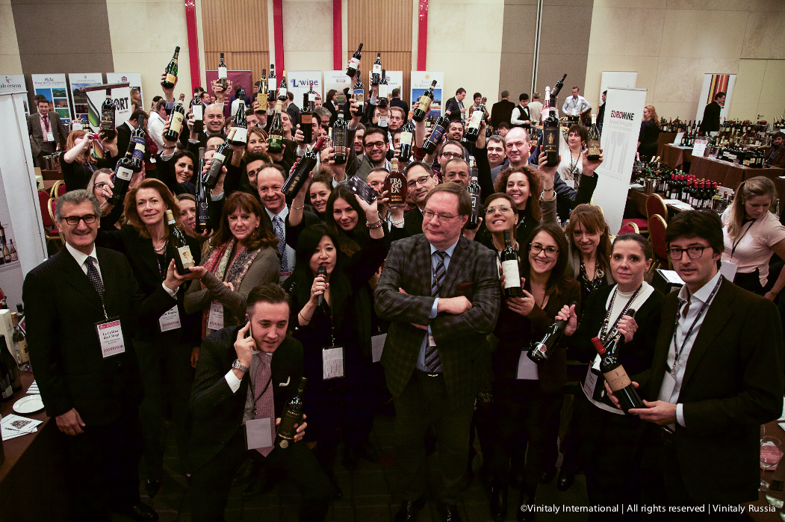

Amidst the 13 educational sessions in program for the day, Vinitaly Russia was also the last stop of the Vinitaly International Academy, that closed this year’s successful round with two Executive Wine Seminars, “Puglia: discovering new wines from ancient grapes” and “Learning about Italy’s many different grapes and wines” led by wine expert Ian D’Agata.
A new addition to this year’s event was also the brand new b2b Speed Tasting session dedicated to all Italian wine producers that still needed to find an importer in the Russian market. After Vinitaly Hong Kong, it was Vinitaly Russia’s turn to launch Vinitaly International’s brand new App that replaced the traditional paper Tasting Notes offering users a complete overview of all Italian wineries and wines presented at the event.
All social media traffic generated during the event was analysed in collaboration with new technical partner Social Meter.
A special thanks also goes to Media Partners, Buona Italia, Enoteka, Simple Wine News and Tipple as well as Technical Partners Cruciani, Ponente, Norda and Riedel for their invaluable support.

About:

Veronafiere is the leading organizer of trade shows in Italy including Vinitaly (www.vinitaly.com), the largest wine event in the world. The 48th edition of Vinitaly counted some 155,000 visitors (+6%) in four days of event, of which 56.000 were international attendees representing 36% of the total. On 100.000 square meters, 4.000 exhibitors welcomed trade professionals, media and producers alike. The next instalment of the fair will take place on 22 – 25 March 2015. The premier event to Vinitaly, OperaWine (www.vinitalyinternational.com) “Finest Italian Wines: 100 Great Producers,” will unite international wine professionals on March 21st 2015 in the heart of Verona, offering them the unique opportunity to discover and taste the 100 best Italian wines, as selected by Wine Spectator. In 1998 Veronafiere also created Vinitaly International to develop a global platform for the promotion of Italian wine producers in foreign markets such as Russia, China, USA and Hong Kong.

# # #

