|  |  |
| --- | --- |
| **For Immediate Release**  November 19, 2014 | Media Contact: Sandra Evans  Sandra@seandassoc.com  415 887 9230 |

**CharmCare’s H2 Wearable Blood Pressure Monitor Meets 60% of Goal on Indiegogo and Launches Charity Donation Stimulus**

*CharmCare will donate 5% of the total donations on Indiegogo for the H2 Wearable Blood Pressure Monitor to the American Heart Association if $50,000 is reached by December 30th*

(SAN FRANCISCO, CA) The worldwide wearable electronics market, already a $14 billion industry and expected to climb to $70 billion by 2024 ([Source IDTECHEX](http://www.heart.org/idc/groups/heart-public/@wcm/@sop/@smd/documents/downloadable/ucm_3195)), has another entry into the health wearable category: The [**H2**](http://www.h2care.com)from **CharmCare**. The company is responsible for developing the world’s smallest and lightest wearable blood pressure monitor. The H2 Blood Pressure Monitor has already raised over $30,000 or 60% of their $50,000 goal on the crowdfunding platform Indiegogo. The [Indiegogo](http://www.indiegogo.com) campaign is expected to reach $50,000 to enable the company to manufacture and distribute the product in the U.S. As part of a new campaign stimulus, CharmCare will donate 5% of the total funds raised to the [American Heart Association (AHA),](http://www.heart.org) if $50,000 in donations are reached by December 20, 2014.

([Source: AHA website](http://www.heart.org)) Hypertension or high blood pressure is a disease. Even though it typically has no symptoms, HBP can have deadly health consequences if not treated. About 78 million U.S. adults have been diagnosed with high blood pressure.

According Dr. Dong Hwa Lee, Co-Founder of CharmCare, “we’re offering this special incentive so we can give a donation of 5% of the funds raised through the Indiegogo campaign to the American Heart Association to support building awareness of preventative care for hypertension or high blood pressure patients.”

The [**H2**](http://www.h2care.com) can track blood pressure anytime, anywhere in just 20 seconds. The attractive, sleek, modern wristband is available in six different interchangeable band colors. While there are portable electronic blood pressure monitors already available in the U.S., the [**H2**](http://www.h2care.com)is a true electronic wearable device that doesn’t require a smart phone or computer in order to operate it. Current blood pressure monitors are bulky and difficult for individuals to use when taking their own blood pressure. The [**H2**](http://www.h2care.com) is easy to use and also records the blood pressure reading each time it’s taken so that hypertension sufferers can accumulate a record for their personal health information and for their physician.

Due to consumer interest on Indiegogo, The H2 already has plans to add new features to the H2: a wristwatch function to the band, expanding the monitoring activities with additional tracking functionality and developing the “Walk Together Campaign” which will help high blood pressure sufferers to build community and make healthy lifestyle choices, such as exercise, smoking and drinking reduction and cessation and nutrition choices.

([Source CDC website),](http://www.heart.org/idc/groups/heart-public/@wcm/@sop/@smd/documents/downloadable/ucm_3195) 67 million adults (31%) have high blood pressure - that is one in every 3 American adults. It greatly increases the risk for heart disease and stroke, the first and third leading causes of death in the U.S. (source CDC website). High blood pressure or hypertension is often related to poor lifestyle choices and can often be managed and improved by making critical lifestyle changes such as quitting smoking, cutting down on alcohol consumption and salt and increasing exercise and a healthy diet. The **H2** has activity tracking capability to assist high blood pressure sufferers with managing and reducing the symptoms associated with hypertension. **H2** also has an alarm feature to remind individuals to take their daily medication.

The **H2** was developed by **CharmCare**, a company established in May 2004, in Seoul, Korea by founders Dong Hwa Lee and Dong Kyu Seo. Both founders have had a successful history in the medical device industry and between them hold over 23 patents in sensor-based medical devices and 10 patents in the wearable category in Korea and the U.S. The **H2** is currently available on Indiegogo, the crowdfunding site and will ship in June 2015. The Indiegogo Campaign has several perks and gifts designed to appeal to caregivers and sufferers of high blood pressure. By contributing to the Indiegogo campaign, contributors can purchase the product to help reduce the time to bring this important product to market and to educate more people about the risks of high blood pressure.

**CharmCare** is currently in development creating a health management community platform that not only tracks activity levels, monitors and manages blood pressure but also fosters an online community that encourages healthy lifestyle choices and habits amongst individuals with hypertension risks. Investor and media inquiries are welcome.

For more information and to make a contribution,visit: <https://www.indiegogo.com/projects/h2-the-first-wearable-blood-pressure-monitor>

**About CharmCare**

Established in 2004, **CharmCare** has been developing sensor-based medical devices for over 10 years and exporting them to more than 40 countries worldwide. With its most recent product, the **H2**, the worlds’ first wearable blood pressure monitor, **CharmCare** is promoting prevention with their ‘‘check your health anytime, anywhere!” products. By making it easy for patients that suffer from hypertension to monitor and manage their blood pressure throughout the day, **CharmCare** continues with its mission to increase overall health and happiness by living a healthy lifestyle. For more information about the H2 visit: <http://www.h2care.com>

Media Contact: Sandra Evans, BrightStone Partners, LLC. 415 887 9230 [sandra@seandassoc.com](mailto:sandra@seandassoc.com) High resolution images available by request.

Note to Media: I can set up interviews with the founders of CharmCare, the creators of the H2 or the spokesperson located in the U.S.

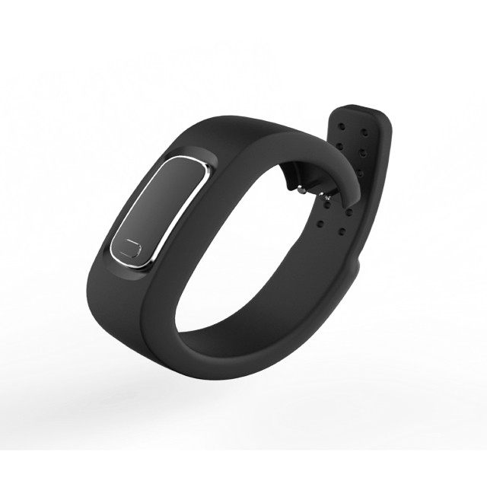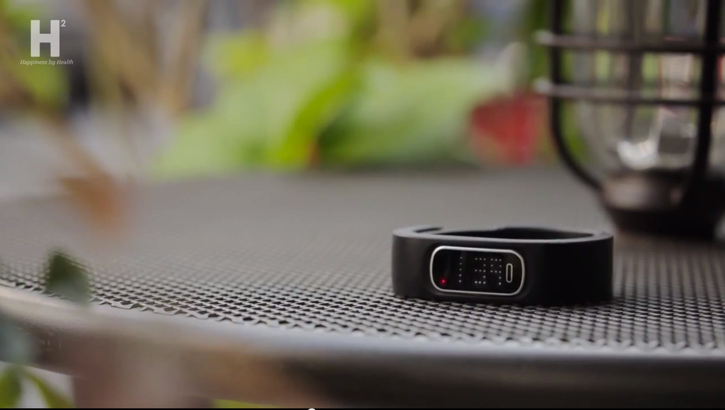

All images © H2 from CharmCare Co., Ltd.

###