**Ronnie “Woo Woo” Wickers Honored with Bobblehead**

**Contact:** Phil Sklar – 414-519-2625 – phil.sklar@bobbleheadhall.com

**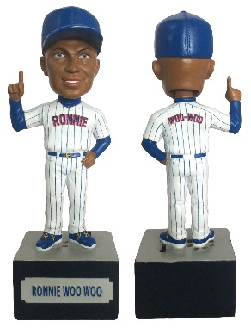***In what is sure to be one of the hottest collectibles for Chicago sports fan everywhere, the limited edition Ronnie “Woo Woo” Wickers bobbleheads are now available for pre-order at* [*www.WooBobbles.com*](http://www.WooBobbles.com)*. The bobbleheads are expected to ship by December 10th, making this the ultimate holiday gift!*

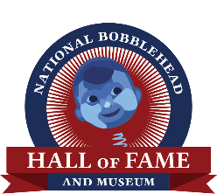*Chicago, IL – November 20, 2014* – – Today, the National Bobblehead Hall of Fame and Museum announced that longtime Chicago Super Fan, Ronnie “Woo Woo” Wickers will be honored with his own Woo-ing bobblehead. Only 5,000 of the individually numbered talking bobbleheads have been made, with pre-orders available beginning today at [www.WooBobbles.com](http://www.woobobbles.com/). The bobblehead will honor long-time Chicago resident and sports fan, Ronnie Woo Woo, who has attended well over 3,000 baseball games throughout the past 50 years.

According to Ronnie, "This is a great honor to have a bobblehead of me made by two long-time fans."

“Coaches, Players and Owners have come and gone over the past 50 years, but there has been one constant, Ronnie Woo Woo” said National Bobblehead Hall of Fame and Museum Co-Founder and CEO, Phil Sklar.

Ronnie will be wearing a traditional pin-stripe jersey with his signature "Woo-Woo" on the back. "Fans everywhere will be able to hear Ronnie whenever they want with the push of a button. It will be great to watch Ronnie's head bobble while he chants his famous 'woos'," according to National Bobblehead Hall of Fame and Museum Co-Founder and President Brad Novak.

The bobbleheads will also benefit the Negro Leagues Baseball Museum located in Kansas City, Missouri, which is a charity close to Ronnie's heart. According to Ronnie, “Through the sales of my bobblehead, I am honoring my late friend and legend Buck O’Neil, who was the person who made the Negro Leagues Baseball Museum a reality". One dollar from each bobblehead will be given to the Negro Leagues Baseball Museum.

Ronnie’s bobbleheads can be purchased at [www.WooBobbles.com](http://www.woobobbles.com/) using all major credit cards and PayPal or by calling the National Bobblehead Hall of Fame and Museum at 800-414-1482. A limited number of bobbleheads will be reserved exclusively for Members of the National Bobblehead Hall of Fame and Museum. "We encourage fans to purchase early since there will be no more of this version ever made" according to Phil.

**Disclaimer:**

The National Bobblehead Hall of Fame and Museum is an independent company and is not sponsored by or affiliated with the Chicago Cubs, with MLB, or with any of their affiliates in any way. This product is not licensed by the Chicago Cubs or by MLB.

**About Ronnie Woo Woo:**

Ronnie Woo Woo has been a constant on the North Side of Chicago since 1947, when he attended his first baseball game in which he witnessed Jackie Robinson play. He is an avid Chicago sports fan and loves interacting with fellow fans that visit the ballpark each year. More information is available at www.WooBobbles.com.

**About the National Bobblehead Hall of Fame and Museum:**The National Bobblehead Hall of Fame and Museum is headquartered in Milwaukee, Wisconsin, and will feature the world’s largest collection of bobbleheads and bobblehead-related exhibits when it opens in 2016. The Hall of Fame and Museum also designs, produces and markets Bobbleheads focusing on Super Fans, Individuals, Mascots and Players. The National Bobblehead Hall of Fame and Museum prides itself of making unique, high-quality bobbleheads for fans and collectors across the nation. More information about the National Bobblehead Hall of Fame and Museum is available at www.BobbleheadHall.com.