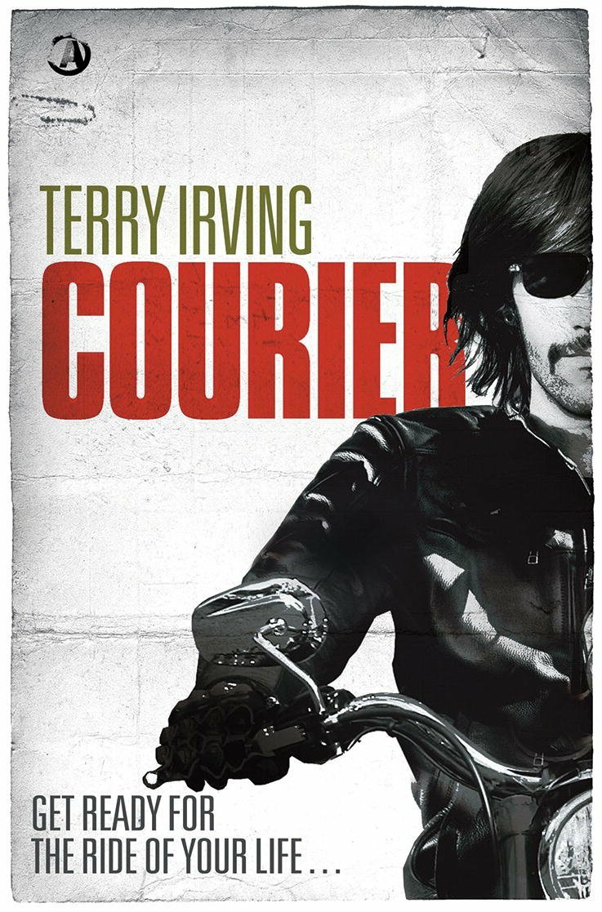

May 1, 2014
Exhibit A Books
TerryIrving.com and TerryIrving.co.uk

 Terry Irving “Courier”
 @TerryIrving  Terry Irving

CONTACT:
Terry Irving
240-210-3336
terry@terryirving.com

“‎I knew Terry could write hard news. ‘Courier’ shows he can write a damn good thriller...”
– Aaron Brown, former CNN anchor

EMMY AWARD-WINNING WRITER AND LONG-TIME JOURNALIST TERRY IRVING REVISITS WATERGATE-ERA D.C. IN ‘COURIER’
Historical suspense novel releases in 40th anniversary year of Nixon’s resignation

WASHINGTON, D.C. – The motorcycle that Vietnam vet Rick Putnam rides around Washington D.C. is fast, but is it fast enough to escape his destructive memories of the war and the hired guns who are trying to kill him?

In his debut novel “Courier” (May 1, 2014, Exhibit A Books), Emmy award-winning journalist and writer Terry Irving paints a gritty picture of a Washington DC that today has completely disappeared under new parks and high-rise office buildings. In the middle of the scandal and drama of Watergate, Rick, a motorcycle courier, unsuspectingly picks up a roll of news film and—after the correspondent and crew are killed—finds that he is next on the killer’s to-do list. With the help of friends—and a woman who threatens to crack the shell he's built to defend his heart—Rick must discover what's on the film and why officials are willing to kill to keep it from the front pages.

Legendary broadcast news anchor Ted Koppel notes how Irving’s first-hand experience brings the novel to life, “If the phrase 'a crackling good yarn' evokes an era before Twitter, Facebook, cell phones, videotape, DVDs or cable television, welcome to Terry Irving’s fast-paced thriller from a bygone age. The Vietnam War is winding down, a wounded vet takes a job as a motorcycle courier at a network's Washington news bureau, and finds himself caught up in the backwash of a harrowing conspiracy. Terry Irving knows the landscape. I was there. So was he.”

In a hat tip to Paul Fussell’s classic “The Boy’s Crusade,” Irving’s story unveils the bonds between men who fight together and the distance between those that order the attacks and those who carry them out.

Irving is a television producer and writer who lives near Washington D.C. He moved to the nation’s capital in 1973 when he – much like the protagonist in his new book – became a motorcycle courier for the ABC Washington Bureau. He has worked in newsrooms at CNN, Fox, ABC and MSNBC. He has won four National Emmy Awards along with multiple Peabody, DuPont and Telly awards.

“Courier” is the first book in The Freelancer Series, with “Warrior” to follow and several other novels planned.
Meet “Courier” Author Terry Irving
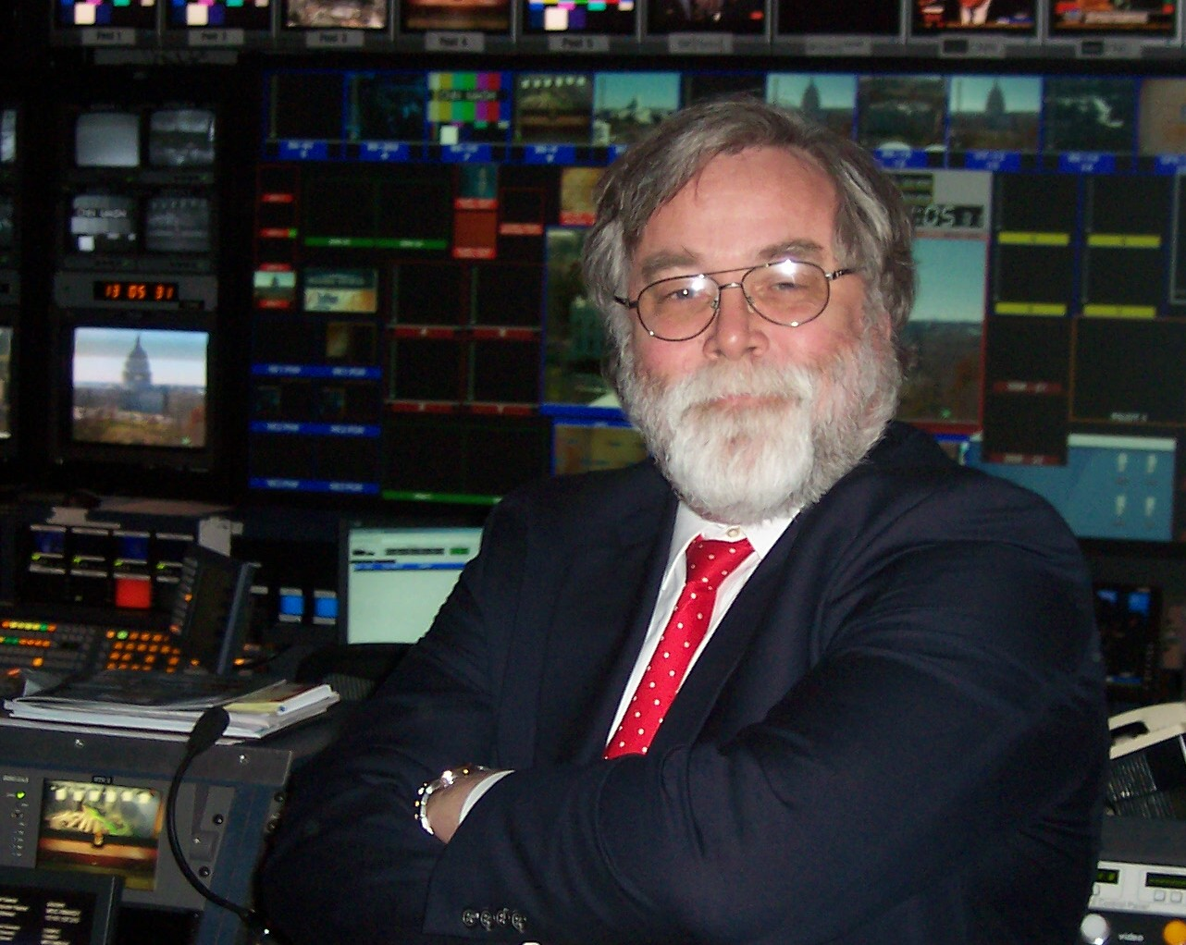
Author and long-time journalist Terry Irving moved to Washington D.C. in 1973 to kick around for a few weeks and never looked back.

In the nation’s capital, Irving started out riding a classic BMW R60/2 for ABC News during Watergate. Carrying that news film was the beginning of a 40-year career that has included producing Emmy Award-winning television news, writing everything from magazine articles to standup comedy and developing early forms of online media. He has traveled and worked in all 50 states plus parts of Europe, Africa and Asia.

Irving is the winner of four National Emmy Awards, multiple Peabody, DuPont and Telly awards, plus an honor at the Columbus Film Festival. He has produced stories around the world from the fall of the Berlin Wall to Tiananmen Square. He worked as a senior live control room producer at CNN, Fox, ABC and MSNBC. He wrote and edited copy for some of the top anchors and journalists in television news including Ted Koppel, Diane Sawyer, Wolf Blitzer, and Aaron Brown.

Irving is an active member of the International Thriller Writers and the Mystery Writers of America, and serves as a board member of the Foundation for Moral Courage.

Irving is the author of the on-going memoir “On the Road” and the self-help book “The Unemployed Guy’s Guide to Unemployment,” both published in 2012 by Rock Creek Consulting LLC. His debut novel “Courier” releases May 1, 2014 from Exhibit A Books, the crime fiction imprint of Angry Robot Books. It’s the first of several books planned for The Freelancer Series.

Irving and his wife live just outside Washington D.C. because their dog simply refuses to live anywhere else.
5-Star Reviews for “Courier”

“Courier is a gritty and gripping political thriller that takes the reader on one hell of a roller coaster ride. From Vietnam to the White House, Nixon to Watergate, author Terry Irving transports the reader back to 1972 Washington D.C., an era of turmoil in US history.” – Jersey Girl Book Reviews
“A 21st century blend of raw Shakespearean humor with Thomas Wolff social commentary. Vivid scenes that bring throbbing motorcycles drama to a level of detail and reality that underlie the autobiographical elements of the novel. A captivating read. I couldn’t put the book down.” – Anthony Root (Goodreads)
“A memorable, exhilarating action thriller that not only becomes a page turner, but might be an alternative history that helps set the record straight! Loved it!” – Book Readers Heaven
“Courier moves at a pretty fast speed and keeps the reader fully engaged and on the edge of their seat. The writing was stellar throughout the entire book. Irving is such an amazing author that I could practically feel the wind blowing through my hair as the main character, Rick Putnam, raced up and down back alleys and busy streets.” – Little Miss Bookmark
“Courier is Terry Irving’s debut novel and it is fantastic. This book is a fast paced thriller that once I started it, I could not put it down. The twists and turns throughout the book kept me guessing until the end.” – For the Love of Books
“The storytelling in Courier mesmerizes, and you’ll be left reeling with all the unexpected turns. If you love Historical Political Thrillers and a wild ride into your imagination, you’ll absolutely love this book.” – Like a Bump on the Blog

"If the phrase 'a crackling good yarn' evokes an era before Twitter, Facebook, cell phones, videotape, DVDs or cable television, welcome to Terry Irving's fast-paced thriller from a bygone age. The Vietnam War is winding down, a wounded vet takes a job as a motorcycle courier at a network's Washington news bureau, and finds himself caught up in the backwash of a harrowing conspiracy. Terry Irving knows the landscape. I was there. So was he."
– Ted Koppel, former Nightline anchor

"The year is 1972, mix the White House, the Watergate burglary, the war in Vietnam and murder in Washington and you've got a terrific story...Kudos to one of television's best producers for writing the thriller of the year!"
– Sam Donaldson, former White House reporter

“Rick is one of those great characters that guys want to be and woman, well, just want... And, boy, do those pages turn fast. This is an incredibly cinematic read, with a fine cast of minor characters also, and fascinating too on the politics and counter-culture surrounding this resonant and rich period of recent U.S. history.”
– Emlyn Rees, author of the best-selling thriller "Hunted"

Two-Minute Movie-Style Pitch for Courier

Paperback, $11.40; eBook, $6.49
ISBN: 978-1909223783
Thriller
Exhibit A Books, May 1, 2014

Why did you pick this title?
A Courier is a man alone in a dangerous situation who must carry out a vital mission against long odds. Anyway, I always thought it was cool.
What’s the logline?
Someone wants this story to miss the deadline, and the messenger just plain dead.
What’s the Teaser Pitch?
It’s 1972 in Washington DC—the middle of Watergate. Rick Putnam works as a courier for a TV network so he can ride a motorcycle like a bat out of hell and wipe the ghosts of Vietnam from his head. One day, he picks up a news film and suddenly, people are trying to kill him, friends disappear, and he’s racing for his life.
Who is your hero and how does he change in the book?
Rick Putnam is a man who was terribly wounded in one of Vietnam’s toughest battles. He’s rebuilt his body to be so tough that he can ignore his injuries and, in the same way, he’s built a wall around his emotions so he can withstand the pain of living. During the book, he moves from total isolation to opening to the possibility of love and finally, even the warmth of a family.
How did you come up with the idea?
Well, I was a motorcycle courier in 1973 so the locations and the feelings of riding and racing the clock are mine. The secret that very powerful people are willing to kill to keep revolves around a single question: Richard Nixon had Congress beat, he was never going to be impeached—why did he resign?
Why should I, the Incredibly Rich Movie Mogul, buy this book?
It’s as exciting as a NASCAR race, as deep a look into political evil as House of Cards, and it even has a love story. What’s not to like?

