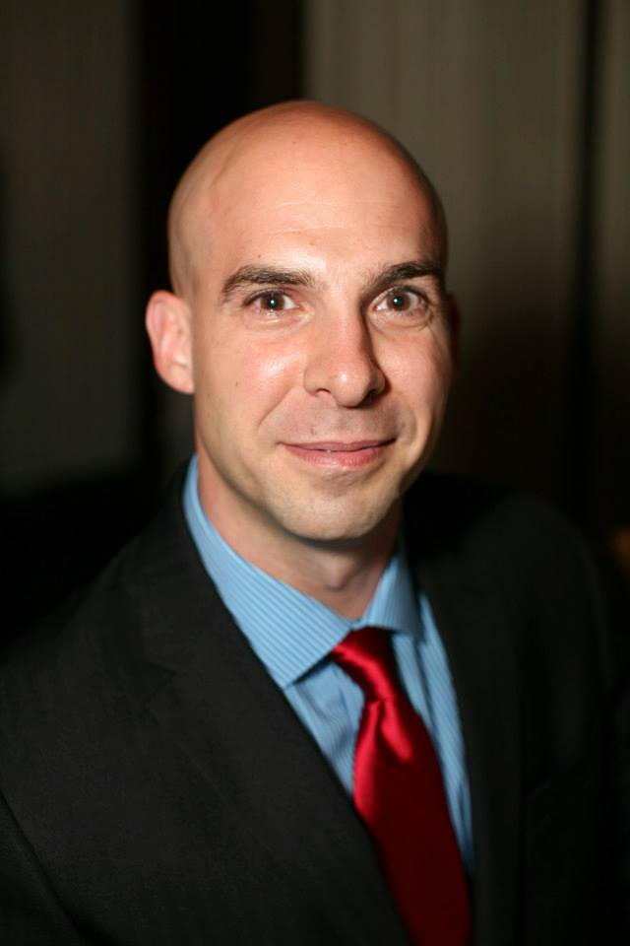
Ken Nercessian
Business Owner
ken@kettlecornnyc.com

Ken Nercessian is the creator and owner of Nercessian Kettle Corn NYC, LLC, better known as Kettle Corn NYC, a mobile kettle corn operation that he started in 2004 and immediately introduced to the New York City street fair scene. Ken has been active ever-since – attending approximately 60 fairs throughout the year where he and his skilled team pop up roughly 15 flavors of fresh kettle corn at each location. The most popular flavors, ranging from sweet to savory to spicy are: Original, Caramel, Cheddar and Spicy Cajun BBQ.
In 2009, Ken shared his secret for making kettle corn on the Food Network’s Unwrapped television series. Also that year, in addition to his street fair commitment, he started participating in Citi Pond at Bryant Park, where kettle corn was a popular attraction for four seasons. Ken has also been featured on WNBC NY Live, Good Day New York and WABC Tory Johnson’s Secret Sales. Former NYC mayor Michael Bloomberg was also spotted with a bag.
Ken is active in charity events in and around the city as well as corporate events and private parties. On Yelp, Kettle Corn NYC has garnered a 4.5 star rating – and sold 1,900 Groupons in a 3-day period.
A few years ago, Ken’s truck with all of his equipment and supplies was stolen. But thanks to his creative problem solving skills, he was eventually able to rebuild. As of late 2014, plans are underway to build a food truck for Kettle Corn NYC.
Ken started Kettle Corn NYC while working full time as a Chef de Partie at the 5-star St. Regis Hotel in NYC, where he was responsible for the preparation of meals for 600 people daily. After 15 years of service, he resigned in 2010 to focus on growing his popcorn business.
In his early days, Ken attended B.O.C.E.S., a technical school for culinary arts where a mentor saw his potential and guided him into the Professional Chef program at SUNY Cobleskill. He graduated with an Associates degree in the program with honors.

