|  |  |
| --- | --- |
| **Press** | Description: Description: Description: OsramCorpLogo-RGBpos |
| Sunnyvale, CA, December 9, 2014 | |

**New Osram Ostar Stage LED for even brighter stage lighting**

Up to 2.6 times the brightness from a component surface only 30 percent larger

**Osram Opto Semiconductors has introduced a new LED for stage lighting. Compared with previous members of the product family, the new Osram Ostar Stage offers more than twice the lumen output with a component surface that is only 30 percent larger. The new version contains two square-millimeter high-current chips per color that can handle a maximum of 4.5 amps (A) per chip. This will enable moving heads for stage and exhibition lighting to be more powerful and more compact at the same time.**

The new Osram Ostar Stage LED is equipped with four high-current chips based on the latest thin-film and UX:3 chip technologies. With an area of 2 mm² each, the chips are twice as large as the previous ones but, at 5.7 mm x 6.4 mm x 1.3 mm, the package size is only slightly larger. Thin-film chips in red and UX:3 chips in green, blue and white are used. Up to 4.5 A can be applied to each chip, which allows more light to be produced from such a small surface area. With a binning current of 1.4 A, the red chips achieve typical values of 140 lumen (lm), and the green chips 280 lm. The “deep blue” chip provides a light output of 1.8 watts (W). If the LED is operated at the maximum current of 4.5 A, the brightness per color increases by a factor of 2.6. The white chip in the new Osram Ostar Stage will have a lifetime of 20,000 hours (L50/B50) at full output thanks to a new C2, ceramic converter, which enables it to achieve a brightness of more than 1000 lm.

**Quality products in different output classes**

The new Osram Ostar Stage from Osram Opto Semiconductors is the latest high-output addition to the company's LED product family for stage, exhibition and architectural lighting. “We are continually developing the chips and the package for the Osram Ostar Stage family so that we can offer our customers high-quality products in different output classes,” said Andrew Lin, NAFTA Product Marketing Manager LED Industry at Osram Opto Semiconductors. “Our aim with this new LED is to raise the standard for moving heads in the high-output category.”

**Compact spotlights thanks to high luminous intensity**

The new Osram Ostar Stage is the latest step by Osram Opto Semiconductors on the path toward high-power LEDs for stage spotlights that emit a large amount of light from a small surface area, leading to more compact spotlight designs. This family of products is ideal not only for stage lighting but also for moving heads and spotlights for trade fairs and architectural lighting.

The new Osram Ostar Stage LED will be unveiled for the first time at the 2015 International Consumer Electronics Show (CES) which takes place from January 6 to 9, 2015, in Las Vegas, USA.

You can find more information on the Osram Ostar Stage family in the [product catalog](http://www.osram-os.com/osram_os/en/products/product-catalog/led-light-emitting-diodes/osram-ostar/osram-ostar-stage/index.jsp).

**Technical data (LE RTDUW S2WP):**

|  |  |
| --- | --- |
| Package dimensions | 5.7 mm x 6.4 mm x 1.3 mm (previously 4.8 mm x 5.9 mm x 1.23 mm) |
| Chip size | 2 mm² |
| Chip colors | Red: 625 nm Green: 530 nm Deep blue: 453 nm White: (x=0.32; y=0.33 to CIE 1931) |
| Brightness (at 4.5 A, max. DC typ.) | Red: 360 lm Green: 680 lm Deep blue: 4.7 W White: 1040 lm (previously 290 lm) |

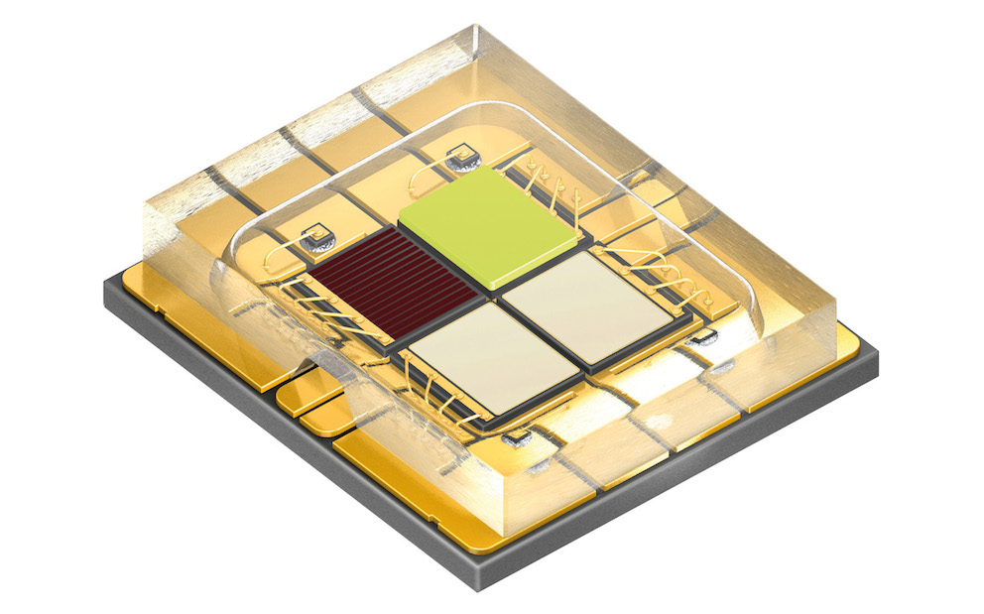

Much greater output from an area only one third larger: the new Osram Ostar Stage LED.

Picture: Osram



Four high-current chips enable more compact spotlights to be designed but with the same luminous intensity.

Picture: Osram

**ABOUT OSRAM OPTO SEMICONDUCTORS**

OSRAM, Munich, Germany is one of the two leading light manufacturers in the world. Its subsidiary, OSRAM Opto Semiconductors GmbH in Regensburg (Germany), offers its customers solutions based on semiconductor technology for lighting, sensor and visualization applications. Osram Opto Semiconductors has production sites in Regensburg (Germany), Penang (Malaysia) and Wuxi (China). Its headquarters for North America is in Sunnyvale (USA), and for Asia in Hong Kong. Osram Opto Semiconductors also has sales offices throughout the world. For more information go to [www.osram-os.com](http://www.osram-os.com).

|  |  |
| --- | --- |
| Press Contact:  Kate Cleveland  Tel. 248-277-8018  Fax 248-596-0395  Email [kate.cleveland@osram-os.com](mailto:kate.cleveland@osram-os.com) | Technical Information: OSRAM Opto Semiconductors Tel. 866-993-5211  Email [info@osram-os.com](mailto:info@osram-os.com) |