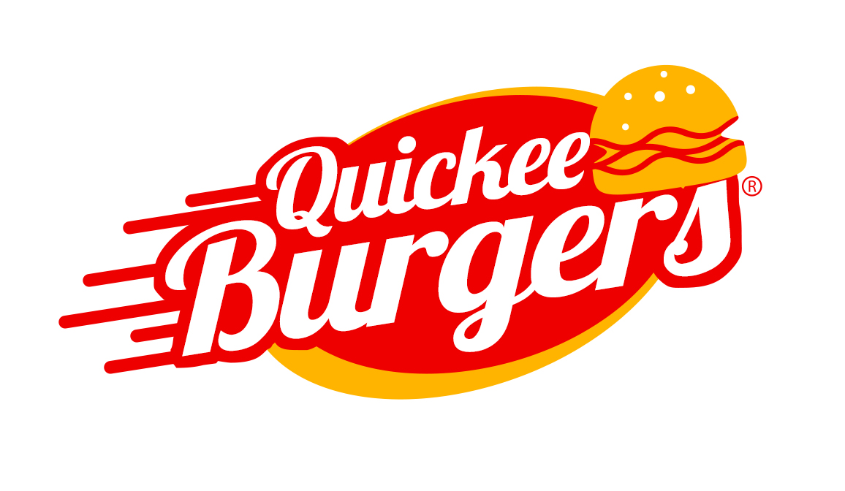
ST Percy Public Relations
Barbara Hunter
ST Percy Public Relations
702.538.0655
hunter@stpercy.com

FOR IMMEDIATE RELEASE
Quickee Burgers Announces Celebrity Partners
Las Vegas, NV –December 15, 2014—Quickee Burgers, announces celebrity partners Mike Tyson, Vince Neil and Ian Ziering ™ to the world’s leading Quick Service Restaurant Concept

As Nevada prepares to welcome its second Quickee Burgers location in Las Vegas, the company announces today their iconic ownership from the worlds of Sports, Music and Television. Boxing Icon Mike Tyson, front man Vince Neil of the legendary rock band Mötley Crüe along with television and film star Ian Ziering have all joined Food and Beverage Magazine founder Michael Politz on the journey to build this new quick service restaurant concept.
Mike Tyson and Vince Neil both reached iconic levels with their careers while at the same time being entrepreneurs and creating businesses and brands of their own. Ziering is about to embark on this seasons Celebrity Apprentice which he says helped ignite the entrepreneur within him. Their combined talent for marketing and brand building, along with the Quickee Burgers team is a recipe for success. Serving high quality natural products in this quick service environment is something they all feel great about.
“Quickee Burgers is committed to continuing the tradition of providing the busy and on-the-go customer with much faster and more efficient burger counter and drive-in services. We are proud to offer healthy hamburgers, shoestring fries and milkshakes that continue to out flavor even the finest restaurants in the country.” Michael Politz stated in a recent article.
The company takes pride in using a standardized systems and technology that will enable them to deliver products and services that are uniform and of high quality. With the introduction of this new hamburger restaurant concept, individuals will be able to experience a better service when ordering their favorite comfort foods. Ordering these products is also made easier since the Drive thru and Walk Up Quickee Burgers are designed to be eaten while on the go or even while standing up.
When coming into a Quickee Burgers location, customers should be on the lookout for one of our partners or their celebrity friends. You never know who is going to be having a Quickee.
They entered into Las Vegas, Nevada in their ever expanding quest to bring quality fast food at a very affordable price for all ages. Expanding into food courts, gas stations and standalone restaurants all over the country, with Las Vegas locations are; 4371 N Rancho Drive, Las Vegas. (corner of Rancho and Craig inside the Arco AMPM gas station), Opening in the busy South East corridor at 8846 S. Eastern Avenue, Las Vegas(Eastern and Pebble).

About Quickee Burgers:
Quickee Burgers is a quick service restaurant concept that aims to provide faster service time in the quick service industry. Amidst the decreasing service time being experienced in various popular food chains, Quickee Burgers is proud to have the best service time without sacrificing the quality of the products that that it offers. It is committed to offering customers with food consistency, uniform customer service, and speed of service. Founders Michael Politz, Cory McCormick and Phil Shalala each bring a long history of extensive knowledge in hospitality from all corners of the industry. Michael Politz is Owner/ Publisher of Food and Beverage Magazine, a national publication for the decision making industry professionals that continues to educate and inform hospitality for almost two decades now. Cory McCormack has spent his career redefining operations in a multitude of establishments- from food carts to world famous nightclubs; always raising the bar has resulted in repeated successes. Phil Shalala has over 15 years in marketing and business practices in many Fortune 500 companies. His time with Hard Rock Hotel and Casino completely revolutionized brand marketing resulting in major expansions on property drastically increasing profits.
For more information on Quickee Burgers, visit their website at: QuickeeBurgers.com
You can follow them on Twitter: @QuickeeBurgers
Like them on Facebook: Quickee-Burgers
Instagram: QuickeeBurgers
For additional information, images or sample requests, please contact Barbara Hunter at ST Percy Public Relations:
ST Percy Public Relations
Barbara Hunter
ST Percy Public Relations
702.538.0655
hunter@stpercy.com
###

