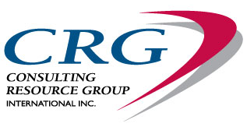

Contact: Harmony Poisson
Tel: (604)852-0566 harmony@crgleader.com
www.crgleader.com
FOR IMMEDIATE RELEASE
November 28, 2014

CRG PRESENTS A LIFE-CHANGING BOOK ON LEADERSHIP

Do you lack confidence, purpose, or understanding of who you really are? Or are you looking for how to be a better leader, and how to best utilize and identify your leadership style?

It does not matter if you are a CEO of a Fortune 500 company, Law Enforcement or Military Officer, Small Business Owner, University Dean, Volunteer Leader, Pastor, Shift Supervisor, Student or Parent - the principles and strategies in Deliberate Leadership apply to everyone who wants to lead self and others more effectively.

Just some of what you will learn:

- The impact and implications of your leadership style
- The two main reasons why leaders fail
- The three skills that every leader must have to succeed
- How to deliberately influence and inspire others
- New definitions of Extroversion and Introversion
- Why playing to your strengths is essential
- Understand what inspires others who are different than you
- How to immediately increase employee engagement
- A system to optimize team and organizational performance

Authors Ken Keis, Ph.D., and Mitch Javidi, Ph.D., together have over 50 years of experience in leadership and personal, professional, and organizational development. They have put all their wisdom into Deliberate Leadership to help transform individuals to become purposeful, intentional, authentic, and inspiring leaders. The practical knowledge in this book will not only enhance your leadership of others, it will enrich your own self-management and self-mastery.

Deliberate Leadership lands in stores January 2015, but you can pre-order now.

Deliberateleadershiponline.com

Every Deliberate Leadership book purchased from the book website by February 1, 2015 will get you entered to win a free 3 day Assessment Certification seat in our June or October 2015 programs. This is a $2,000 value and includes $1,200 in materials!!

