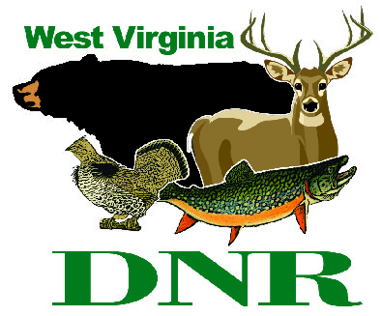 | West Virginia Division of Natural Resources  www.wvdnr.gov  Earl Ray Tomblin, Governor  Frank Jezioro, Director  News Release: Dec. 16, 2014  Facebook: West Virginia State Parks  Twitter: WV State Parks  Hoy Murphy, Public Information Officer 304-957-9365 hoy.r.murphy@wv.gov  Contact: Sissie Summers, Parks and Recreation Section 304-558-2764 Sissie.A.Summers@wv.gov

Bring in the New Year at a West Virginia State Park

SOUTH CHARLESTON, West Virginia – Lodges at West Virginia’s state parks offer a variety of New Year’s Eve celebration options to bring in 2015. Different packages that feature dinner and dancing as well as overnight stays are available at the 10 state parks with lodges. Those include Blackwater Falls, Cacapon, Canaan Valley, Chief Logan, Hawks Nest, North Bend, Pipestem, Stonewall, Twin Falls and Tygart Lake.
Some parks will have music provided by disc jockeys, while Chief Logan Lodge will have live big band music with The Jaguars and North Bend Lodge will feature Pop Avenue Band.
Early reservations for the New Year’s Eve celebrations at West Virginia’s state parks are recommended. Get details by calling the individual parks or by visiting online www.wvdnr.gov and clicking the “Events Calendar” button.

**DNR**

