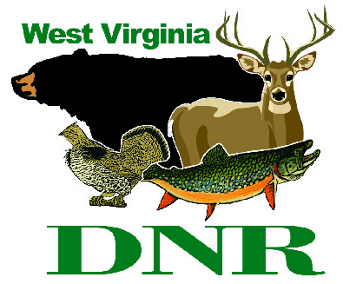 | West Virginia Division of Natural Resources  www.wvdnr.gov  Earl Ray Tomblin, Governor  Frank Jezioro, Director  News Release: Dec. 16, 2014  Facebook: West Virginia State Parks  Twitter: WV State Parks  Hoy Murphy, Public Information Officer 304-957-9365 hoy.r.murphy@wv.gov  Contact: Paul Redford, Parks and Recreation Section  304-558-2764 DNR.Parks@wv.gov

Discover some of West Virginia’s state park lodges

in January 2015 with a “WV50” $50 room rate

SOUTH CHARLESTON, W.Va. – WV50 is a “visit a state park” discount rate promotion to encourage friends, families and meeting planners to use lodge facilities in January.
“Reduced rates can be a very effective way to can encourage visitors to come to state parks at a time they might not normally consider,” said Paul Redford, district administrator with the West Virginia state park system. Redford wants to open doors at several West Virginia State Park lodges to introduce people to good accommodations, dining and activities.
“January is a good month to spend a day or a weekend away without spending much money,” Redford said. “We want people to discover state parks in January, when added services and discounts can make a difference for families to travel and enjoy mini-vacations.”
State parks participating in the WV50 promotion are Cacapon Resort, Chief Logan Lodge, Hawks Nest, North Bend, Pipestem Resort, Twin Falls Resort and Tygart Lake. Room rates at these lodges are $50 for standard forest and mountain view rooms in January 2015, as available, for one or more night rentals.
“Winter lodge rates are already lower. The ‘WV50’ rate is even more attractive,” said Redford.
Reservations can be made by calling the participating parks in advance and asking for WV50. The WV50 rate includes weekends.
Blackwater Falls State Park features “Blackwater50.” The room rate at Blackwater Falls is also $50, but the days are mid-week, Monday – Thursday, for both January and February 2015.
To discover West Virginia’s state parks, visit www.wvstateparks.com. Calls to 800 CALL WVA are greeted by a tourism travel counselor who will transfer your call to the requested state park.

**DNR**

Photo courtesy of the West Virginia Department of Commerce
Twin Falls Resort is one of seven West Virginia State Parks providing the WV50 lodging discount in January 2015.

