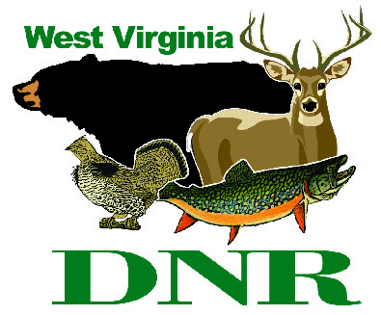 | West Virginia Division of Natural Resources  www.wvdnr.gov  Earl Ray Tomblin, Governor  Frank Jezioro, Director  News Release: Dec. 16, 2014  Facebook: West Virginia State Parks  Twitter: WV State Parks  Hoy Murphy, Public Information Officer 304-957-9365 hoy.r.murphy@wv.gov  Contact: Wendy Greene wendy.l.greene@wv.gov  304-558-2754

Calling all bird lovers! North Bend State Park’s Winter Wonder Weekend Jan. 16-18, 2015, is “For the Birds”

CAIRO, W.Va. – Bird lovers and other winter outdoors enthusiasts are invited to flock to the 2015 Winter Wonder Weekend at North Bend State Park Jan. 16-18. The theme for this annual event is “For the Birds” and will feature bird-related programs, crafts and activities. Outdoor opportunities will include sleigh riding (weather permitting) and hikes.
The weekend begins Friday afternoon, Jan. 16, and concludes Sunday, Jan. 18. Featured guest Bill Beatty of Wellsburg, West Virginia, will provide interesting theme-related programs throughout the weekend.
Friday evening features dinner, a family dessert contest and hot beverage bar. Saturday offers a winter bird hike, crafts, a trip to Harrisville, and post-dinner entertainment by Stepping Stone Band. Sunday is wrap-up day with a morning devotional and final programs. Games, crafts and other activities will be available at various times.
Reservations for rooms, cabins and meals should be made by Jan, 9, 2015. Reservations are honored on a first-come, first-served basis. Weekend information is online at www.northbendsp.com under the “events” tab or by calling Wendy Greene at 304-558-2754. The weekend cost will be $145 per person based on double occupancy. Single occupancy reservations are $170. The rate includes two nights lodging in either the lodge or a cabin, five meals and registration fee, which includes a craft, door prizes and all weekend activities. Lodging for children ages 12 and younger is free. Family rates for cabin occupancy are available.
North Bend State Park is located in Ritchie County near Cairo and Harrisville. The park is open year-round and is known for its hospitality, service and family oriented atmosphere. The park hosts Winter Wonder and Nature Wonder weekends annually in addition to multiple special weekend and overnight packaged rates. To learn more, visit www.northbendsp.com or call 304-643-2931.

**DNR**

Photo Courtesy of the West Virginia Department of Commerce
Each year, Winter Wonder Weekend participants enjoy special programming and activities at North Bend State Park. The 2015 event is Jan. 16-18.

