Altium Updates Next Generation Altium Vault for Collaboration and ECAD Design Data Management Solution

The latest update is built on valued feedback from customers leading their respective sectors and will allow them to pull even further ahead of their competition

San Diego, CA – January 21, 2015 - Altium Limited, a global leader in Smart System Design Automation, 3D PCB design (Altium Designer®, CircuitStudio®, CircuitMaker®), ECAD design data management (Altium Vault®) and embedded software development (TASKING®), has announced an update to their next-generation enterprise data management and collaboration platform - Altium Vault® 2.1. By centralizing, managing and formalizing the component libraries, design data and team collaboration using the Altium Vault, design teams will be able to achieve significant productivity improvements and reduce potentially costly errors.

"Proper design data management remains a key factor in successful product launches, both in terms of budget and timeline targeting", noted Nikolay Ponomarenko, Product Manager for Altium. "With this update, we’ve implemented a lot of improvements and feature enhancements as requested by our customers so they can pull even further ahead of their competition.”

Released in June 2014, Altium Vault 2.0 manages product versions and releases, design reuse and design library management, provides a platform for real-time collaboration, and even manages installation deployment and configuration. Altium Vault 2.1 improves workflow and usability for day-to-day operations saving even more time and reducing the risk of human error.

The Altium Vault provides design teams and design team leaders with:
- A centralized, shared location to manage the organization’s components and supply chain data;
- Managed copies of all templates, reference designs and current designs, complete with precise change information, version and revision history;
- The ability to effectively collaborate on projects across all design domains and even co-design in real-time on the same PCB; and
- Design environment infrastructure management tools for IT departments.

The Altium Vault is offered in three bundles tailored to small, mid-sized and enterprise teams.

The Altium Vault technology responds well to growing industry trends. A recent Aberdeen Group study shows; 81% of Best-In-Class companies reported that “component libraries are centrally built and managed” and 72% of Best-In-Class companies responded that the “entire product design team works collaboratively with PCB engineers”.

Availability
The Altium Vault is available today in three editions; Component, Workgroup, and Enterprise Editions for design teams from small to large. Altium Vault 2.1 can be purchased through Altium sales offices and authorized resellers.

For existing Altium Vault Server license holders with Subscription, Altium Vault 2.1 is a free upgrade. Contact your Altium sales office or authorized reseller to obtain your copy.

More information about Altium Vault 2.1 can be found on the Altium website, here.

IMAGE AVAILABLE:
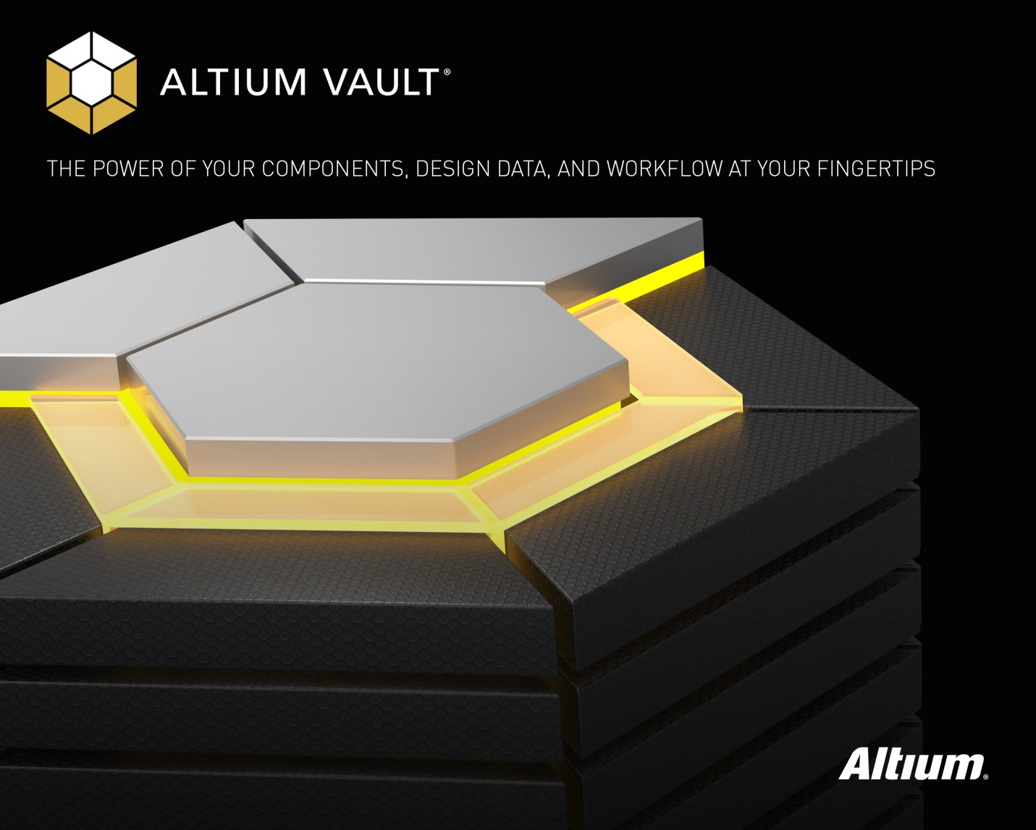

ENDS

Contacts:

Americas | Wendy Krugman  The Hoffman Agency  +1 408 859 6394  wkrugman@hoffman.com | Frank Krämer  Altium Europe GmbH  +49 721 8244 108  frank.kraemer@altium.com
EMEA | Gabriele Amelunxen  PRismaPR  +49 8106 247 233  info@prismapr.com | Frank Krämer  Altium Europe GmbH  +49 721 8244 108  frank.kraemer@altium.com
Monika Cunnington
PRismaPR (UK, Scandinavia, Benelux)
+44-20 8133 6148
monika@prismapr.com
APAC | Celine Han  Altium Public Relations  +86 186 1685 9685  celine.han@altium.com
Greater China | 王婷  霍夫曼公关顾问（北京）有限公司  电话: + 86 (0) 21 62033366-136  电子邮件：dwang@hoffman.com | 仓巍  Altium中国  电话：+86 21 6182 3922  电子邮件：max.cang@altium.com

ABOUT ALTIUM

Altium Limited (ASX: ALU) is an Australian multinational software corporation that focuses on electronics design systems for 3D PCB design and embedded system development. Altium products are found everywhere from world leading electronic design teams to the grassroots electronic design community.

With a unique range of technologies Altium helps organisations and design communities to innovate, collaborate and create connected products while remaining on-time and on-budget. Products provided are Altium Designer®, Altium Vault®, CircuitStudio®, CircuitMaker® and the TASKING® range of embedded software compilers.

Founded in 1985, Altium has offices worldwide, with US locations in San Diego and Boston, European locations in Karlsruhe, Amersfoort, Kiev and Zug and Asia-Pacific locations in Shanghai, Tokyo and Sydney. For more information, visit www.altium.com. You can also follow and engage with Altium via Facebook, Twitter and YouTube.

