MEDIA ALERT

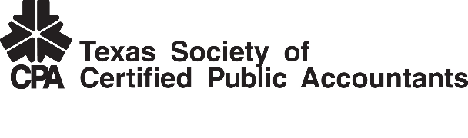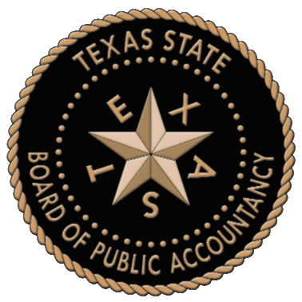

Texas House of Representatives Speaker Joe Straus

to be Honored Speaker in Austin

Special Event Celebrating 100 Year Anniversary of CPA Profession, and Centennial Milestones

of Texas Society of CPAs and Texas State Board of Public Accountancy

Austin, TX (January 21, 2015) -
WHAT: TSCPA is hosting a Legislative Reception to celebrate the 100 year anniversaries of TSCPA and TSBPA and to recognize the CPA profession which has been a certified and licensed profession for 100 years. Speaker Joe Straus will be the primary speaker during the invitation-only event.

WHO: Invited guests include: Statewide officials, state legislators, TSCPA members and former members, TSBPA members and the media.

WHEN: January 27, 2015 from 5:30-7:30 p.m.
5:30 p.m. - Reception begins
Speaker Straus photo opportunity and statement

WHERE: Sheraton Austin Hotel (map or directions)
701 E. 11th Street
Austin, TX 78701
512-478-1111

AGENDA: Welcoming remarks from TSCPA Chair Mark Lee, CPA
Introduction of Representative John Otto
Introduction of Speaker Straus by Otto
Remarks by Speaker Straus
Introduction of TSBPA Presiding Officer Tom Prothro
Remarks by Prothro
Brief video presentation from TSCPA and TSBPA
Closing remarks by Lee

ABOUT TSCPA
Texas Society of CPAs is a nonprofit, voluntary, professional organization representing Texas CPAs. The society has 20 local chapters statewide and has nearly 27,000 members, one of the largest in-state memberships of any state CPA society in the United States. TSCPA is committed to serving the public interest with programs that advance the highest standards of ethics and practice within the CPA profession.

ABOUT TSBPA
The mission of the Texas State Board of Public Accountancy is to protect the public by ensuring that persons issued certificates as certified public accountants possess the necessary education, skills, and capabilities and that they perform competently in the profession of public accountancy.

###

Media Contact: Event Contact:
Stacey Gaswirth, GO PR Bob Owen, CPA
Phone: 214-213-4675 Phone: 214-213-7576
sgaswirth@gopublicrelations.com bowen@tscpa.net

