**PRESS RELEASE                                       FOR IMMEDIATE RELEASE**

**For More Information, Contact:** January 24, 2014

Brian Luckman  
New Era Electronics   
+1 905-265-1235 local 231  
brian@neweraelectronics.com

**New Era Electronics Welcomes New Partner KYOCERA**

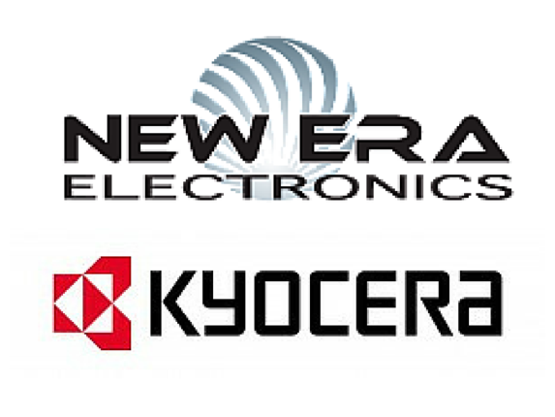**Vaughan, Ontario** - January 24, 2014 - New Era Electronics, a distributor and integrator of industrial computer components and systems based in Vaughan, Ontario has announced their partnership with KYOCERA, a leading designer of flat panel displays based in Tokyo, Japan.

"KYOCERA has been an expert on providing industrial grade products for over 30 years which will enable us to continuously provide the highest quality service and industrial systems," says Brian Luckman, President of New Era Electronics. "We have been distributing their products for several years so this partnership with KYOCERA is important for us."

This partnership will see:

- Increase in product range

- Faster availability of new products

- Faster time to market for custom orders

New Era Electronics was founded in August 2000 and provides a one stop source for all OEM computing requirements. They provide a wide range of products and services to meet your equipment needs exactly when you need it.

More information about New Era Electronics and KYOCERA is available on the company's website: <http://neweraelectronics.com/manufacturers/kyocera>.