FOR IMMEDIATE RELEASE

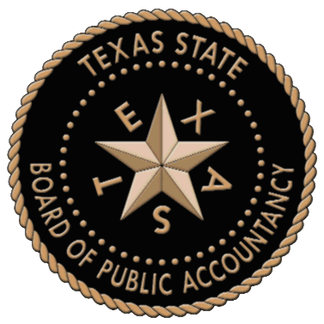

Texas House of Representatives Commemorates 1OO Year Anniversaries of the Texas State Board of Public Accountancy, the Texas Society of Certified Public Accountants and the CPA Profession

Proclamation Presented during 84th Texas Legislative Session

AUSTIN, TX (January 27, 2015) – TSCPA and TSBPA jointly announce the acceptance of a proclamation presented during the 84th Texas Legislative session today recognizing the 100 year milestones of both organizations, and the centennial anniversary of accounting as a certified and licensed profession in the state of Texas.
The proclamation, drafted and sponsored by Representative John Otto, states that because “each are celebrating their 100th anniversary in 2015, this provides a fitting occasion to commemorate the first century of accounting as a licensed profession in the state of Texas.”
“The public has relied upon the skill and integrity of CPAs in the conduct of personal, commercial and public activities,” said John Sharbaugh, CEO of TSCPA. “We are 100 years strong and growing! It is an exciting time to be a part of the celebrations for this significant milestone.”
“We are truly honored to be a part of this momentous occasion,” said Bill Treacy, Executive Director of TSBPA. “We are extremely proud to be a part of a profession with 100 years of historical success.”
The Texas Legislature created the TSBPA in 1915 as an essential regulatory agency to oversee the examination and certification of accountants in Texas, ensuring they possess a high level of expertise. That same year, TSCPA was created. Today TSCPA has 20 chapters across the state, with a membership of nearly 27,000 members.
The proclamation also extended best wishes stating, “The House of Representatives of the 84th Texas Legislature hereby commemorate the 100th anniversary of the Texas State Board of Public Accountancy and the Texas Society of Certified Public Accountants and extend to their officers and members sincere best wishes for continued success with their important work.” (Source: Otto proclamation, pg. 2)
TSCPA and TSBPA are hosting a Legislative Reception from 5:30 – 7:30 p.m. at the Sheraton Austin Hotel (map or directions) located at 701 E. 11th Street, Austin, TX 78701. Speaker Joe Straus will speak during the invitation-only event. Members of the press are invited.

ABOUT TSCPA
Texas Society of CPAs is a nonprofit, voluntary, professional organization representing Texas CPAs. The society has 20 local chapters statewide and has nearly 27,000 members, one of the largest in-state memberships of any state CPA society in the United States. TSCPA is committed to serving the public interest with programs that advance the highest standards of ethics and practice within the CPA profession.

ABOUT TSBPA
The mission of the Texas State Board of Public Accountancy is to protect the public by ensuring that persons issued certificates as certified public accountants possess the necessary education, skills, and capabilities and that they perform competently in the profession of public accountancy.
###

Media Contact:
Stacey Gaswirth, GO PR,
Phone: 214-213-4675
stacey@gopublicrelations.com

