27 January, 2015

GEA gets 3A approval for its CIP-able SANICIP™ bag filter

GEA has received 3A approval in the USA for its SANICIP™ bag filter with Clean In Place (CIP) technology. The CIP-able SANICIP™ system is proven technology that has been available elsewhere in the world for many years and has gained a reputation for efficiency and practicality. This new validation means that food and dairy processors in the USA can buy the same market leading technology with the confidence that it exceeds all US industry requirements for sanitary operation and particulate emissions.

GEA is recognized as the global technology leader for this type of application. SANICIP™ is used widely for the collection of powder fines from dryer exhausts thereby improving yields and reducing the powder content of emissions to the atmosphere to below the required levels.

All the fines discharged from the bag filter are returned to the process. This means that virtually no powder is lost as waste, but sold as first-class product. Retrofits of old plants equipped with cyclones and traditional bag filters or wet scrubbers can now be done by replacing the old exhaust system with a SANICIP™ bag filter. Low-pressure drop across the bag filters means long bag life, reduced energy consumption and quiet operation.

Benefits of SANICIP™
The possibility to clean the entire system in place has many benefits for users. With standard bag filters the bags have to be taken down and replaced every three/twelve months depending on the application. Using a CIP-able system the number of bag changes can be reduced thereby saving material cost; downtime and labor costs are reduced; and there is much less opportunity for contamination to enter the sanitary systems as all cleaning operations are performed within a closed environment. The frequency and duration of the cleaning sequence can be adjusted to suit actual running conditions.

Steve Wright is Powder Technology Manager for GEA Process Technology Inc. in Hudson, WI. “It is a long process for the 3A approval and we thank our customers for their patience,” he said. “There is no other technology quite like the SANICIP™ so we have already made plans to meet the anticipated demand from our US customers.”

The first CIP-able SANICIP™ in the US is operational in a dairy facility producing milk powders. SANICIP™ installations have successfully been running in Canada for the past 10 years.

END

Photo: SANICIP Bag filter from GEA

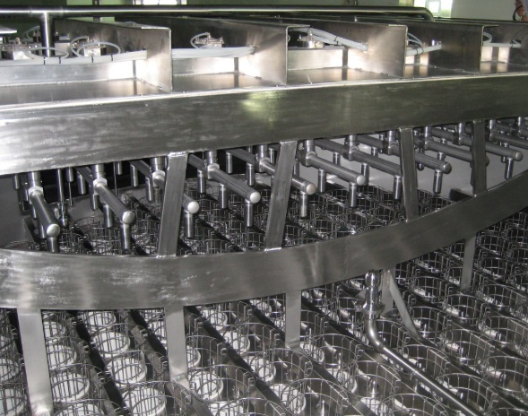

High res image available from: nikki@thewordsworkshop.co.uk

All editorial enquiries to:
Steve Jordan
The Words Workshop Ltd.
Tel: +44 1908 695500
Email: steve@thewordsworkshop.co.uk
Web: www.thewordswoprkshop.co.uk

All business enquiries to:
Nathan Allen
FODA Sales Manager
GEA Process Engineering Inc.
GEA Process Engineering
Phone +1 715-377-1453
Mobile +1 715-690-4436
Nathan.allen@gea.com
www.gea.com
Editor’s information

Working Principle of SANICIP™
The exhaust air containing powder particles is passed through the GEA SANICIP™ filter. It consists of a cylindrical bag housing with a tangential or direct air inlet, clean air plenum on top, and a conical bottom with fluidized powder discharge. During operation, the product collected on the outside of the filter material is blown off by a compressed air jet stream from the inside of each bag by means of a specially designed reverse jet air nozzle (patented) positioned above the bag. This results in a very even discharge of powder. Bags can be up to 23ft in length.

SANICIP™ Features and Benefits:
- Sanitary design - all areas of the bag filter are CIP-cleaned;
- Removable top covers - easy access to bags and cages;
- Easy maintenance - no moving parts;
- Tangential or direct (radial) air inlet – for optimization of plant layout;
- Low pressure drop – reduces power consumption and noise emission;
- Up to 23ft bags are available – for reduced footprint;
- Fluidized bottom – even difficult high fat powders can be discharged from the filter;
- Heated cone - to avoid powder build-up and bacteria growth.

About GEA Group
GEA Group Aktiengesellschaft is one of the largest suppliers for the food processing industry and a wide range of other process industries. As an international technology group, the Company focuses on process technology and components for sophisticated production processes. In 2013, GEA generated consolidated revenues around US$5 billion, more than 70 percent of which came from the food sector, which is a long-term growth industry. The group employed about 18,000 people worldwide as of December 31, 2013. GEA Group is a market and technology leader in its business areas. It is listed in Germany’s MDAX stock index (G1A, WKN 660 200) and the STOXX® Europe 600 Index. Further information is available on the Internet at: www.gea.com.

