Press
Sunnyvale, CA, January 29, 2015

High-power laser bars display unique brilliance
New laser diode from Osram simplifies fiber-coupled systems

The new SPL BF98-40-5 laser bar from Osram Opto Semiconductors combines unprecedented power and beam quality. Thanks to its high brilliance, this laser diode considerably reduces the complexity of coupling light into fibers and diode or fiber laser systems for material processing can be made simpler and more cost-effective. Even at its maximum output of more than 60 watts, the component has an impressively long life.

For its SPL BF98-40-5 laser bar, Osram has optimized the chip design in terms of beam quality. The result is a laser with a wavelength of 976 nanometers (nm) and high brilliance – the yardstick for the beam quality of a laser. The laser achieves a brilliance of 3 watts (W) per millimeter and one mrad divergence angle at an optical output of 44 W – an unsurpassed combination. The SPL BF98-40-5 laser bar is 5 mm wide and consists of five emitters, each 100 micrometers (μm) wide and each with a cavity length of 4 mm.

Brilliant laser sources generate a narrow beam of light with extremely small beam divergence and high power density. The lateral divergence of the beam emitted by the SPL BF98-40-5 is between 6° at 30 W and approx. 9.5° at 60 W. This divergence was calculated for the portion of the laser beam containing 95 percent of the optical output power.

Simple injection into fibers
With its unique brilliance, the SPL BF98-40-5 laser bar is setting new standards for fiber-coupled systems. The beam quality of a laser is a crucial factor for coupling laser light into optical fibers. The lower the brilliance, the less light is coupled into the fiber. This, in turn, makes the systems more inefficient and more expensive. Conversely, a brilliant light source greatly simplifies the design of the optical system. "Our new laser bar can significantly reduce the system costs for fiber-coupled diode lasers," said Sevugan Nagappan, product marketing manager for IR at Osram Opto Semiconductors.

Fiber-coupled diode laser systems are used predominantly in the automobile industry for vehicle chassis welding, soldering and coating. The laser diodes are also often used for pumping fiber lasers. The wavelength of 976 nm is ideal for pumping ytterbium-doped fiber lasers in particular. These are laser types that can be used for cutting metal, thanks to their excellent beam quality. Osram has specifically matched the wavelength of the SPL BF98-40-5 to this pumping application.

Long operating life
Apart from its high brilliance, the new laser bar offers excellent electro-optical efficiency of, e.g., 65 percent at 44 W. This reduces the level of cooling needed for the laser diode and improves the efficiency of the entire system. The temperature rise at the chip is therefore not as great so the laser exhibits very good aging stability. Tests show a drop in output of less than one percent after 4000 hours of operation at an optical output of 65 W and a cooling water temperature of 25°C.

Osram Opto Semiconductors defined the fundamental principles for developing the high-power high-brilliance laser bar within the HEMILAS project sponsored by the German Ministry for Education and Research (BMBF).

Technical data:
Bar dimensions (W x L) | 5 mm x 4 mm
Emitters | Five emitters each with 100 μm emission width at 1 mm spacing
Wavelength | 976 nm
Maximum output | 60 W
Brilliance | 3 W/mm*mrad at 44 W
Efficiency | 65% at 44 W

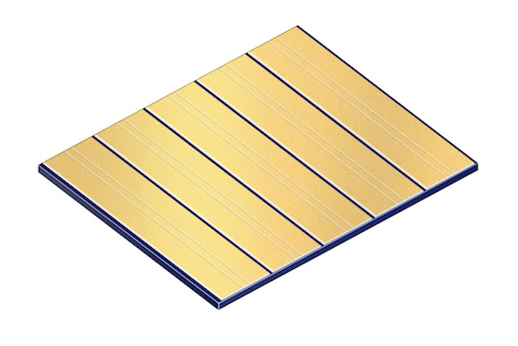
With its unique brilliance of 3 W/mm*mrad at an output of 44 W, the SPL BF98-40-5 laser bar reduces the system costs for fiber-coupled diode lasers.
Picture: Osram
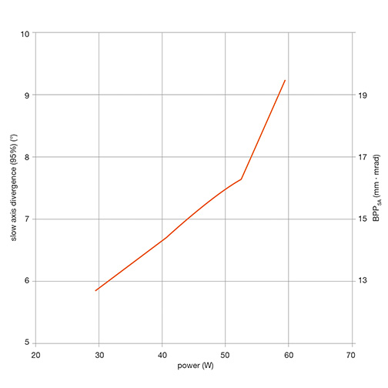
The SPL BF98-40-5 laser bar offers excellent beam quality and extremely long life for an optical output of up to 60 W.
Picture: DILAS Diodenlaser GmbH

http://www.osram-os.com/pr-laserbars

ABOUT OSRAM OPTO SEMICONDUCTORS
OSRAM, with its headquarters in Munich, is one of the two leading lighting manufacturers in the world. Its subsidiary, OSRAM Opto Semiconductors GmbH in Regensburg (Germany), offers its customers solutions based on semiconductor technology for lighting, sensor and visualization applications. Osram Opto Semiconductors has production sites in Regensburg (Germany), Penang (Malaysia) and Wuxi (China). Its headquarters for North America is in Sunnyvale (USA). Its headquarters for the Asia region is in Hong Kong. Osram Opto Semiconductors also has sales offices throughout the world. For more information go to www.osram-os.com.

Press Contact:  Kate Cleveland  Tel. 248-277-8018  Fax 248-596-0395  Email kate.cleveland@osram-os.com | Technical Information:  OSRAM Opto Semiconductors  Tel. 866-993-5211  Email info@osram-os.com

