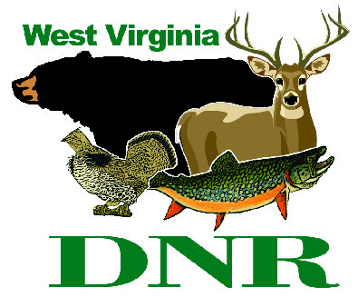 | West Virginia Division of Natural Resources  www.wvdnr.gov  Earl Ray Tomblin, Governor  Bob Fala, Director  News Release: Jan. 29, 2015  Facebook: West Virginia State Parks  Twitter: WV State Parks  Hoy Murphy, Public Information Officer 304-957-9365 hoy.r.murphy@wv.gov  Contact: John Bracken, Superintendent hawksnestsp@wv.gov 304-658-5212

Winter weekends at Hawks Nest State Park are for entertainment

ANSTED, West Virginia – From music to murder mysteries to magic, Hawks Nest State Park has entertainment lined up for winter weekends through March. Located in Ansted, Fayette County, the year-round destination is popular for its view of the New River as well as dining room views and comfortable lodge accommodations. The weekend entertainment schedule includes:

Saturday, Jan. 31
Dinner performance - “Tribute to Red Skelton”
"His humor, His sorrow, With the Greatest Respect” is a family friendly comedic act that "takes you back in time." Laugh and be entertained by one of the top-rated Red Skelton impersonators, Jennings Barnett. The Tribute to Red Skelton is entertainment for all ages.
Saturday, Feb. 7
Dinner performance - “Laura Ingalls Wilder”
The widely held 'Little House books' containing the stories of Laura's experience homesteading in the American West are brought to life with Karen Vuranch's portrayal of Laura Ingalls Wilder. Experience life on the American frontier as you're taken into the childhood memories and life journeys of the popular author. The performance is by Karen Vuranch and wventerprises.com.
Saturday, March 7
Dinner performance - “Coal Camp Memories”
Karen Vuranch returns to Hawks Nest State Park with her one-woman performance titled “Coal Camp Memories.” It is the gentle and poignant story of life in West Virginia Coal Camps that recreates an era while it delights audiences of all ages. Karen Vuranch becomes “Hallie Marie” who ages in front of the audience during the show, growing from an exuberant 10-year-old to a demure teenager, then a young wife, and finally a woman wise with years of love, hardship and experience.
Saturday, March 14
Dinner performance - “A Night of Magic with John Slicer”
Enjoy a magical performance by nationally renowned magician John Slicer as he astounds audiences of all ages. His captivating sleight of hand, illusions and mind reading will leave you saying "How did he do that?" Slicer includes audience participation during the evening.

Dinner theaters and dinner shows at Hawks Nest State Park are an overnight package that includes accommodations for two adults at Hawks Nest Lodge, exceptional dinner menu and show, a 20 percent gift shopping coupon, an Express Breakfast for two, taxes and gratuities. The overnight package is $169 total for two people; dinner and show only is $59. Reservations are recommended by calling 304-658-5212.

**DNR**

