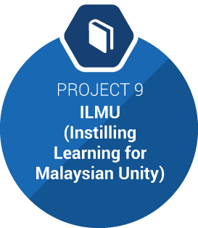

Impact area

Education (FREE Education for all and Knowledge Sharing)
Thousands of educational topics are available online for free to all who want to learn more, but are underused due to the lack of awareness of these tools. Free learning resources will benefit underprivileged children with poor access to schools, single parents, or unemployed youths looking to upgrade their skills, while encouraging a lifelong learning culture among Malaysians.
This project will be a national campaign to promote MyMobile University, a free online resource, while encouraging Malaysians to share their research, theses and other related work using this digital site, to promote a knowledge-sharing culture. This resource will help preserve knowledge, and improve educational access to rural areas, while ensuring the proper documentation of heritage, history, original works, and academic papers.

http://www.vip.org.my/impactprojects/

- The VIP Fellowship Programme
The Volunteering for International Professionals (VIP) Fellowship Programme is designed specially for professionals on career breaks who wish to volunteer in Malaysia.
The VIP Fellowship programme is a Malaysian government initiative to create a large pool of talented professionals, who are passionate about sharing their expertise and experiences globally, as expert volunteers to contribute towards nation-building.
This initiative is part of the government’s goal to transform Malaysia into a high-income nation by 2020, as announced by Malaysia’s Prime Minister, Dato’ Sri Najib Razak, at the National Blue Ocean Strategy (NBOS) Summit in December 2013. International expert volunteers offer transferable and high value skills as well as knowledge to enrich the Malaysian landscape, contributing towards the country’s ambition of being a high-income nation.
The Fellowship is designed, delivered and hosted by Impact HUB Kuala Lumpur and Scope Group on behalf of the Ministry of Finance Malaysia.
- This four-month fellowship offers the opportunity for professionals to use their expertise in addressing Malaysia’s most pressing social issues. The programme aims to evoke a long-term social change in the country.
In order to ensure a successful programme, we will match each volunteer to a placement within the local communities where his/ her expert knowledge will have the greatest impact.
- By working alongside local partners and fellow volunteers, you will use your skills to tackle critical issues in the following areas:

  - Youth-at-risk
  - Environment and Wildlife
  - Women Empowerment
  - Homelessness
  - Access to Education
  - Social Equality
  - Unemployment
  - Rural Transformation
  - Health

