

FOR IMMEDIATE RELEASE

Galbreath Expands Lightweight Roll-Off Trailer Line
New M6-250 Series Trailer is Ideal for Heavy Scrap and Construction Debris

CHARLOTTE, N.C. [Feb. 11, 2015] — Galbreath®, a Wastequip brand, and the waste industry’s most trusted manufacturer of hoists, container handlers, and trailers, today announces the launch of the M6-250 Series Roll-off Trailer. This powerful trailer is an exciting addition to Galbreath’s newest line of lightweight trailers.

Designed to handle roll-offs with heavy loads like scrap and construction materials, this lightweight trailer weighs only 15,650 pounds, has a shorter overall length for greater maneuverability, and an impressive gross vehicle weight rating (GVWR) of 72,500 pounds. With container size capacity up to 30 feet, more materials can be transported per haul. The M6-250 series roll-off trailer is available in outside rail (OR), extendable tail (EX), inside/outside rail (IO), and deadlift (HH) configurations. It features two telescoping lift cylinders that provide greater stability when lifting heavy loads. Plus, its lower trailer height accommodates taller containers than standard trailers.

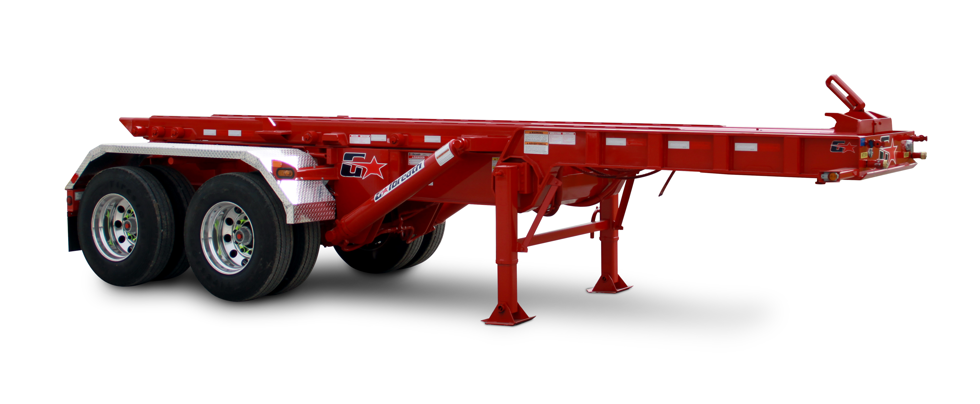
The M6-250 series trailer is designed for safety and ease of operation with features that include:

- “Plug n’ Play” wiring system eliminates crossed wires, loose connections, corrosion, and splices.
- Automatic front container spring-loaded locking system and rear container hold-downs help keep container
in place.
- Hoist-up alarm is a standard safety feature; when hoist is engaged, alarm will sound to alert about
hoist movement.
- Dual safety props add extra security when the hoist is in the up position.
- Seven (7) rollers per side help guide container as it’s loaded or unloaded on hoist. Each roller is equipped with a bearing and grease fitting for easy rolling and maintenance.
- Two (2) cylinders are mounted on the outside of the rails to provide added stability when loading/unloading heavy containers.

“Galbreath made its mark many years ago with our popular A5 series of trailers, but there was still a need in the marketplace for a lighter-weight trailer that would handle heavy payloads with greater accessibility and maneuverability,” said John Defenbaugh, president of Wastequip’s mobile products division. “In late 2013, we introduced the M6-200 series trailer − the first in a series of heavy-duty lightweight trailers. The new M6-250 series trailer handles longer containers.”

“Galbreath has been manufacturing industry-leading hoists and trailers for handling roll-offs in the waste, recycling, construction, and scrap industries for more than four decades,” Defenbaugh continued. “We’re always listening to our customers, and we engineer new products that exceed the needs of the end-users who depend on our products day in and day out. This new M6-250 series trailer is a fantastic example Galbreath’s commitment to our customers.”

Available options for Galbreath’s M6-250 series roll-off trailer include tarping systems, aluminum wheels, outboard-supported rollers, auto grease system, auto air inflation system, air ride suspension, tire carriers, rear wing plates, toolboxes, and more.

The new Galbreath M6-250 series roll-off trailer is available through Galbreath’s extensive North American dealer network.

###

ABOUT THE MOBILE PRODUCTS DIVISION:
Wastequip’s mobile products division includes its industry-leading Galbreath, Mountain Tarp, Pioneer, and Cusco brands. The mobile division includes eight manufacturing and installation facilities in the U.S. and Canada dedicated to hoists, tarping systems, container handlers, and vacuum trucks. For more information, visit www.galbreathproducts.com.

ABOUT WASTEQUIP:
Wastequip is the leading North American manufacturer of waste and recycling equipment, with an international network of manufacturing facilities and the most extensive dealer network in North America. Wastequip’s broad range of waste and recycling equipment and systems is used to collect, process and transport recyclables, solid waste, liquid waste and organics. The company’s brands include Wastequip, Toter, Galbreath, Pioneer, Accurate, Cusco, Mountain Tarp and Go To Parts. For more information, visit www.wastequip.com.

Media Contact:
Kelly Rouse
Marketing Manager
Wastequip
704-501-8207
krouse@wastequip.com

