18 February, 2015

**GEA to show an Air Disperser for a full-scale Spray Dryer at Anuga FoodTec**

GEA will be one of the main exhibitors at the Anuga FoodTec tradeshow in Cologne, Germany (24-27 March, 2015). At the tradeshow, GEA will be promoting its complete portfolio of technology and processes for the production of food and dairy powders.

One of the highlights at the show will be a full-scale GEA Niro Air Disperser type DDD. The Air Disperser is a key component in a spray drying plant and its performance is crucial for both product quality and plant efficiency. The DDD Air Disperser incorporates all the latest knowledge within spray drying and is designed using GEA’s proprietary CFD simulation tools. It is supplied with most new, medium and large-size GEA Niro Spray Dryers and has proved its reputation in more than 90 plants with capacities up to 30 tons/hour producing products such as milk powder, nutritional formulas and food ingredients.

Several cases have proved the efficiency of the DDD Air Disperser. It provides better control of the drying process - compared with other types of Air Dispersers - producing a more uniform product, and longer production runs between cleaning thereby reducing down-time. This has proved to increase the production capacity of spray dryers by up to 15-17%.

Designing the complete powder plant for continuous operation – by adding additional evaporation and feed systems – allows producers to take full benefit of the DDD Air Disperser’s production capacity. Gaining an additional 3-4 hours uptime every day, where the plant would normally be out of operation for cleaning, improves the overall plant output by 15-20%.

Also at the show will be some of the latest spray drying process monitoring and safety measures from GEA – including the GEA Niro POWDEREYE™ in-line powder analysis system and GEA Niro SPRAYEYE™ nozzle monitoring system – featured with the DDD Air Disperser. GEA will also be promoting its GEA Niro DRYCONTROL™ process control system for spray dryers. Building on real-time data and software based on Model Predictive Control technology (MPC), GEA Niro DRYCONTROL™ continuously assesses and compares current and predicted operational data with the desired results whilst setting new control targets to reduce in-process variability and thereby improve process performance. This system has already proved its value: by allowing the spray dryer to be operated closer to the maximum residual moisture content, yield is increased and the spray dryer’s capacity is fully utilized.

GEA will be in hall 9.1, stand A080 E089.

END

**Editorial enquiries:**

Steve Jordan

The Words Workshop Ltd.

Tel. +44 1908 695500

Email: [steve@thewordsworkshop.co.uk](mailto:steve@thewordsworkshop.co.uk)

**Business enquiries:**

GEA Process Engineering A/S

Gladsaxevej 305

DK-2860 Soeborg

Denmark

Tel: +45 3954 5454

Email: [gea-niro.food@gea.com](mailto:gea-niro.food@gea.com)

[www.gea.com](http://www.gea.com)

**Caption:** The GEA Niro Air Disperser type DDD is a key component in GEA Niro Spray Dryers and recognized for its superior product quality and plant efficiency.

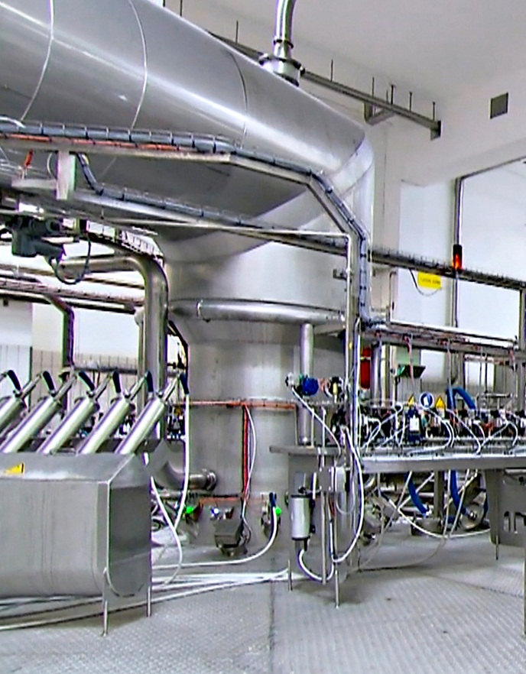

High resolution image available from nikki@thewordsworkshop.co.uk

**About GEA Group**

GEA Group Aktiengesellschaft is one of the largest suppliers for the food processing industry and a wide range of other process industries. As an international technology group, the Company focuses on process technology and components for sophisticated production processes. In 2013, GEA generated consolidated revenues in excess of EUR 4.3 billion, more than 70 percent of which came from the food sector, which is a long-term growth industry. The group employed about 18,000 people worldwide as of December 31, 2013. GEA Group is a market and technology leader in its business areas. It is listed in Germany’s MDAX stock index (G1A, WKN 660 200) and the STOXX® Europe 600 Index. Further information is available on the Internet at: [www.gea.com](http://www.gea.com).