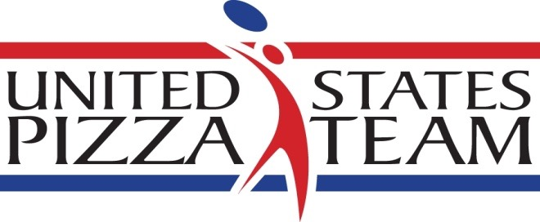

US Pizza Winter Team Acrobatic Trials held at NAPICS
Winner of freestyle acrobatics heads to Italy

Columbus, Ohio –The US Pizza Team held its annual Winter Acrobatic Trials at the NAPICS show in Columbus, Ohio. February 15-16, and Bradley Johnson of Mellow Mushroom Pizza of Chattanooga took the grand prize. Johnson dazzled the judges with his freestyle acrobatics routine earning a trip to Italy for his performance.

The Acrobatic Trials draw pizza athletes from across the country to compete for their spot on the team and a grand prize of a trip to Parma, Italy to compete in the World Pizza Championships in May. Placing second was newcomer Scott Volpe of Fiamme Pizza in Tuscon, Arizona. Third place was Jacob Bens of Ramundo’s Pizza in Cincinnati, Ohio.

Competitors were tested on a variety of dough skills such as largest dough stretch, fastest pie maker and freestyle acrobatics. The event also included a fastest box folder competition.

Taking home the gold for his first time, Mad Mushroom’s Rick Wheeler of Lafayette, Indiana was named fastest pizza maker with a score of 1.2167 minutes. Johnson of the Chattanooga Mellow Mushroom store finished second with 1.2189 minutes. David Whisker of B.C. Pizza in Boyne City, Michigan was third with 1.28 minutes.

In largest dough stretch, Johnson of Mellow Mushroom came in first with 32 inches. Dave Sommers of Mad Mushroom in West Lafayette, Indiana came in second with 31 inches and Whisker came in third with 27.5 inches.

In fastest box folding, newcomer Kyle Hambley of Samosky’s Homestyle Pizzeria in Valley City, Ohio took the gold with 20.91 seconds. Whisker, who medaled in three categories, took second with 24.77 seconds. Sommers earned third place with 25.87 seconds.

For more information contact Brian Hernandez at 662-234-5481 x129 or by email @ brian@pmq.com. For images, contact Melanie Addington at Melanie@pmq.com.

The U.S. Pizza Team consists of expert pizza makers and dough-spinning acrobatic performers from pizza restaurants across the United States. The squad won second place in Individual Free Style in 2014 and first place in the Team Acrobatics World Championship in Italy in 2011. PMQ Pizza Magazine, the business trade publication for the pizza restaurant industry, created the U.S. Pizza Team in 2000. The US Pizza Team is sponsored by Grain Craft, California Milk Advisory Board, Gordon Food Service, LaNova, Paradise Tomato Kitchens, Bag Solutions, Fontanini Meats, Lillsun, Marsal and Sons, Univex, PizzaInsurance.com, Rock Tenn and Presto Foods. ##

