Pucker Images Press Release – Before & After Cut-Out Example (3/5/15)

Before:
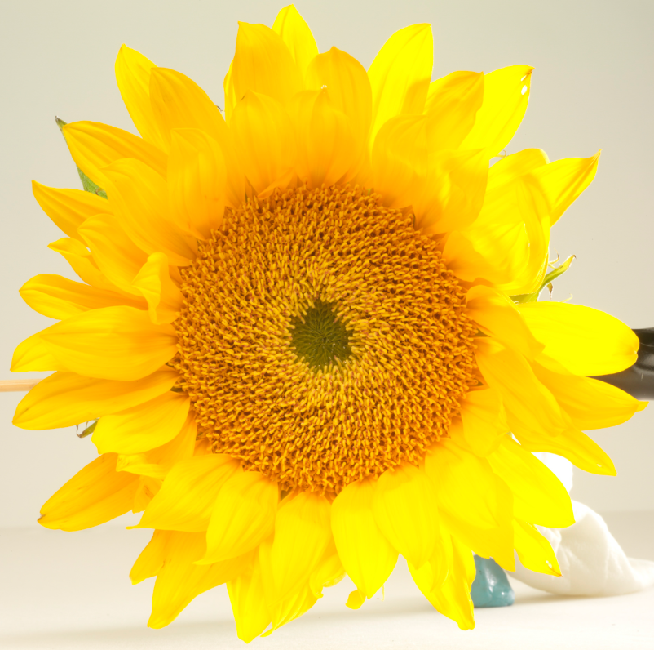
After:

