Pucker Images Press Release Addendum – Industry Pricing & Inventory Size (3/5/15)

I. Pricing To eliminate worry and hassle, Pucker Images offers one flat price for all images regardless of size and resolution. You don't need to know all your uses up front to determine the price, or deal with restrictions and added costs down the road should you need to add a medium or market. There are no confusing pricing models. For $5, you get the 300 pixel per inch high-resolution image to use however you like, wherever you like, forever, royalty free. That includes making things with images and selling those things, where competitors charge extra.
Some competitors charge more for a bigger size, most encourage purchase volume.

II. Inventory Size
A) Internal Search Problem The traditional sites have become so big that internal keyword search results often run to hundreds, even thousands of pages.
Search for “apple” on big site:

The Pucker approach by comparison harkens back to a famous print ad, which changed how people think about cars.
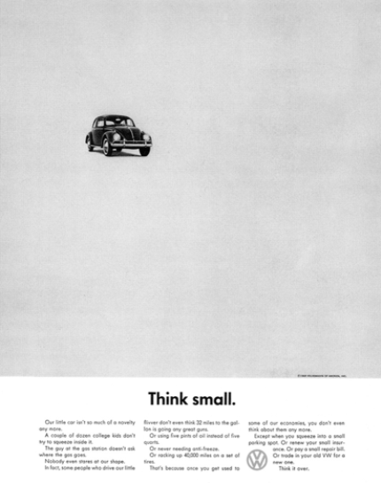
Pucker Images is akin to a boutique with something unique, albeit one that’s accessible globally.

B) Crowd Source Photographer Problem The traditional sites’ enormous inventories are also creating a problem with contributors. To keep top contributor earners from switching sites, internal keyword search settings are adjusted to favor their images. This in turn causes the majority of photographers to have to upload new images regularly so their images continue to get found, too. This post from a big site contributor blog details the problem:
