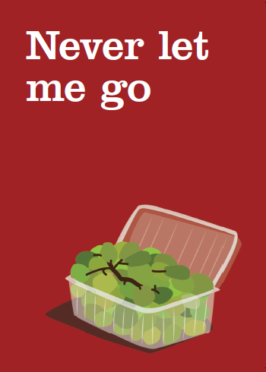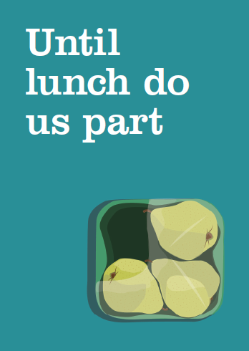
Fresher for Longer – key messages
Top 5 key messages:
- The national Fresher for Longer conference takes place on 5th February 2014 to call for collaboration across local government and industry to help everyone waste less food by storing our food in the best way possible.

- Only a sixth of the public realise that packaging can play an important role in protecting food in the home.
From ziplocks on cheese packs to breathable fruit and veg bags, packaging has been perfectly designed with all sorts of cunning features. So when you get your food home, keep it in its original packaging and follow instructions on the pack to keep food fresher for longer.

- Throwing away food as a result of it being not used in time is costing us, as consumers, £5.6 billion a year or £210 for the average household. With the majority of us believing that keeping fresh fruit and vegetables in their original packaging makes them ‘sweat’ and go off quicker, whereas the opposite is true, it’s easy to see why.

- The impact on the environment of throwing away an apple is 6 times greater than the pack it comes in

- For tips on the best way to store your food and keep it fresher for longer go to lovefoodhatewaste.com

Top tweets
- Only 1 in 6 of us realise that packaging can play an important role in protecting food in the home #FresherforLonger bit.ly/1i2WUUj
- Throwing away food as a result of it being not used in time is costing the average household £210 a year #FresherforLonger bit.ly/1i2WUUj
- Most of us believe keeping fresh fruit and veg in their packs makes them sweat & go off quicker but the opposite is true #FresherforLonger
- The impact on the environment of throwing away an apple is 6 times greater than the pack it comes in #FresherforLonger
- The impact on the environment of throwing away tomatoes is 30 times greater than the pack they come in #FresherforLonger
- The impact on the environment of throwing away lettuce is 100 times greater than the pack it comes in #FresherforLonger
- Most fresh fruit & veg will last up to 2 weeks longer if kept in the fridge in their original pack #FresherforLonger
- Shrink-wrapped cucumbers will last around three times longer than non-shrink-wrapped ones #FresherforLonger

