Press Release Contacts:
For Immediate Release Vinitaly International
International Media Dept.
+39 045 8101447
media@vinitalytour.com
www.vinitalytour.com
Twitter: @VinitalyTour
Join Vinitaly International Network on LinkedIn

As the OperaWine wine list is gradually disclosed, Vinitaly International announces new record with 20 new Finest Italian Wine Producers

A high level of suspense surrounds this year’s edition of OperaWine with the official wine list only gradually being announced week by week in a growing crescendo that is leaving wine aficionados holding their breath. In the meantime Vinitaly International has officially disclosed the complete list of the 100 top Italian wineries that have been selected this year by Wine Spectator, with a record number of 20 new entries that once again seek to act as spokespeople for their territories, spreading awareness of the great wines that can come from both well and lesser-know wine regions.
"This is my first time at OperaWine and I am both excited and apprehensive,” says Giorgio Anselmet owner of Maison Anselmet winery, the farthest North new entry, just a short distance away from Parco del Gran Paradiso in the Valle d’Aosta region. "I worked hard on this wine and indeed after many national and international awards here we are with the final step: US expert tasters. From my point of view, it is not important to add a recognition on my bulletin board, but to make sure that my work of finishing makes my wine evolve the way I want it”.
For these wineries, to have been selected is an honor validated both by the reach and authority of Wine Spectator and also by the growing importance that the event has acquired since its very first edition back in 2012.
“There is much talk and fame about OperaWine and I am excited to be part of it this year. It is a great honor for me to be participating at this year’s edition and I am looking forward to celebrating together with these iconic estates!” says Elena Walch, who works alongside her two daughters in her winery in Trentino Alto Adige.
Edoardo Falvo, owner of Masseria Li Veli in Apulia, also expresses the same enthusiasm at being selected for this exclusive premier event to Vinitaly: "We are honored to be part of OperaWine this year. We have been working hard for years at Masseria Li Veli trying to make great wines from indigenous varietals and we see this as a wonderful recognition and a great chance to present one of our best wines to the most selected public. We very much look forward to the event.”

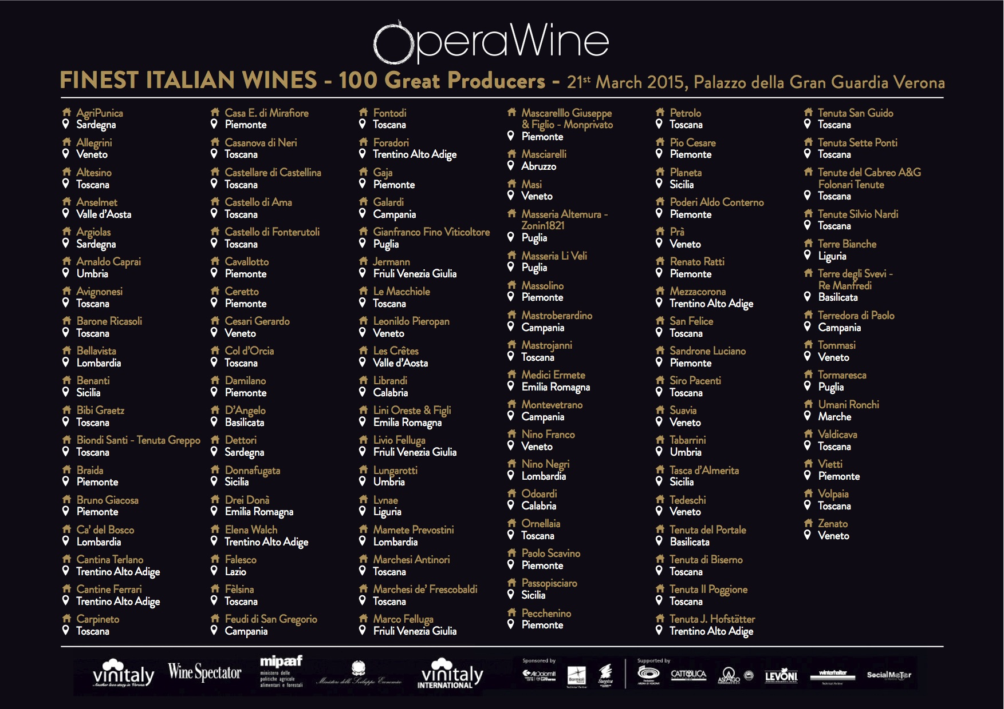

Tuscany still today is the region with perhaps the greatest concentration of renowned wine makers from Italy like the noble family of Frescobaldi, a name that can boast 7 centuries of history through 30 generations and 1200 hectares of vineyards . “We are very proud to take part in OperaWine in the year of the 21st anniversary of Luce. I am very happy to share this important goal with the attendees of such a prestigious event that celebrates the great excellence of Italian wine”.
It is not just their territories that these wineries seek to promote, but also the local grapes that have produced these exceptional wines and the tradition and history that lies behind each label.
Rocco D’Angelo, owner and winemaker of Casa Vinicola D’Angelo, inherited his passion for wine from his father Lucio. Today the Winery is the trademark symbol of the most authentic tradition of the Vulture and offers austere reds of great depth whose tradition has been renewing itself for decades drawing its inspiration from old local practices. “To be among the 100 greatest producers in Italy is an incentive to continue the production of wines that faithfully express the characteristics of Aglianico del Vulture and its territory,” explains Rocco D’Angelo, owner of Casa Vinicola D’Angelo in the far South of Italy, in Basilicata. “Our constant commitment to endorsing and spreading knowledge of Aglianico del Vulture in the world is reflected in each bottle that we produce. The same bottles that, as true custodians of our territory, we like to call home."
This year the event, which features the producers themselves pouring their award-winning wines, will be an even more intimate and exclusive affair with a number of VIP delegations from different countries attending the traditional afternoon Grand Tasting. The candidates of the very first Vinitaly Internatonal Academy Certification Course, that is beginning today at Villa Quaranta, will also be present at the exclusive event and the newly nominated Italian Wine Experts will be formally announced during the Press Conference.
“It is an honor for my family and I that our passion for winemaking has been appreciated by Opera Wine,” says Giampaolo Tabarrini, Owner of Tabarrini Montefalco in Umbria. “I am overwhelmed to be among such distinguished artists, it is comforting to see so many familiar faces. Clearly, I among friends from across the different territories of Italy. I thank Vinitaly International and Wine Spectator for this incredible opportunity. And now.. I must go back to the vineyards and continue the good work you have entrusted me with”.
For the complete list of wineries and the white and sparkling wines that have been made public up until today, you can visit the OperaWine Internet site at http://www.operawine.it/who-they-are.

About:

Veronafiere is the leading organizer of trade shows in Italy including Vinitaly (www.vinitaly.com), the largest wine and spirits fair in the world. During its 48th edition Vinitaly counted some 155.000 visitors and 4.000 exhibitors on a 100.000 square meter area. The next edition of the fair will take place on 22 – 25 March 2015. The premier event to Vinitaly, OperaWine (www.vinitalyinternational.com) “Finest Italian Wines: 100 Great Producers,” will unite international wine professionals on March 21st 2015 in the heart of Verona, offering them the unique opportunity to discover and taste the 100 best Italian wines, as selected by Wine Spectator. Since 1998 Vinitaly International travels to several countries such as Russia, China, USA and Hong Kong. In February 2014 Vinitaly International launched an educational project, the Vinitaly International Academy (VIA) with the aim of divulging and broadcasting the excellence and diversity of Italian wine around the globe. VIA is now ready to present the first edition of its VIA Certification Course to be held in Verona from the 16th to the 20th of March 2015 with the aim of creating new Ambassadors of Italian Wine in the World.

###

