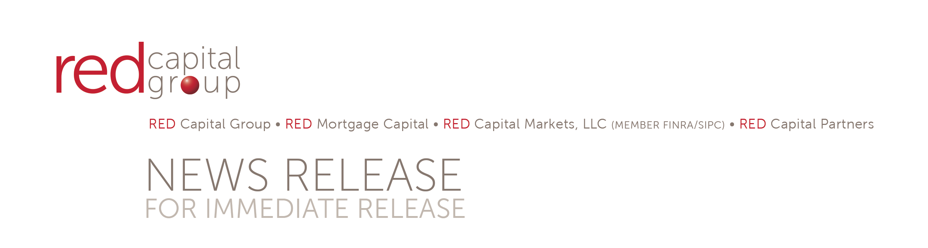

RED Closes $13.86M Balance Sheet Construction Loan for Summit Senior Living in Utah

COLUMBUS, OH, March 18, 2015 – RED Capital Partners, LLC, the proprietary debt and equity banking arm of comprehensive capital provider RED CAPITAL GROUP, LLC, recently completed a $13.86 million balance sheet construction loan to Link Development LLC, for the construction of Summit Senior Living, located in Kearns, Utah, just outside Salt Lake City.
The loan will support the construction of a 2 story Assisted Living (AL) and Memory Care (MC) facility built on approximately 3.9 acres parcel and located at 5600 West and 6200 South. It will consist of 75 assisted living apartments as well as 32 specially designed memory care bed apartments. Once completed, the community will be managed by Milestone Retirement Communities, LLC, (Milestone) located in Vancouver, Washington. Currently, Milestone manages over 29 communities in 9 states.

Summit Senior Living is purposefully designed to cater to active seniors, those needing assistance with activities of daily living, and those with dementia or other memory loss. Summit Senior Living will be providing residents with a beautiful home-like environment and personal care services as needed.

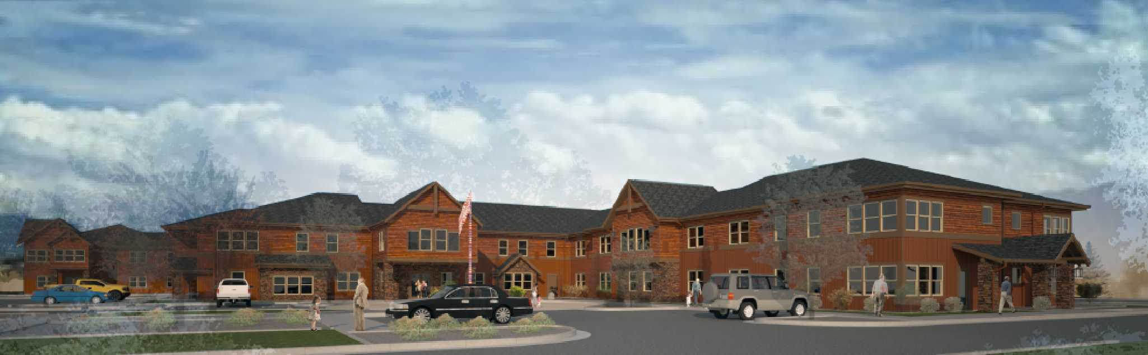
Rendering of Summit Senior Living

Ron Ziebart, owner and developer for Link Development, LLC, stated “I’m proud to have a facility like this built in such a beautiful area as Kearns. I would like to express my great appreciation and sincere thanks to Red Capital Group for their interest, participation and excellent service during the construction loan process. This has been an amazing experience and we look forward to further projects in the future.”

Link Development, LLC, is an Oregon based company that specializes in developing assisted living centers and has ten projects across the west. Seabold Construction, Inc, is the General Contractor on the $17.9 Million Dollar project with a projected completion date of early March 2016. Ankrom Moisan Architects are the architects on the project.

Kathryn Burton Gray, Senior Managing Director for RED, said, “We have great relationships with Milestone and Seabold Construction and are always happy to work with those teams. This was a very complex deal and a great opportunity for RED to develop a new relationship with Ron Ziebart and Link Development. We look forward to working with him and his team on future projects.”
* * *
About RED CAPITAL GROUP, LLC

Recognized for its industry expertise, innovative and comprehensive structures, and consistently high rankings, RED CAPITAL GROUP, LLC has provided over $55.3 billion of integrated debt and equity capital since 1990 to the seniors housing and health care, multifamily, affordable, and student housing industries through three operating companies. RED Mortgage Capital, LLC is a leading Fannie Mae DUS® and MAP- and Lean-approved FHA lender with a mortgage servicing portfolio of almost $16.6 billion. RED Capital Markets, LLC (MEMBER FINRA/SIPC) is a leader in the distribution of Fannie Mae and Ginnie Mae Project MBS, and provides structuring, underwriting, placement, and advisory services for tax-exempt and taxable housing and health care bonds. RED Capital Partners, LLC provides proprietary debt and equity solutions, and asset management in a range of forms, including subordinated gap and bridge loans. RED CAPITAL GROUP, LLC is a subsidiary of ORIX USA Corporation. For more information on RED CAPITAL GROUP, LLC, visit www.redcapitalgroup.com.

About ORIX USA Corporation

ORIX USA Corporation is a diversified financial company with approximately $6 billion of assets in sectors spanning commercial finance, venture finance, commercial real estate and public finance, as well as $25 billion of assets managed for others. Operating subsidiaries include Houlihan Lokey, RED CAPITAL GROUP and Mariner Investment Group. Headquartered in Dallas, Texas, ORIX USA and its subsidiaries have more than 1,400 employees and offices in major cities including New York, Los Angeles, London and Tokyo.

ORIX USA is a wholly owned subsidiary of ORIX Corporation, a Tokyo-based, publicly owned international financial services company with operations in 35 countries worldwide. ORIX Corporation is listed on the Tokyo (8591) and New York Stock Exchanges (IX). For more information on ORIX USA, visit www.orix.com.

DUS® is a registered trademark of Fannie Mae

For more information on this announcement and RED CAPITAL GROUP, LLC please contact:

Lisalynne Quinn
Director of Marketing
RED CAPITAL GROUP, LLC
+1 469 385 1434
llquinn@redcapitalgroup.com

