Press Release Contacts:
For Immediate Release Vinitaly International
International Media Dept.
+39 045 8101447
media@vinitalytour.com
www.vinitalytour.com
Twitter: @VinitalyTour
Join Vinitaly International Network on LinkedIn

From Château Cheval Blanc to Amarone, Vinitaly International Academy announces VIA Executive Wine Seminar Series for Vinitaly 2015

A year after its successful launch, Vinitaly International Academy returns to Vinitaly with a series of fascinating Executive Wine Seminars that will be highlighting once again the truly international nature of VIA and its ability to speak knowledgeably also about wines beyond Italy.
With this international focus in mind, the EWS Verona series will kick off on Sunday with no less than three sessions and go on to cover both Monday and Tuesday as part of Vinitaly International's Talk Business Series program.
They will be informative and educational seminars as well as practical tasting sessions, as the Academy’s scientific director Ian D’Agata explains: "there are already enough opportunities to just drink – with VIA we have created something more academic, with a serious scientific basis. We need to know how to look abroad, otherwise we lose the opportunity to exchange information and knowledge, and also learn from each other."
This is the scope of the first seminar in the series, “Château Cheval Blanc: Portrait of Cheval Blanc and Petit Cheval” that will be held at 11 am on Sunday 22nd of March and represents the perfect sequel to last year’s homage to French wines with the special tasting that was dedicated to Chateau d'Yquem, the world-famous French sweet wine, as well as Y, its dry version.

During this year’s session, Ian D’Agata will be joined by Pierre Lurton, Managing Director of the estate, providing together an exceptional opportunity for all in attendance to appreciate precisely why Chateau Cheval Blanc is widely acknowledged as being one of the ten greatest wines in the world. Tastings will be conducted on Chateau Cheval Blanc and Le Petit Cheval which, despite being the estate's second wine, is often considered the equivalent of some of the best wines from Bordeaux. The vertical tasting of each vintage of these Cabernet Franc-Merlot blends will showcase one of the two grape varieties at their best.

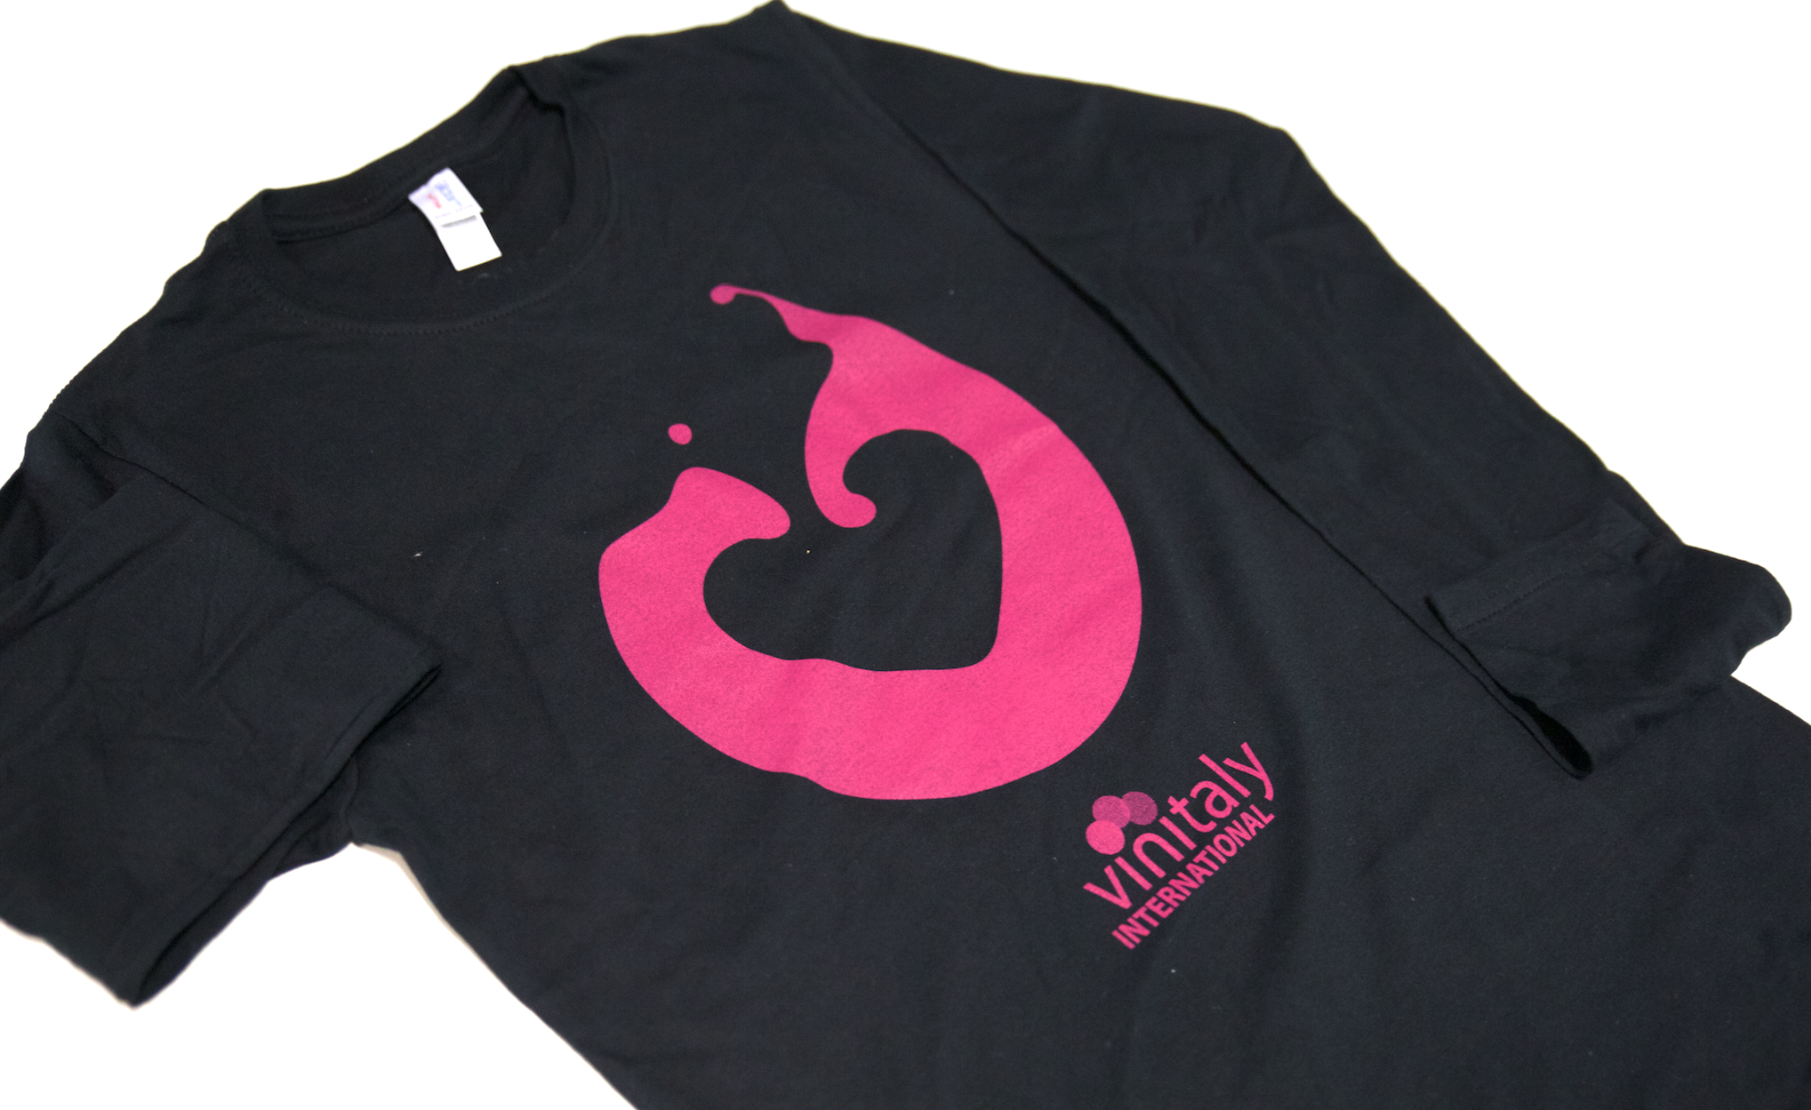

Mr Lurton will remain with Ian for the following session to explore the market potential of Bordeaux reds and whites and the reasons behind the success of Pierre's proprietary wine, Chateau Marjosse, in “Chateau Marjosse: great Bordeaux Rouge and Bordeaux Blanc ages well and costs a fraction of the price of Crus Classés” to be held on Sunday 22nd of March at 12.45 pm.
In this seminar Ian D’Agata and Lurton will try to 'go beyond the label' avoiding the assumptions usually made about Bordeaux wines that are strongly conditioned by the big names associated with the region (Margaux and Petrus come to mind). They will maintain that Bordeaux is best at producing low alcohol wines with a fresh acidity and will remind us that that these go remarkably well with food. Unlike 'modern behemoths' "all oak, vanilla and alcohol”, wines like Chateau Marjosse reveal themselves to be medium-bodied, and to have those well balanced qualities that have led them to being recognised by true wine cognoscenti and which now enjoy good sales in fine restaurants and expensive hotels worldwide.
During the tasting the two wine experts will analyse six different vintages back to 2008 of both the Chateau Marjosse Rouge and Blanc.
With the third tasting seminar VIA returns to its domestic duties and the foothills bordering the fair in "Amarone della Valpolicella: focus on old and new vintages". On Sunday 22nd of March at 12.45 pm, Ian D'Agata will investigate why Amarone is such a unique wine and why it seems so difficult to reproduce elsewhere, as demonstrated in various less interesting attempts at appassimento styled wines. Ian will conduct an analysis to better define Amarone in a tasting across nine/six Amarone wines from different vintages, chosen to illustrate how variations in growing conditions and production methods can lead to remarkably different results. These various factors and the interplay between them will be explained whilst identifying the fil rouge connecting the wines to be tasted as a key to understanding what makes Amarone so unique.
In the last tasting session of the series "How wine modifies it's aroma and flavour profile when it comes into contact with oxygen: Arneis, Barbaresco and Barolo and the Coravin system”, speakers Ian D'Agata and Federico Ceretto of the world famous Ceretto winery and the inventor of the system in the session’s title, will tackle the issue of oxygenation which presents real practical problems, particularly for connoisseurs and collectors, in appreciating their wines to the full and will investigate how these might be overcome using the Coravin system.
They will start by explaining how once a bottle has been opened, oxygen will rapidly change a wine’s aroma and flavour profiles to a radical extent. In practical tastings the two speakers will then go on to demonstrate what happens with wines that have been opened at different times.
The Coravin system will be put to the test in a ‘horizontal’ tasting between two bottles of a Barolo 'Bricco Rocche' 2005 and a Barbaresco 2012: while one of each will be freshly opened the other will have been poured with the Coravin system some time earlier. The comparison should be interesting and its implications for the way that wine is consumed in the future could be profound.

About:

Veronafiere is the leading organizer of trade shows in Italy including Vinitaly (www.vinitaly.com), the largest wine and spirits fair in the world. During its 48th edition Vinitaly counted some 155.000 visitors and 4.000 exhibitors on a 100.000 square meter area. The next edition of the fair will take place on 22 – 25 March 2015. The premier event to Vinitaly, OperaWine (www.vinitalyinternational.com) “Finest Italian Wines: 100 Great Producers,” will unite international wine professionals on March 21st 2015 in the heart of Verona, offering them the unique opportunity to discover and taste the 100 best Italian wines, as selected by Wine Spectator. Since 1998 Vinitaly International travels to several countries such as Russia, China, USA and Hong Kong. In February 2014 Vinitaly International launched an educational project, the Vinitaly International Academy (VIA) with the aim of divulging and broadcasting the excellence and diversity of Italian wine around the globe. VIA is now ready to present the first edition of its VIA Certification Course to be held in Verona from the 16th to the 20th of March 2015 with the aim of creating new Ambassadors of Italian Wine in the World.

###

